Зубарева Юлия Сергеевна
учитель английского языка
МБОУ Борис-Глебская СОШ
Борисоглеб Муромский район
Краткая аннотация.
Дидактическая разработка краеведческого характера «Meshchеra National Park » предназначена для обучающихся 6-8 классов в рамках изучения темы «Speaking about the wonders of nature». Во время работы над данным текстом у учащихся расширяется кругозор, происходит знакомство с культурой, историей и традициями своей малой Родины.
Данный материал является актуальным, так как в нем реализуются главные задачи образования и воспитания учащихся на уроке иностранного языка, а именно, формирование гражданской позиции, чувства патриотизма и коммуникативной компетенции. Содержание текста направлено на формирование познавательного интереса учащихся к изучению традиций и культуры малой Родины. Цели и задачи работы: 1. Формирование чтения с целью понимания основного содержания; 2. Развитие навыков поискового чтения, чтения с детальным пониманием прочитанного; 3. Развитие умения анализировать полученную информацию; 4. Совершенствование навыка монологической и диалогической речи; 5. Знакомство с новыми лексическими единицами, способствующими обогащению словарного запаса; 6. Формирование умения высказывать свое мнение по теме. Разработка включает в себя предтекстовые, текстовые и послетекстовые задания, способствующие формированию основных компетенций, которыми учащиеся должны овладеть по предмету английский язык в средней школе.

Before reading
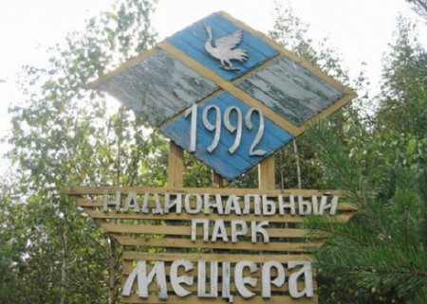
- Answer the following questions:
Have you ever heard about Meshchеra National Park ?
Where is it located?
What is it famous for?
What information can you find in the text? Give your ideas.

2.Complete the mind map. What nouns are associated with the word combination «National Park»?

National park

3.Match the words with their translation.
lowland | Хорошо выраженный
swampy | Приток
penetrate | Заболоченный
weakening | Проникать
well-defined | Низменность, низина
perennials | Водоем
tributary | Многолетние растения
reservoir | Ослабление

While reading
1.Read the texts and match them with the titles. There is one extra title you don’t have to use.
A. Animals and birds
B. Location of the park
C. Legends of the park
D. The main rivers of the park
E. Climate
F. Plants
G. Attractions of the park
H. Reptiles, amphibians and other

2.Match the words and the pictures

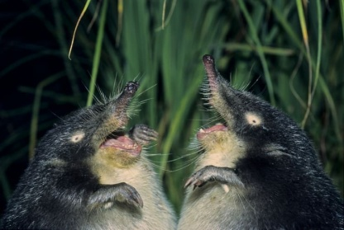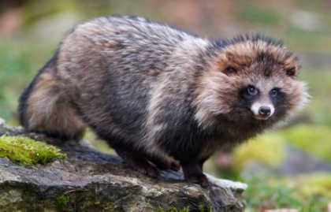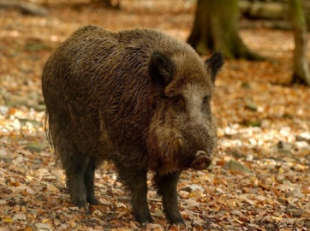

_______________________________________ _____________________________________ ________________________________________

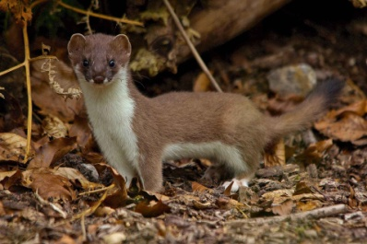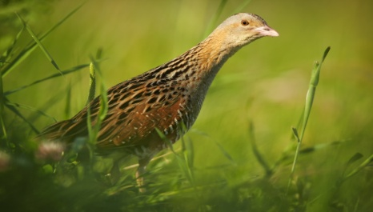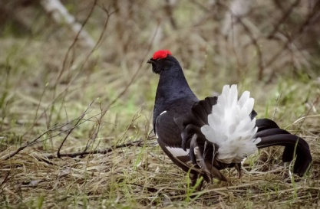
____________________ ________________________ ______________________
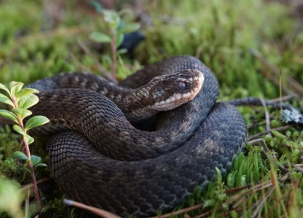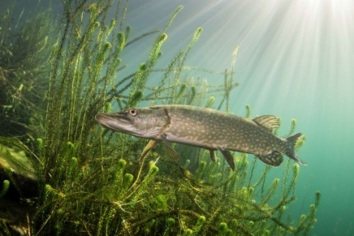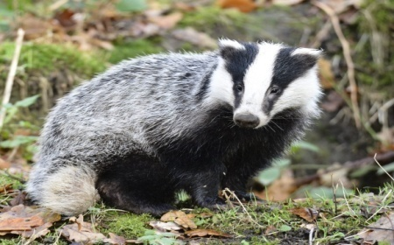
____________________ __________________ ____________________
Ordinary viper- гадюка
Ermine-горностай
Black grouse-тетерев
Pike- щука
Badger-барсук
Corn- crake- коростель
Muskrat-выхухоль
Raccoon dog-енотовидная собака
Wild boar-кабан

3.Read the text, find the answers to the following questions.
1. What animals live in Meschera National Park?
2. What birds can you see in this area?
3. What do you know about the climate conditionals of the Park ?
4. Would you like to visit Meshchеra National Park ? Why? Why not?

4.While reading the text fill in the table. (для сильных учеников)
Name | Date of organization | Location | Definition | Animals | Plants

Meshchеra National Park
1.Meschera National Park was organized in 1992, on April 9. It is located in the southeastern part of the Vladimir region. The landscape of the national park was formed in ancient times. It is a plain called the Meshcherskaya lowland, swampy and covered with pine-birch forests.
2.The territorial boundaries of the Meschera National Park are dominated by a temperate continental climate, which is characterized by well-defined seasons. Wet air masses penetrate from the Atlantic into the protected area with cyclones, which leads to a weakening of frosts and snowfalls in winter, and in summer causes rains and a decrease in temperature.
3.The main rivers of the Meschera − Buzha National Park and its tributary Pol, as well as Soroka, Poserda, Karaslitsa, Tasa. In the south-west of the park is the Holy Lake.
4.The plant world of Meschera is mainly represented by plants of the family: Buttercup, Norichnik, Clove, Legumes, Cabbage, Pink, Sedge, Cereals, Aster. Most of the flora species are herbaceous plants, among which perennials prevail. Annual plants are widespread. Most of the lands of the national park are occupied by forests – about 70%. Birch and pine forests predominate.
5.The fauna of the Meschera National Park is characterized by a strong anthropogenic influence. The protected area is inhabited by otter, forest polecat, hare, badger, marten, wolf, ermine, weasel, American mink, raccoon dog, beaver, wild boar, common elk, fox, squirrel, white hare. Also here you can meet the Russian muskrat and brown bear. Among the birds, the typical inhabitants of the park are corn- crake, kobchik, marsh harrier, black grouse, capercaillie, gray crane. Rare are grey, white–backed, three-toed and green woodpeckers, grey shrike, curlew, grey heron, great spindle, grey partridge, pigeon, drink, white stork.
6.An ordinary viper, an ordinary snake, a viviparous and nimble lizard, a spindle – representatives of reptiles. Amphibians are represented by red-bellied zherlyanka, chesnochnitsa, frogs (grass, sharp-faced, pond, lake), toad, combed and common newts. In the reservoirs there are rotan-firebrand, crucian carp, pike, perch, common roach, common loach, as well as rare species – white-eye and blue. On the territory of the Meschera National Park, 149 species of weevil-like beetles and approximately 520 species of lepidoptera have been registered.
7.Meschera is an amazing country of swamps and forests, lakes and rivers. These lands have long been considered a dense, mysterious, protected land. There are legends that Meschera is inhabited by mermaids, watermen, and goblins. They say that nearby, on the ancient Murom highway, there was a Nightingale-robber himself. Meschera attracted many writers, poets, artists and musicians.

Post-reading
- Write the words in four groups: animals, reptiles, fish and birds.
animals | reptiles | fish | birds

hare, corn- crake, badger, wolf, lizard, raccoon dog, pike, beaver, wild boar, common elk, black grouse, fox, ordinary viper, squirrel, rotan-firebrand, muskrat, brown bear, pigeon, crucian carp .

2.Say true or false:

1.Meschera National Park was organized in 1992, on August 9.
2. In the south-west of the park is the Holy Lake.
3.There are many animals in the park: hare, badger, marten, wolf, ermine, weasel, American mink, raccoon dog, beaver, wild boar, common elk, fox, squirrel, white hare, the Russian muskrat, polar and brown bear.
4. Most of the lands of the national park are occupied by rivers– about 70%.
5. Annual plants are widespread.

3.Find in the text the following word combinations:
1.Сосново-березовые леса_______________________________
2.Вызывает дожди______________________________________
3.Хорошо выраженные сезоны____________________________
4.В основном представлена_______________________________
5.Занято лесами__________________________________________
6.Антропогенное влияние__________________________________

4.Complete the text about Meshchеra with the appropriate words. (для сильных учеников)
The Meschera National Park was organized in 1992 on the territory of the Vladimir region 1_________the natural complex of the Meschera lowland. The National Park is located in the southwest of the region. Тhe landscape of the park is a swampy plain covered with pine and birch 2______________. The climate of the park, in general, is moderately continental, characterized by 3__________seasons. The vast majority of flora species are herbaceous plants, among them 4_________predominate. Annual plants are numerous. If you want to visit our National Park, follow the established 5__________and do not harm the nature around you!

5.Make a presentation about Meshchеra National Park according to a plan:
- the location of the раrk;
-climatе;
-plants and animals of the park;
-legends

Keys
Before reading
Task 3.
lowland | Низменность, низина
swampy | Заболоченный
penetrate | Проникать
weakening | Ослабление
well-defined | Хорошо выраженный
perennials | Многолетние растения
tributary | Приток
reservoir | Водоем

While reading
Task 1.
A-5, B-1, C-7, D-3, E-2, F-4, H-6, G-лишний
Task 2.
- Muskrat-выхухоль
- Raccoon dog-енотовидная собака
- Wild boar-кабан
- Ermine-горностай
- Corn- crake- коростель
- Black grouse-тетерев
- Ordinary viper- гадюка
- Pike- щука
- Badger-барсук

Post-reading

Task 2.
1.F, 2.T, 3.F, 4.F, 5.T

Task 3.
- Pine-birch forests
- Causes rains
- Well-defined seasons
- Mainly represented
- Occupied by forests
- Anthropogenic influence
Task 4.
- To preserve
- Forests
- Well-defined
- Perennials
- rules

Интернет-ресурсы.
1.Национальный парк Мещера » Заповедники и национальные парки мира (zapovedniki-mira.com)
2.Национальный парк Мещёра | Команда Кочующие (komanda-k.ru)

