Муниципальное общеобразовательное автономное учреждение
«Средняя общеобразовательная школа № 51 имени Героя Советского Союза,
генерал – полковника И.А. Шевцова»
г. Оренбурга

Конспект урока английского языка
по УМК Ю.Е. Ваулиной, Д. Дули, О.Е. Подоляко, В. Эванс
«Английский в фокусе»
8 «Б», классы
на тему «Родная страна. Развитие умений определять своё отношение к прочитанному»

Автор:
Мукаева Салима Шакировна
учитель английского языка
высшей квалификационной категории
МОАУ «СОШ № 51»
г. Оренбурга, Оренбургской области

Оренбург, 2022г.

Цель урока: формирование коммуникативной компетенции обучающихся на основе изученных лексических единиц по страноведческой тематике.

Задачи урока.
1. активизировать знания лексики по теме «Россия»
2. организовать учебное сотрудничество для освоения нового материала
3. практиковать обучающихся в аудировании.

Оборудование: иллюстрации, раздаточный материал, ноутбук, презентации,

ХОД УРОКА
1. Организация начала занятия
Приветствие:
- Good morning, students! I am very glad to see you
2. Мотивация
(Ученики смотрят на картинки, где изображены достопримечательности России)
– Look at the pictures. What do they have in common?
- What is the theme of our lesson?
- Тhе topic of our lesson is “Russia”
3. Актуализация знаний
You are going to watch a video about sights of Russia. Complete the sentences (раздаточный материал)
Russia is large, endless and _________
It is a home for _______nationalities.
It is a country where religions have coexisted _____ .
The country is a combination of _______
Выполнение письменного задания

4. Проверка домашнего задания (стр.91, упр. 4, слова на слайде, взаимопроверка)
T: Which of the following activities do the foreigners enjoy doing while on holiday in Russia?

5. Овладение новым знанием.
T: What is the official name of our country?
T: What is the capital of the Russian Federation?
T: Why do we call the Russian Federation a multinational country?
T: Russia is the largest country in the world, isn’t it?

5.1 - Match the headings to the text «RUSSIA» (раздаточный материал)
- Politics
- Nationalities
- Attractions
- Nature
- Climate
- Location

1. Russia (the official name – the Russian Federation) is the largest country in the world. The country is situated in Eastern Europe, Northern and Central Asia. It occupies about 1/6 of the Earth surface. Its total area is over 17 million square kilometers. Our land is washed by 12 seas, most of which are the seas of three oceans: the Arctic, the Atlantic and the Pacific. In the south and in the west the country borders on fourteen countries. It also has a sea-border with the USA.
2. The country has a great variety of flora and fauna. There are numerous forests, plains and steppes, taiga and tundra, highlands and deserts in our land. The highest mountains are the Altai, the Urals, and the Caucasus. There are over 2 million rivers in the Russian Federation. The longest of them are the Volga, the Ob, the Yenisei and the Lena. Our land is also rich in various lakes. Lake Baikal is the deepest lake in the world.
3. On the Russian territory there are 11 time zones. The climate conditions are rather different: from arctic and mild (moderate) – to continental and subtropical. Our country is one of the richest in natural resources countries in the world: oil, natural gas, coal, different ores, ferrous and non-ferrous metals and other minerals. It is one of the highly developed industrial powers in the world. The main industrial branches are machine-building, aircraft, aerospace, automobile, textile, chemical and others.
4. The Russian Federation is a multinational state. It comprises many national districts, several autonomous republics and regions. The population of the country is over 140 million people. More than 100 different nations and nationalities live in the Russian Federation. Russian is the official language of the state. The national symbols of the Russian Federation are the state white blue-red flag and 2-headed Eagle.
5. The Russian Federation is a constitutional state headed by the President. The President controls only the executive branch-the government, but not the Supreme Court and Federal Assembly. The country government consists of 3 branches: legislative, executive and judicial. The legislative power belongs to the Federal Assembly comprising two chambers: the Council of Federation (upper Chamber) and the State Duma (lower Chamber). Each chamber is headed by the Speaker. The executive power belongs to the Government (the Cabinet of Ministers) headed by the Prime Minister. The judicial power belongs to the system of Courts comprising the Constitutional Court, the Supreme Court and federal courts.

5.2. Аnswer the following questions:
1. Is Russia the largest country in the world?
2. What oceans wash the borders of the Russian Federation?
3. What are the highest mountains in Russia?
4. What is the climate in Russia like?

5.3 Самостоятельная работа.
- Mark the sentences TRUE or FALSE
- The level of population is high in Russia.
- Lake Baikal is the deepest lake in the world.
- On the Russian territory there are 19 time zones
- Our country is one of the poorest in natural resources countries in the world:
- The national symbols of the Russian Federation are the state white blue-red flag and 2-headed Eagle.
- 1. TRUE
- 2. TRUE
- 3. FALSE
- 4. FALSE
- 5. TRUE

6.Первичное закрепление изученного материала
- What information was interesting and new for you? Fill in the table
+
-
!
?

7.Систематизация знаний.
- Read the dialogue . You have met your pen friend Tom.
Dialogue
- Hi, Tom. How are you? Glad to see you in Russia.
- Hello, Sasha. Thanks, I'm well. I'm glad too. At least we've met in real life.
- Yes, you're right. Have you ever been to Russia?
- No. It's my first time. And I'd like to visit many sights. What can you advise me?
- Oh, there are so many interesting places in the Russian Federation. Here, in Moscow, you can visit Red Square, Tretyakov Art Gallery, St. Basil’s Cathedral
- Great. Unfortunately, I have no much time. So I'll go to Saint Petersburg in two days. What can I see there?
- Of course, Hermitage. It's very interesting and exciting. I'm sure, you'll like it.
- By the way, I have a great chance to come to Russia in winter too. Will you show me Russian nature, forest, villages soon?
- Really? I'll be waiting for you. My grandparents live in the country, near the forest and river. We can go there.
- Wonderful! Sorry, I should go now. I'll write you e-mail. Thanks a lot, Sasha.
- You're welcome.

8. Закрепление изученного материал (резерв)
Write the words

1)The highest law of the Russian Federation.
9)One of good characteristics.
5)The main Russian church.
3)Traditional Russian souvenir.
8)What holiday do we celebrate on the ninth of May.
11) The main symbol of Russia.
2)The capital of our country.
10) What is the deepest lake in the world.
7)The head of the Republic of the Russian Federation.
4) Russian people are great lovers of drinking it.
6)Russians like to drink it with
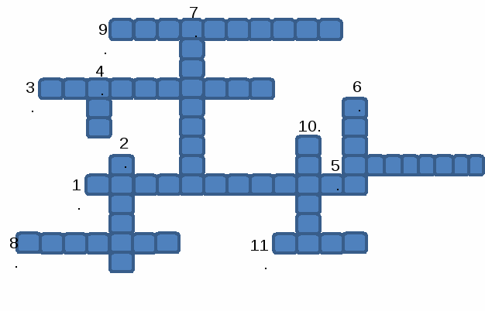

8. Подведение итогов урока.
8.1 Рефлексия
Составление синквейна у доски по изученной теме.

8.2.Выставление оценок за урок

8.3 Объяснение домашнего задания (рассказать об одной известной достопримечательности России + презентация).

Литература:

https://www.youtube.com/watch?v=t2a01EH6-88
Учебник «Английский в фокусе», 8 класс, Ю.Ваулина, В.Эванс

