Государственное общеобразовательное учреждение
«Перевальская гимназия № 1»

Устный журнал «What to say and how to behave»
На английском языке для учащихся 8-9 классов
общеобразовательных учреждений

Разработала учитель английского языка
ГОУ ЛНР «Перевальская гимназия № 1»
Яценко С.Н.

2023
Эпиграф «Behavior is a
Mirror in which everyone
Displays his image» (Goethe)
Ведущий: My dear friends! Today we shall discuss some questions concerning to the etiquette.
What is the etiquette? – I страница.
Etiquette is based on three very important principles:
- Treat others, as you want to be treated. –
Относитесь к другим так, как вы хотите, чтобы относились к вам.
What does it mean? – Every one of us has to be treated with kindness and respect. If we hope you receive kindness and respect from other people, we must treat them with the same.
- Beauty is as beauty does. – красота проявляется в красивых поступках.
This means that our personal beauty depends on our behavior rather than we look like, rude behavior can make us ugly.
- A thing of beauty is a joy forever! – Красотой восторгаются всегда!
Think about it. When you are around something that is ugly, you feel sad and depressed. On the other hand, when you are around something that is beautiful, you feel happy and inspired.
Ученик: Generally speaking, people do not want to be around a person who make them feel unhappy and depressed. Instead, they want to be around someone who makes them feel good.
Учитель: So we can say that etiquette includes good manners, and think that etiquette begins with a communication between two persons. So our next page is «Spoken etiquette». It is very important to know how to use the proper form of greetings and farewells. And do you know how to greet somebody or to say «Good bye»?
I Ученик: In the morning we usually say «Good morning» to each other. You say «Good morning» to people you know little your greeting is more formal this formula is used before lunch. To those you know well you may say simply «Morning».
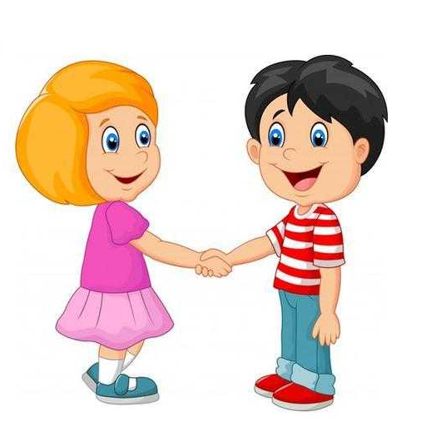
II Ученик: You say «How do you do» to a person when formally introduced or when you meet him for the first time. This formula may be used almost any time of day.
3d: You say «Good afternoon» to people you do not know well between lunch time and tea time. And you say «Good evening» to people you do not know very well after 6 p.m. To Those you know well say «Evening».
4th: The proper informal greeting is «Hello». This formula is usually used with the first name. After an informal or friendly greeting often comes the question «How are you?»
5th: The usual phrase to use when you leave is «Good bye». But there are other formal ways of parting, such as: bye-bye, see you later, so long, farewell…
Учитель: Now let’s reproduce some dialogues to show how to greet each other:
(ученики выходят парами)
а) – How do you do, Mr. Black?
- How do you do, Mr. Hardly?
- How are you today?
- I’m quite well, thank you. And how are you?
- Fine, thank you.
b) – Morning, Frank.
- Hello, Jim. How are you?
- More or less all right, thanks, and you?
- Very well, thank you. Be seeing you soon.
- Bye!
c) – Good evening, Mr. Mailer, nice to see you well again.
- Thank you Mr. Davis? And how are you feeling?
- I’m not so well unfortunately.
- I’m sorry to hear it.
d) - Good morning, Mrs. Smith.
- Good morning, Mrs. Garret. How do you like the weather today? Isn’t it awful?
- Yes, it has been pouring since yesterday morning and the outlook is not very promising.
e) - Good afternoon, Mrs. Ferris.
- Good afternoon, Mrs. Collins. Nice day today, isn’t?
- Oh, yes, lust lovely. I believe it’s a bit colder than yesterday.
- Yes, the mist has cleared but the weather forecast says, it will be snowing later in the day.
f) – Good-bye, Mrs. Blake. I’m sorry, but I must go now.
- Good-bye, Miss Jones. Happy to have met you!
- You are very kind. Thank you.

Учитель: Thank you to everybody. And now look at this picture and say a few words on it. (Демонстрируется рисунок и даются предполагаемые ответы):
- People talk about the weather more in Britain than in most parts of the world. The weather is a safe topic of conversation. If you do not know each other well enough to talk about personal matters, you can at least sound friendly by talking about the weather. When two people meet in the street they will often say something about the weather as they pass, just to show their friendliness.
Учитель: In what cases we can also show our friendliness? I think in the street, when you go to school or somewhere.

So our next page is called «Good manners in the public».
Good manners include saying «please» whenever you ask for anything and «thank you» when anybody does anything for you. Do you remember a single poem, you have learned when you were in the sixth form? Who can recite it?
- Hearts like doors will open with ease to very, very little keys and don’t forget that two of these are «thank you» and «if you please».
Good manners include... let's read and translate for our guests the words on this placard:
(дети читают и переводят по цепочке)
- Not spitting in public.
- Not walking round in crowds forcing people off the pavement.
- Not making a lot of noise in public, especially at night when other people are sleeping.
- Not dropping your empty crisp or sweet packets in the street.

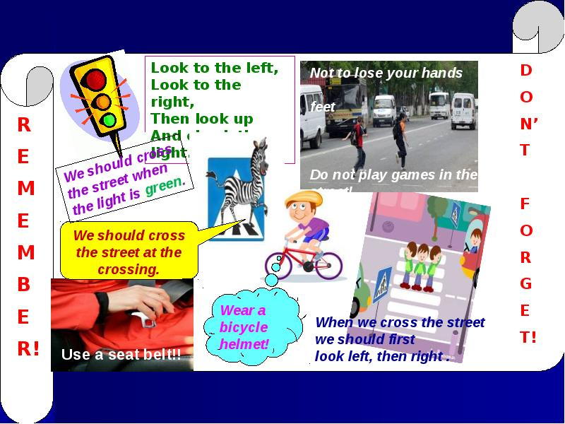

Учитель: I believe you will be always kind in the street. And now let's show some dialogues imaging you are in the town.
(диалоги):
a) Excuse me... I'm a stranger here and I'm completely lost. Could you tell me the way to Gorky Street?
- Well, I happen to be going in the same direction myself, so I might show you the way.
- Oh, thank you. It's very kind of you.
b) - Pardon, madam, which is the quickest way to the center of the town?
- Take a Number 21 trolley-bus and go as far as Regent Street.
- Will it be the very centre of the town?
- Yes, certainly.
Учитель: And let's have a little rest and sing our favourite song, (исполн. песню).
- You often telephone to each other and now we shall speak about "Telephone etiquette".
Here are some expressions you have to use on the telephone: (можно написать на доске или на плакате):
-Hello, is this...?
-Hello, may I speak to...?
-Good morning, I'd like to speak to...?
-Just a moment, please.
-Could you speak up, please?
-Speaking.
-Could you ask...to call me back, please?
-I'll call you back.
-I'm sorry, you have the wrong number.
-What is your telephone number?
Диалог: -Hello?
-Hello, may I speak to A...?
-I'm sorry. She is out at the moment.
-May I leave a message.
-Sure. I'll write it down. Who is calling?
-This is N. My number is +79592011343.
-And what is the message?
-It’s about the school newspaper. Could A. please call me this evening?
-Yes, that's all. Thank you.
-You are welcome. Good-bye. -Good-bye.

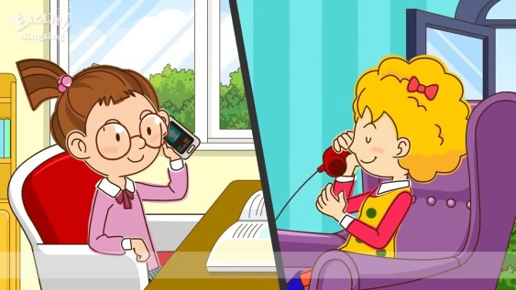

Учитель: And here are some good rules for those who have a telephone and calls somebody: (написано на плакате)
-Always say "Good-bye" before you hang up the telephone.
-Always use a pleasant voice when speaking a telephone.
-Don't speak on the telephone for too long.
And don't forget that "kind words can be short and easy to speak, but their echoes are truly endless".
(Mother Theresa)

Our next page is "The ABC at Table Manners".

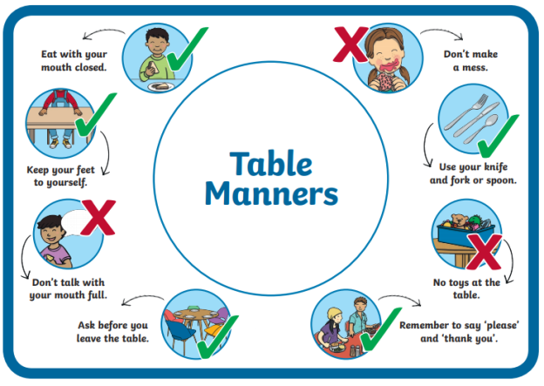

(Slogan - "An attractive table is a sign of tire cook's or the horst's pride and respect for you" - "Красиво накрытый стол - предмет гордости повара или хозяина и знак уважения к вам.")
-So let's read and remember the ABC at table manners:
1. Be punctual, or the meal may be spoilt.
- Wash your hands before coming to table.
- Take your napkin and put it on your lap.
- When eating take as much as you want, but eat as much as your take.
- Do not eat too fast or too slowly.
- Take a little of every dish that is offered to you.
- Sit up straight and face the table, do not put your elbows on the table while eating.
- Do not reach across the table - simply say: "Would you please pass the salt".
- When refusing a dish simply say: "No, thank you".
- Do not leave the spoon in your cup, when drinking tea or coffee.
(Диалог "In a tea shop")
John: Hello, Mary. I'm glad you were able to come.
Mary: Hello, John. I'm afraid, I'm rather late. Have you been waiting long?
John: Oh. no, only a few minutes.. Let's sit over there, shall we?
Mary: Yes. let's.
John: Here is an empty table. Now, let me help you with your coat.
Mary: Thank you, John.
John: Now. what would you like, tea or coffee?
Mary: I think. I'd like tea, please.
John: Waitress! Can we have a pot of tea for two. please?
Waitress: Yes, sir. And what would you like to eat?
Mary: I'd like bread and butter, a cheese sandwich and some cake.
John: So would I. Have you got any of your special chocolate cakes today? Waitress: Yes, we have. I'll bring you some. Anything else?
Mary': No, I don't think so, thank you.
Waitress: Tea for two, bread and butter, cheese sandwich and chocolate cakes. John: That's right. Thank you.
Учитель: And now let's have a quiz. I'll give you some tasks and ask questions and you must answer quickly.
- The first question: What should you do if someone asks you a question while you have food in your mouth? - Answer: Remember: never to talk when a mouth is full of food. Finish chewing food, swallow and then answer.
- When should you begin to eat your meal? - After all the plates are served, unless the host or hostess ask you to start eating.
- What should you do if you spill food on your clothes? - Go to a sink. Get clean cloth. Wash it with cold water. Lemon will help you to get rid of the spots. Gently
rub the area with the wet cloth. The longer food remain on the clothes, the harden it will be to remove the stain.

Our last page is devoted to the parties.
"At the party".

You often go to visit your friends or invite them to your place. You often meet at the parties or disco dances. How to behave on this case we shall show you. Диалоги:
a) - Hello, Oleg! I'm glad to meet you here.
- Hello, Ann! You look smart today.
- Thank you. Let's dance this waltz. I like waltz best of all.
- O.K.
- I'm very sorry. I can't dance waltz. If you don't object we'll dance twist or tango.
b) - Look at those young fellows. They are very rude.
- You are right. They are talking at the top of their voices and are extremely impolite at the party. I am really surprised at their behavior.
- Look, one of them is rather handsome and slender.
- Oh, never judge by appearance.
Учитель: I know, that one of the girls is fond of ball dances. Ball dances is her hobby. I suppose she can teach our boys to dance, (звучит мелод. вальса)
В заключение: I hope you will be always polite everywhere:
at home, at school, in the public. And please show your respect to parents and teachers. They deserve it. Let us try to be polite. In everything we do. Remember always to say «please». And never forget «Thank you».

Используемая литература:
- Т.Б. Клементьева «Счастливый английский»
Издательство «Титул». Калужская область. Зарубежная литература.
- Р.Л. Стивенсон «Poems»
Библиотека «Школьные праздники»

