Дидактический материал
по учебному предмету
Иностранный язык в профессиональной деятельности
по теме Measuring Tools
(Измерительные приборы)
для студентов 2-3 курсов технических специальностей

Автор: Журавлева Ингрид Витальевна
Место работы: ГБПОУ ВО «Ковровский
промышленно-гуманитарный колледж»
Должность: преподаватель английского языка

Пояснительная записка
Данный дидактический материал предназначен для занятий со студентами 2-3 курсов технических специальностей колледжа по предмету Иностранный язык в профессиональной деятельности.
Цель данного дидактического материала - подготовка студентов к самостоятельному чтению английской научно–технической литературы.
Дидактический материал содержит текст, составленный с помощью различных Интернет-ресурсов (см. список источников).
Разработанные упражнения нацелены на организацию адекватного понимания содержания текста, расширение лексического словарного запаса, совершенствование речевых навыков, развитие аналитического мышления.
Спецификой материала является познавательный характер, так как текст несет энциклопедические знания и будет интересен студентам.
Материалы, представленные в пособии, могут использоваться как в ходе самостоятельной работы студентов над иностранным языком, так и на практических занятиях под руководством преподавателя.

MEASURING TOOLS
There is a wide range of measuring tools available today, which can measure anything from angles to temperature.
Machined workpieces are measured by accurate measuring tools, such as precision vernier calipers, micrometer calipers, inside micrometers and limit gauges.
In performing accurate work a precision vernier caliper is required. The micrometer caliper, or simply micrometer, is used for more accurate measurements of external dimensions of work, such as diameters, thickness and lengths. Internal dimensions may be measured with an accuracy of 0.01 mm using inside micrometers.
The best measuring tools for checking threads are standard and limit thread gauges.
Angle gauge is predominantly used by foresters. They are held at a set distance from the user’s eye to quickly establish whether a tree is within the boundary of a plot. Angle gauges can also be used in other professions where it is necessary to measure angles.
Slope inclinometers establish the angle or gradient of a slope. These are often used in medicine to determine the angle of a person’s body, such as their back, or in working machinery to maintain safe operations.
Tape measures are probably the most commonly used measuring device of all measuring tools. Tape measures are made from long and flexible pieces of metal that have inches and centimeter measurements marked out along their length. These tools can be used to measure the length, width, height, or depth, of almost any object.
Laser measures are an alternative to traditional tape measures, and are used to measure a length of space. They work by sending out a laser beam at the press of a button, which hits the desired target and is able to measure the distance based on the detected reflection.
A compass is usually made from two lengths of metal, which are joined together at one end. One of the metal pieces will have a sharp point so that it can grip onto paper, while the other piece of metal can have a pencil attached to it. This tool will be commonly used by architects or anyone who makes technical drawings, and it can also be used in navigation.
Pressure gauge is a common measuring tool that is used to measure the pressure of liquids and gases, such as water, air, or oil. Pressure gauges are important tools in industrial and commercial environments.
Levels are used for measuring whether an angle is a level and equally balanced. There are many different types of levels that can be made from plastic, metal, or wood.
A thermometer is a traditional tool for measuring temperature. A classic thermometer will consist of a glass tube that has a small amount of mercury in the bulb at the base, and as the temperature rises, the mercury level rises up the tube to indicate a higher temperature. There are many modern types of thermometers that are digital, and used for determining a person’s body temperature.
A speedometer is a measuring gauge that instantly determines the speed that a vehicle is traveling.

Vocabulary
accurate – точный
accuracy – точность
angle [ˈæŋɡl] gauge – угломер
to attach - прикреплять
beam - луч
bulb – колба
button - кнопка
dimension – размер
depth - глубина
to detect - обнаруживать
flexible - гибкий
gauge [ɡeɪdʒ ]– измерительный прибор
gradient - уклон
height [ haɪt]- высота
inch - дюйм
laser measure – лазерная рулетка
length [leŋθ]– длина, отрезок
level - уровень
limit gauge – концевой датчик
to machine – обрабатывать
to measure [ˈmeʒə] – измерять
measuring tool – измерительный прибор
mercury [ˈmɜːkjərɪ] – ртуть
micrometer caliper - микрометрический штангенциркуль
plot – участок
precision vernier caliper - прецизионный штангенциркуль
pressure [ˈpreʃə] gauge - манометр
reflection - отражение
slope inclinometer - уклонометр
tape measure – рулетка
thermometer [θəˈmɒmɪtə] - термометр
thickness – толщина
thread gauge – резьбомер
width - ширина
workpiece – заготовка

1. Read and translate the text in written form.

2. Find in the text the English equivalents of the following Russian words and expressions.
широкий ассортимент измерительных приборов
точные измерения внешних размеров изделий
проверка резьбы
в пределах границы участка
измерять углы
обеспечивать безопасные операции
длинные и гибкие куски металла
альтернатива традиционным рулеткам
лазерный луч
при нажатии кнопки
технические чертежи
измерять давление жидкостей и газов
уровень ртути

3. Complete the sentences.
1. A precision vernier caliper is required in… .
2. Internal dimensions may be measured with an accuracy of … .
3. An angle gauge is used in … .
4. Slope inclinometers determine … .
5. Tape measures are made from … .
6. Laser measures are used to… .
7. Pressure gauges are important in … .
8. Levels can be made from … .
9. A thermometer is a … tool for measuring temperature.
10. A speedometer determines … .

4. Answer the questions.
1. What measuring tools do you know?
2. What are machined workpieces measured by?
3. What are the best measuring tools for checking threads?
4. What measuring instrument do foresters use?
5. Where are slope inclinometers used?
6. What is the most commonly used measuring device?
7. What is the alternative to traditional tape measures?
8. Where is usually compass used?
9. What is measured with pressure gauges?
10. What are levels used for?
11. What types of thermometers can you name?
12. What measuring instruments do you use?

5. Match the pictures with the names of the measuring instruments.
1 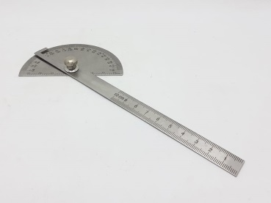 | A tape measure
2 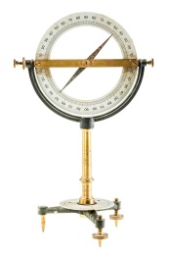 | B angle gauge
3 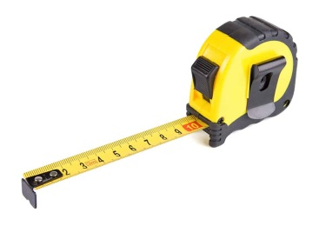 | C slope inclinometer
4 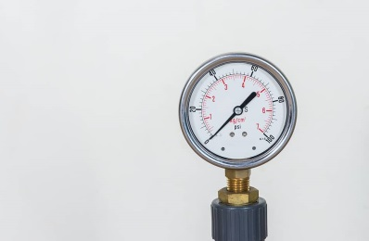 | D thermometer
5 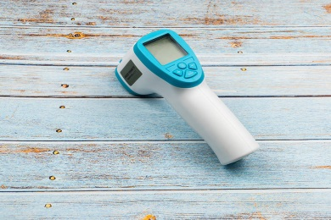 | E pressure gauge

6. Fill in the diagram with words from the frame:
thermometer, micrometer, thread gauge, angle gauge, tape measure, level, compass, pressure gauge, speedometer, diameter, temperature, speed, angle, thread, direction, angular deviation, pressure, length/width/depth/height, measuring tools

Web-References
- http://elib.osu.ru/bitstream/123456789/9012/1/1879_20110826.pdf
- https://www.homenish.com/types-of-measuring-tools/
- https://www.wikipedia.org/
- https://www.multitran.com/

