Сценарий внеклассного мероприятия по английскому языку
«Литературный ринг»
Внеклассное мероприятие для 4х классов (4а, 4б), где каждый класс делиться на подгруппы. В итоге получается 4 команды. Мероприятие начинается с постановки командами фрагментов из произведений А.Милна «Винни Пух и все, все, все», Л.Керолла «Алиса в стране чудес», Дж.Роулинг «Гарри Потер», Р.Киплинга «Книга Джунглей». Задача остальных команд узнать название произведений. Так дети узнают о теме мероприятия. Далее все конкурсы связаны с этими произведениями.
Цель: развитие интереса обучающихся к драматизации англоязычных произведений.
Задачи:
1)знакомство учащихся с литературой страны изучаемого языка, пополнение словарного запаса;
2)развитие внимания, памяти, фантазии, воображения и артистизма обучающихся, а также их коммуникативных навыков;
3)создать условия для активизации познавательного интереса и воспитания навыков межличностного общения.
Материалы и оборудование: костюмы для постановки сценок, проектор (или картинки с изображением белой совы, горшка с медом, волшебной палочки, огня, пузырька с надписью «Drink me», воздушного шарика, лиан, чеширского кота)
Форма проведения: литературный ринг
Участники: 4е классы
Ход мероприятия
Ведущий: Good afternoon, dear guests and participants of our literature ring! We are very glad to meet you today! This competition will be connected with English fairy-tales and novels. Dear friends, welcome to our party. We like fairy tales very much and we are going to show you our favorites.
Дорогие ребята, сегодня мы собрались на встречу с английской сказкой. У каждого народа есть свои сказки. У русского народа свои русские народные сказки, у татар – татарские народные сказки, у немецкого народа – свои немецкие народные сказки и у англичан тоже есть свои английские народные сказки. В сказках отражается душа народа, его мудрость и мысли. Впервые собрал и опубликовал два тома английских народных сказок Джозеф Джекобс, президент английского фольклорного клуба.
English fairy tales are very diverse and they attracted many Russian writers’ attention. But today we talk about fairy tales, which have the authors and they are known all over the world.
Слайд 1
Our today's competition is called "Literature Ring", because it consists of rounds as in competition of Boxing. But you will have to compete in knowledge English literature. We will visit those places where good and funny fairy-tale characters live. We will remember the journey that fairy-tale characters had. In short, we will visit the amazing country of literature heroes, in its different areas – poetry and detective, puzzle and entertainment. Four teams will take part in our game.
Let the captains come to me, shake hands and promise to fight fair for the victory. Of course, in order to judge who will be the best at our meeting, we need a strict jury. You see, our jury has an accurate stopwatch and a time bell. For non-compliance, the team will be removed points. So, are the teams ready? The jury is ready too. Our meeting are beginning now. Remember how people say – "it's never too late to Learn". And my favorite proverb is, "Reading is the best teaching." I'm announcing Round one.
Round 1 "Hometask»
So, each team has prepared a small staging of different tales of English writers. Your task is to guess the name of that tale. One point for each right answer.
4A (1st group) “Winnie the Pooh and all, all, all”
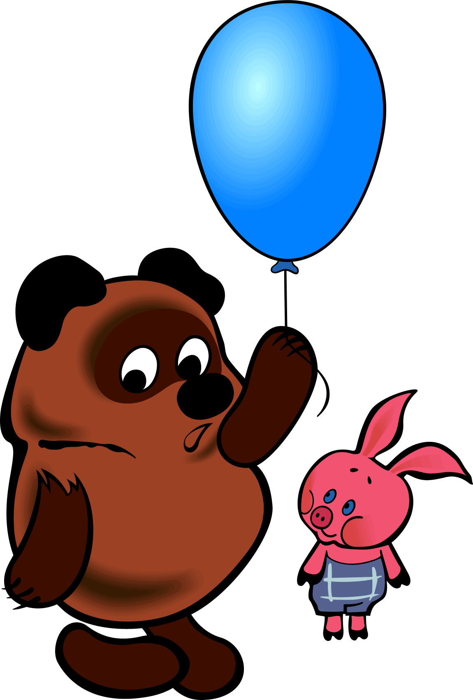
WINNIE the POOH : Who pays a morning visit
He does a clever did
And never one knows why it is way
To stay in jolly mood!
PIGLET : To stay in jolly mood!
WINNIE the POOH : Listen, Piglet, and why do we go to somebody to visit ?
PIGLET : To visit ?
WINNIE the POOH : Yes, I said just to go to somebody to visit and get a little snack!
PIGLET : Come on ! Where are we going ?
WINNIE the POOH : To your place of course!
PIGLET : Come on !
WINNIE the POOH : Who pays a morning visit
He does a clever did
And never one knows why it is way
To stay in jolly mood!
PIGLET : To stay in jolly mood!
POOH : Listen, Piglet, do you have anything to eat ? Well, for example, honey ?
PIGLET : No, I don't have honey !
WINNIE the POOH : No ? ( Pooh scratched his head with his paw. )
You know, Piglet, perhaps we won't go to you !And what happens then? I'm going to visit and you're not !
PIGLET : Okay ! Come to your place then !
( Winnie the Pooh and Piglet again cheerfully walk and sing a song .)
WINNIE the POOH : Who pays a morning visit
He does a clever did
And never one knows why it is way
To stay in jolly mood!
PIGLET : To stay in jolly mood!
WINNIE the POOH : Hey, Piglet! What is it that I'm not going to visit now?
PIGLET : What must we do then ? ( pause ) Pooh, I think I made it up !
Let's go to someone else !
WINNIE-the-POOH : That's Right ! To whom?
PIGLET : ( looks around ) There seems to be a Rabbit living nearby !
WINNIE-the-POOH : That's Right ! Well Done, Piglet ! Rabbit is quite good company !
A suitable company, this is where we can be treated to something! [1]
http://www.lib.ru/MILN/pooh.txt
4A (2nd group) “Alice in Wonderland”
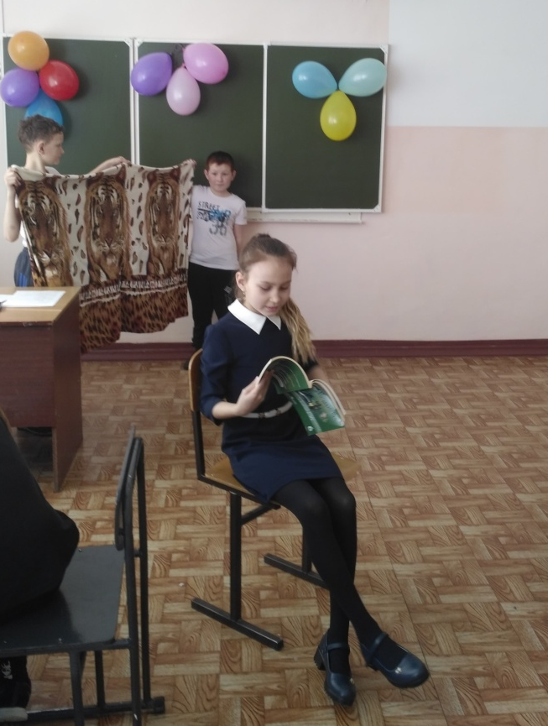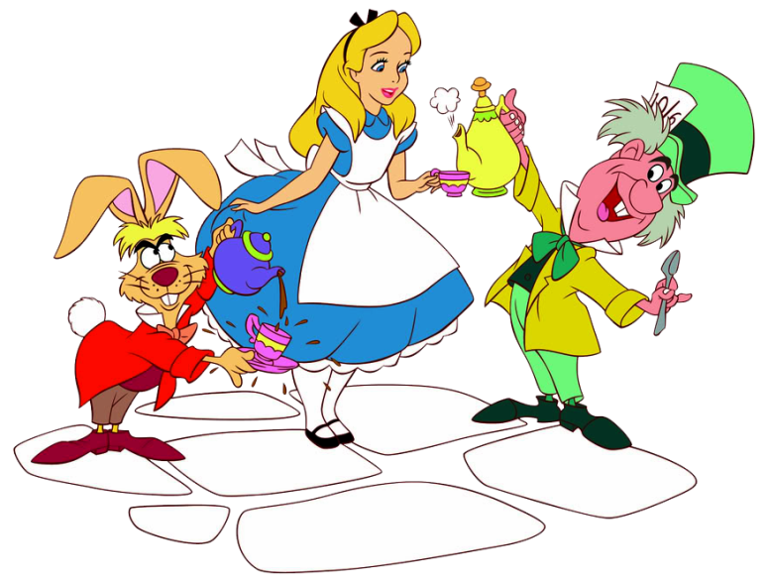
Alice sits reading a book and sighs
Alice. I have already played with a kitten, and read a book. (he puts the book down.) What is the benefit of a book if it has no pictures or conversations. Although... no. It hasn’t even pictures. Boring! Bored when everyone knows in advance when the answers to all the questions lie on the surface. Even wonder does not work…
White Rabbit runs
White Rabbit. Oh, my God. I'm late! I'm late!
Alice looks at the Rabbit. Rabbit pulls out his watch, checks the time.
WR. Oh, my God, hurry, hurry up!
Alice. Bunny. Bunny! Stop!
WR. Oh no, oh no, I’m being late.
Alice. You saw a talking Bunny!
WR. Ay-ay-ay. Ay-ay-ay. Ay-ay-ay. Ay-ay-ay.
Alice. Bunny. Bunny! Stop! I'll catch up with you.
WR. Not a Bunny. I'm white Rabbit!(proudly leaves)
Alice. Whatever, Bunny, rabbit.
WR. Ay-ay-ay. Ay-ay-ay. Ay-ay-ay. Ay-ay-ay.
Alice. Bunny, wait, wait, wait. Wait, wait. Where are you?
WR 2. Ay-ay-ay. Ay-ay-ay. Ay-ay-ay. Ay-ay-ay.
Alice. Stand. Come here. Wait, wait. Wait. Where is he?.
WR 2Ay-ay-ay. Ay-ay-ay. Ay-ay-ay. Ay-ay-ay. (dives into the hollow)
Alice. Rabbit!!!! Rabbit appears on Alice's behind
WR 2 and Alice together: Rabbit!!!!
Get scared and jump into the hole. Lights turn off

4B (2nd group) “Harry Potter”
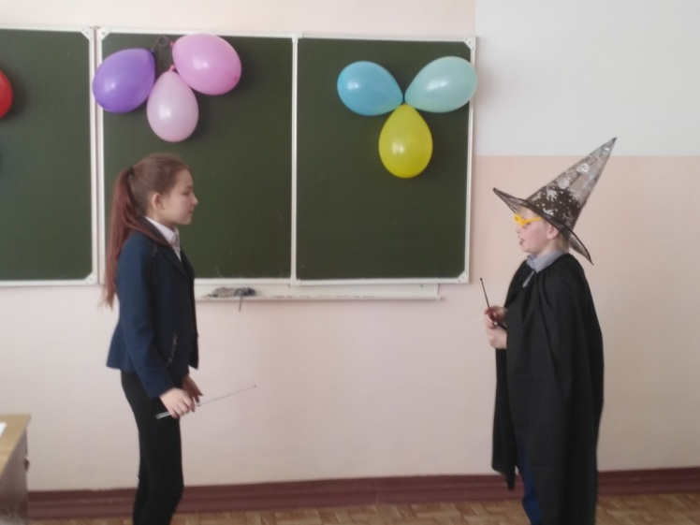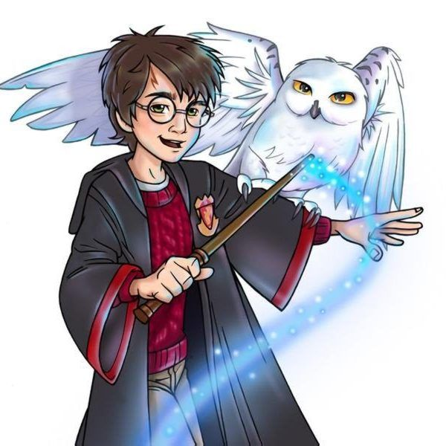
AT THE RAILWAY STATION
( scene from far right and Ron comes out with the ball and three train ticket)
Author: Harry Potter goes to the train station to catch the train to magic school at Hogwarts. But he can't find platform nine and three-quarters and Hagrid's gone.
Harry: Excuse me?
Ron: Huh? ( with right-wing the scene conductor and black Lord endure a poster " Platform 9 3\4»)
Harry: Could you tell me how to get to platform nine and three-quarters?
Ron: Of course. Go through that secret entrance.
Harry: What's your name?
Ron: My name is Ron Weasley. I'd like to be your friend. I'm going to study at Hogwarts. It’s my first year. Do you have brother or sister?
Harry: no.
Ron: And I have there is five brothers and sister. You're lucky!

4B (1st group) “Jungle Book”
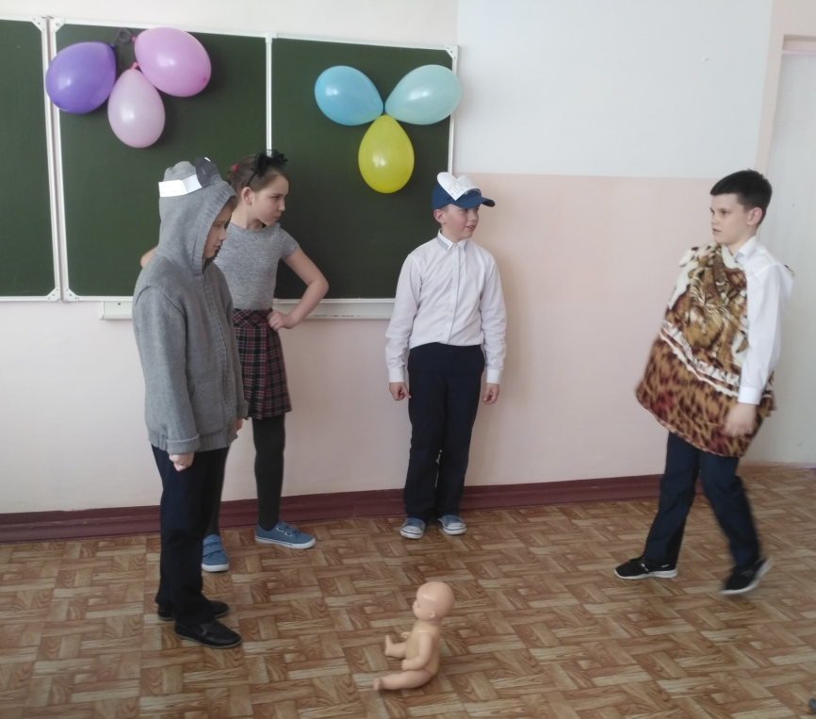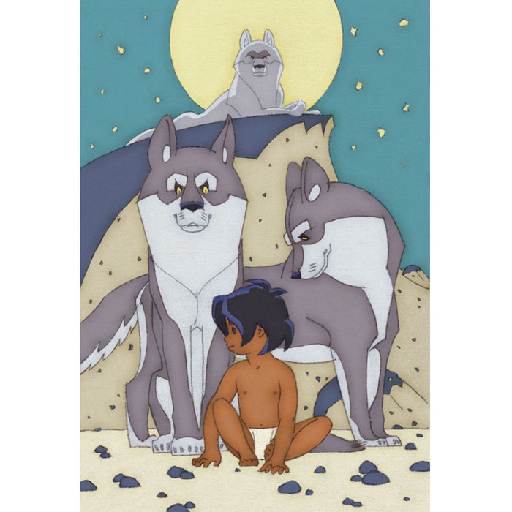
FATHER WOLF Look! A human cub!
The MOTHER WOLF A human cub? I've never seen them before. He's naked.
FATHER WOLF - What a little. I could have killed him with a slap! Rrrr-rrrr!
MOTHER IS WOLF - He is not afraid.
TOBACCO (running) – Sir, he came in here!
The tiger Sher Khan appeared, but when he saw the wolves, he stopped.
FATHER WOLF (the threat) – Shere Khan, it’s great honor! What does Sher Khan want?
SHER-KHAN - My booty! A human cub came in here, give it to me!
SHER KHAN (fiercely) – my Cub! Give it back!
FATHER WOLF - Is it not enough in the pond of frogs and beetles that you began to eat human cub? Man is the weakest and most defenseless of all living creatures, and it is unworthy of a hunter to touch him!
SHERE KHAN the man-cub is mine. I'm talking Sher Khan!
MOTHER-WOLF - man-cub is mine. No one will kill him! Now get out of here!
SHER KHAN (retreating) – In his yard every dog barks. Let's see what the Pack says (leaves with the Jackal).
FATHER WOLF - This time Sher Khan is telling the truth: the cub must be shown to
the Pack. You still want to keep him, mother?
MOTHER WOLF To Leave? Keep it... I'll keep it.
FATHER-WOLF – I’ll call him little frog, Mowgli, I will call you soon and you, you are going to hunt Shere Khan as he is gunning for you now.

Ведущий: This is an interesting beginning of our meeting. You are just "Great" team members
Round 2
In the second round you must give the full name to these tales, tell who is the author and name 5 heroes.
Key: 1 "Winnie the Pooh and all, all, all" Alan Milne. Main characters: Winnie the Pooh, Piglet, donkey Eeyore, Owl, Rabbit (Christopher Robin, Tiger)
2 "Alice in Wonderland" by Lewis Carroll. Main characters: Alice, Cheshire cat, Hatter, White rabbit, White Queen, Red Queen (mouse Sonia, Caterpillar)
3 "Harry Potter and the philosopher's stone" by J. Rowling". Main characters: Harry Potter, Ron Weasley, Hermione, Volan de Mort, Hagrid, Dumbledore, (Severus Snape, Draco Malfoy)
4 "Jungle Book" By Rudyard Kipling. Main characters: Mowgli, the bear Baloo, the Panther Bagheera, the tiger Shere Khan, Akela the wolf, (the Python Kaa, the Jackal Tobacco)
Round 3 "Blitz poll»
Each team will answer on my question in its order. If it is difficult – the right to answer goes to the next team.
1. На чём отправился за мёдом Винни – Пух из сказки А. Милна Винни – Пух» и все-все-все»? (На воздушном шарике)
2 Чего боялись все звери Джунглей (Красного цветка – огня)
3 Как называлась школа волшебства и магии, куда пригласили Гарри?( Хогвардс)
4 Как в «Алисе в стране чудес» звали кота, у которого появлялась сначала голова?
( Чеширский Кот.)
5 С ним хозяин ,мальчик Робин И приятель…………………….. (Пятачок)
6 Кто такой Шер Хан (тигр)
7 Какие цветы перекрашивали карты в красный цвет в «Алисе в стране чудес» (розы)

8 Какой волшебный вид спорта полюбился Гарри? (Квиддич)

9 Что было написано на бутылочке, которая стояла на столе в произведении «Алиса в стране чудес» (Выпей меня)
10 Для него прогулка праздник И на мед особый нюх Это плюшевый проказник Медвежонок…( Вини-пух)
11 Как мать-волчица называла Маугли? (Лягушенок)
12 Кто был лучшим другом Гарри Поттера? (Рон Уизли)

Round 4 "Detectives»
The next round for detectives. Do you know what a detective is ????????????? This kind of literature, in which detectives find human on the most minor details his looks or character. I will ask each of the teams to find out the name of the hero, and name of the book in which he lived, listening to an episode from his life. (I read an episode for each team)
. 4а ( 1я группа)
БАЛУ:
Maugli, what have you got?
МАУГЛИ:
Look, I have got an iron tooth. Bagira, I am strong and I have got an iron tooth.
БАГИРА:
It′s very good, Maugli. But it′s not, enough to be the jungles tsar.
БАЛУ:
Yes, it′s right. Bagira, tell him about the Red Flower
МАУГЛИ:
The Red Flower – what is it?
БАГИРА:
People have got the Red Flower. It warms a man, but the Red Flower can kill us, the inhabitants of jungle.
4а (2я группа)
Say you've spent the first 10 years of your life sleeping under the stairs of a family who loathes you. Then, in an absurd, magical twist of fate you find yourself surrounded by wizards, a caged snowy owl, a phoenix-feather wand, and jellybeans that come in every flavor, including strawberry, curry, grass, and sardine. Not only that, but you discover that you are a wizard yourself! This is exactly what happens to young Harry Potter in J.K. Rowling's enchanting, funny debut novel, Harry Potter and the Sorcerer's Stone. In the nonmagic human world-the world of 'Muggles'-Harry is a nobody, treated like dirt by the aunt and uncle who begrudgingly inherited him when his parents were killed by the evil Voldemort.

4б (1я группа)
There seemed to be no use in waiting by the little door, so she went back to the table, half hoping she might find another key on it, or at any rate a book of rules for shutting people up like telescopes: this time she found a little bottle on it, ('which certainly was not here before,' said Alice,) and round the neck of the bottle was a paper label, with the words 'DRINK ME' beautifully printed on it in large letters.
It was all very well to say 'Drink me,' but the wise little Alice was not going to do THAT in a hurry. 'No, I'll look first,' she said, 'and see whether it's marked "poison" or not'; for she had read several nice little histories about children who had got burnt, and eaten up by wild beasts and other unpleasant things.

4б (2я группа)
Once upon a time, a very long time ago now, about last Friday, Winnie-the-Pooh lived in a forest all by himself under the name of Sanders.
"It means he had the name over the door in gold letters, and lived under it."
One day when he was out walking, he came to an open place in the middleof the forest, and in the middle of this place was a large oak-tree, and, fromthe top of the tree, there came a loud buzzing-noise.

5. Раунд «Let guess!»
Задачи по представленному предмету определить произведение
Вини Пух: воздушный шарик, горшок с медом
Алиса в стране чудес: Чеширский кот, флакончик с надписью «Выпей меня»
Гарри Поттер: белая сова, мяч для квидич
Маугли: огонь, лиана
Жюри подводит итоги. Ребята, пока жюри подводит итоги, я хотела бы поблагодарить вас за ваши рисунки, без которых не состоялась бы наша выставка. Ребятам поощрительные призы…… Ребята, мы благодарим вас за честную и интересную игру, и нам осталось только предоставить последнее слово жюри. Но не зависимо от результатов сегодняшней встречи давайте вспомним золотое правило героических олимпиад: главное в олимпиаде – не победить, а главное – (Дети хором) в ней участвовать. Поэтому я думаю, что вы все получили пользу от этой встречи, полюбите читать новые увлекательные книжки и еще раз перечитаете старые, хорошо знакомые. Слово жюри. Оглашение результатов. 1-ое место команда 2-ое место команда 3-е место команда Идет награждение победителей. А теперь я хотела попросить выйти капитанов команд.
Список использованной литературы
1. отрывок из «Винни Пуха» http://www.lib.ru/MILN/pooh.txt
2. отрывок для перевода на английский «Гарри Потер» https://corp.lingualeo.com/ru/2016/06/09/reading-skills-practice-chitaem-knigi-na-angliyskom-yazyike/
3. отрывок из «Книги Джунглей» https://studyenglishwords.com/book/%D0%9C%D0%B0%D1%83%D0%B3%D0%BB%D0%B8/131?page=1
4. отрывок из «Алисы в стране чудес» https://liteka.ru/english/library/23-alice's-adventures-in-wonderland

