Aa

[ei]
открытый слог – оканчивается на гласную (чаще всего немую е)
name
skate

закрытый слог –
оканчивается на согласную

sad
mad

- Прочитай слова с закрытым типом слога
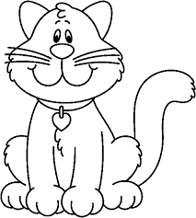
dad stand ant land Ann
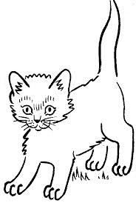
stamp cat bat plan Jack
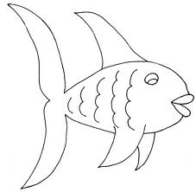
fat ham apple hand Japan

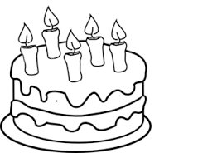
- Прочитай слова с открытым типом слога
name cake bake make Kate
take wake table taste Jane
skate plane face shame Dale

- Прочитайте чередование открытого и закрытого слога.
pan – pane hat - hate
Sam – same mad – made
man – mane jam – Jane
can – cane plan – plane
glad – glade back – bake
- Обведи слова с открытым типом слога в овал.

Name, game, apple, lamp, hand, skate, hat, rat, face, table, bag, place, can, dad, make, mat, rabbit, tank, plate, tram, cane, hate, mad, jam, sad, brave, snake, black.

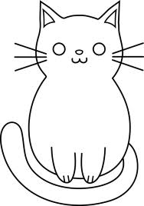
- Прочитай скороговорки.
My cat is black, A black cat sat on
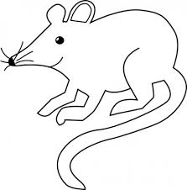
My cat is fat, a mat
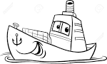
I like my cat, and ate
It is my pet. a fat rat
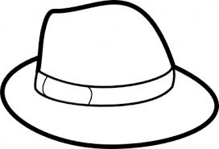
- It is a black hat.
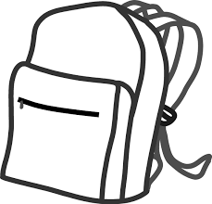
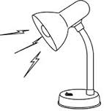
It is a fat rat.
It is a red lamp.
It is a green bag.
I can see a pet.
It is a cat.
The cat is fat.
The cat is black.
I like my cat.

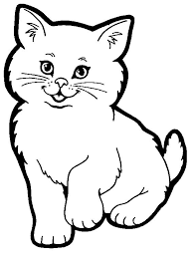

Ann
Ann has got
Ann has got a cat
Ann has got a black cat
Ann has got a fat black cat
Ann has got a fat black cat and
Ann has gat a fat black cat and a rat
Ann has got a fat black cat and a sad rat

a+r = [ :]
park Barbie market
farm card far
smart star chart
car large carpet
dark bar March

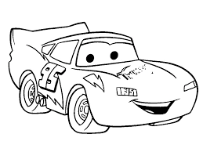

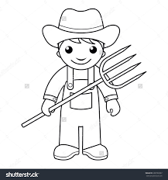
a black cat
a brave farmer
a dark park
a smart rabbit
a dark garden
a strong man
a + s = [ ] a + l = [ ]
grass task ball salt
class mask tall false
glass last small already
pass basket also always

Candy, part, wall, party, fast, hard, lane, fat, date, splash, save, ham, art, walk, grass, cave, ant, match, mark, glad, almost, cash, mane, bank, ask, ball, market, already, hand, face, shame, plate, operate, angel, bald, castle.
[ о ]
what, wash, watch, water, was, want, autumn, August, fault, daughter, cause, because, taught, sausage, awful, law, draw, saw, jaw, war, warm, ward, award, towards, quarter.

That lake is a famous place in a Wales.

The parks and gardens are large and charming.

