Пояснительная записка

Проект подготовлен учителями МБОУ «Гимназия № 102» г. Казани - Кругловой Ольгой Васильевной - учителем английского языка и Боровой Светланой Игоревной - учителем информатики и ИКТ.
Проект «Тесты и кроссворды для учеников 6 класса» может использоваться как в урочной, так и во внеурочной деятельности учителя английского языка.

Цели и задачи данного проекта:
Электронная версия данного проекта позволяет
- привлечь внимание и интерес учащихся, повысить мотивацию учащихся
- экономить время на проверку знаний
- создать условия для работы в индивидуальном режиме и темпе
- выявить пробелы для их дальнейшего устранения

Структура проекта:
Данный проект содержит кроссворды и тесты:
- 4 теста с выбором ответа. Каждый учащийся получает 10 вопросов, каждому вопросу дается 4 варианта ответа, из которых только один верный. Вопросы и ответы «перемешиваются» при каждом запуске. На выполнение работы рекомендуется отвести 10-15 минут.
- 6 кроссвордов различного уровня сложности. На выполнение работы рекомендуется отвести 15-20 минут.

Список литературы:
- В.М.Карпов и Л.М.Шагалов «Английский язык на досуге». Издательство «Просвещение», Москва,2004
- О.И.Медведева «Творчество учителя на уроках английского языка. Из опыта работы». Издательство «Просвещение», Москва,2000
- О.В.Захарьина «Английский язык 4-11 классы. Современные образовательные технологии». Издательство «Учитель», Волгоград, 2000

Инструкция по работе

- Создайте на жестком диске С:\ каталог engproekt_34, скопируйте в нее архив и распакуйте его. Проект запускается файлом Start_engproekt_34.exe
- При выполнении заданий типа А (выбор ответа) нужно выбирать один из вариантов ответов.
- При работе с кроссвордами
Внимание! Если появится сообщение: «В целях безопасности браузер не разрешает этому веб-узлу выполнение скриптов или элементов управления ActiveX, которые могут получать доступ к компьютеру…». Нужно выполнить команду «Разрешить».

Test 1

Choose the right variant.

- He is going to have his bad tooth ____.
a) be take out c) be taken out
b) take out d) taken out
- If Mary ____ with us, we wouldn’t have had a good time.
a) would come c) would have come
b) had come d) came
- Mrs. Smith was in her office ten minutes ago, but she ____ now.
a) went c) have gone
b) has gone d) had gone
- If it ____ so late, we could stay a little longer.
a) won’t c) isn’t
b) weren’t d) not be
- I wish they ____ know it.
a) won’t c) didn’t
b) don’t d) haven’t
- My plane to New York ____ off early next Monday.
a) will take c) is going to take
b) takes d) took
- Look! Our cat ____ the mouse!
a) will catch c) catches
b) would catch d) is going to catch
- I wish the weather ____ not so wet today.
a) will c) were
b) would be d) is
- Have you ever been ____ Italy?
a) in c) to
b) at d) into
- ____ lunch on the plane was awful!
a) a c) the
b) an d) –
- It is the last warning ____ you.
a) on c) to
b) for d) at
- Have you ever warned me ____ doing it?
a) on c) from
b) at d) against
- They were messing ____ the bedroom when their mother came in.
a) about to c) in
b) at d) –
- It was ____ good idea to take an umbrella! It is going to rain.
a) the c) a
b) such d) an
- The trains run here ____ twenty minutes.
a) each c) all
b) every d) at
- There wasn’t ____ sense in her words.
a) many c) few
b) much d) a few
- ____ visitors come here at Christmas.
a) only few c) only a few
b) only little d) only a little
- My little brother could open the lock ____.
a) easily c) most easy
b) easy d) easiest
- Mary’s granny works on the computer so ____!
a) bad c) better
b) well d) good

Answers: 1.d 2.b 3.b 4.b 5.c 6.b 7.d 8.c 9.c 10.c 11.c 12.d 13.a 14.c 15.b 16.b 17.a 18.a 19.b

Test 2

Choose the right item.
- I think my new jeans ____ terrific!
a) look c) looks
b) are looking d) is looking
- If I ____ that you were busy, I wouldn’t have interrupted you.
a) knew c) had known
b) would know d) would have known
- You had no choice, ____ you?
a) did c) hadn’t
b) had d) didn’t
- I ____ this story while I was reading Spotlight the other day.
a) had found c) would find
b) was finding d) found
- She ____ to live near the sea.
a) wanted always c) always wants
b) always want d) has always wanted
- If I lost my job, I ____ to the sea for a week.
a) would have gone c) will go
b) would go d) can go
- I have been driving ____. I have got a lot of experience.
a) since nineteen c) after nineteen years
b) nineteen years ago d) nineteen years old
- Don’t go out! It ____ hard.
a) rain c) had rained
b) is raining d) rains
- We ____ the third game of chess when they finally came.
a) had been finishing c) had finished
b) finished d) would have finished
- They forecast ____ good weather but I don’t believe it.
a) a c) an
b) – d) the
- I liked ____ music but the words were silly.
a) some c) –
b) a d) the
- They became quite attached ____ the little boy.
a) with c) at
b) to d) by
- The curtains were flapping ____ the wind.
a) in c) at
b) on d) with
- Would you like ____ sandwich?
a) other c) others
b) another d) the others
- This information is useless and I am not interested in ____.
a) they c) them
b) it d) their
- I don’t visit art galleries. – ____.
a) So I do c) So do I
b) Neither do I d) Neither I do
- Don’t talk to her! She is ____ rude!
a) so a c) so
b) such a d) such
- This drink smells a little ____.
a) stranger c) strange
b) strangely d) more strange
- I asked for another pair of jeans, because the first ones did not fit me ____.
a) more proper c) proper
b) most properly d) properly
- You live even ____ from the city center than me.
a) farther c) furthest
b) far d) more far

Answers: 1.a 2.c 3.a 4.d 5.d 6.b 7.a 8.b 9.c 10.b 11.d 12.b 13.a 14.b 15.b 16.b 17.c 18.c 19.d 20.a

Test 3

Complete the sentences using the given words.

detached, tied, starched, attached, dignified, outfit, uniform, dignity, funeral, tie

- She made a ____ departure.
- The table was covered with a ____ white tablecloth.
- Try to take a more ____ view.
- It is easy to become ____ to the the children you work with.
- The label was ____ onto my suitcase.
- She bought an elegant two-piece ____ in shades of apricot for the wedding.
- That day my father was wearing a black jacket and a black ____.
- The children refused to put on their school ____.
- The ____ will be held at St. Martin’s church.
- Even in prison they tried to retain some human ____.

Answers:
1. dignified
2. starchered
3. de tached
4. attached
5. tied
6. outfit
7. tie
8. uniform
9. funeral
10. dignity

Test 4

Task: choose the right variant of the conditional sentence.

- We (go) to the river if the weather (be) fine.
- We shall go to the river if the weather is fine.
- We go to the river if the weather will be fine.
- If it (not/ rain) I (go) shopping.
- If it will not rain I go shopping.
- If it doesn`t rain I shall go shopping.
- If you (work) hard you (get) good results in English.
- If you will work hard you get good results in English.
- If you work hard you will get good results in English.
- When Henry (leave) for London I (ring) you up.
- When Henry leaves for London I shall ring you up.
- When Henry will leave for London I ring you up.
- As soon as we (get) home we something to eat.
- As soon as we shall get home we have something to eat.
- As soon as we get home we shall have something to eat.
- Before she (come) I (have) a bath.
- Before she comes I shall have a bath.
- Before she will come I have a bath.
- I (help) you if you (ask) me.
- I shall help you if you ask me.
- I help you if you will ask me.
- If I (have) wings I (fly) as a bird.
- If I shall have wings I fly as a bird.
- If I have wings I shall fly as a bird.
- If we (not/ come) on time we (not/ have) good seats.
- If we shall not come on time we don`t have good seats.
- If we don`t come on time we shall not have good seats.
- I (meet) you if you will (tell) me the number of your flight.
- I shall meet you if you tell me the number of your flight.
- I meet you if you will tell the number of your flight.

Answers: 1.a 2.b 3.a 4.b 5.a 6.b 7.a 8.b 9.a 10.b
CROSSWORD № 1

 | Keys
Across:  1. Persons who sing or play a musical instrument.  6. You can drink that at breakfast.  7. A feudal ruler; one who rules over other.  9. A large number of people all together.  11. Another word for “story” children like to listen to.  12. It rotates round the sun.  13. You … a cat at home.  15. Short for “Mister”.  16. A piece of music performed by one person. | Across:  1. Musicians  6. Tea  7. Lord  9. Crowd  11. Tale  12. Earth  13. Keep  15. Mr.  16. Solo
Down:  1. You must have it to buy things.  2. A round, flat figure.  3. Short for “north–east”.  4. The Past Indefinite of the verb “to say”.  5. You get them from your pen–friends.  8. Something seen during sleep.  10. H₂O.  13. You open the door of your flat with this instrument.  14. The negative prefix with the help of which you form antonyms from such words as “legal, literate, legible”, etc. | Down:  1. Money  2. Circle  3. At  4. NE  5. Said  7. Letters  8. Dream  10. Water  13. Key  14. Un

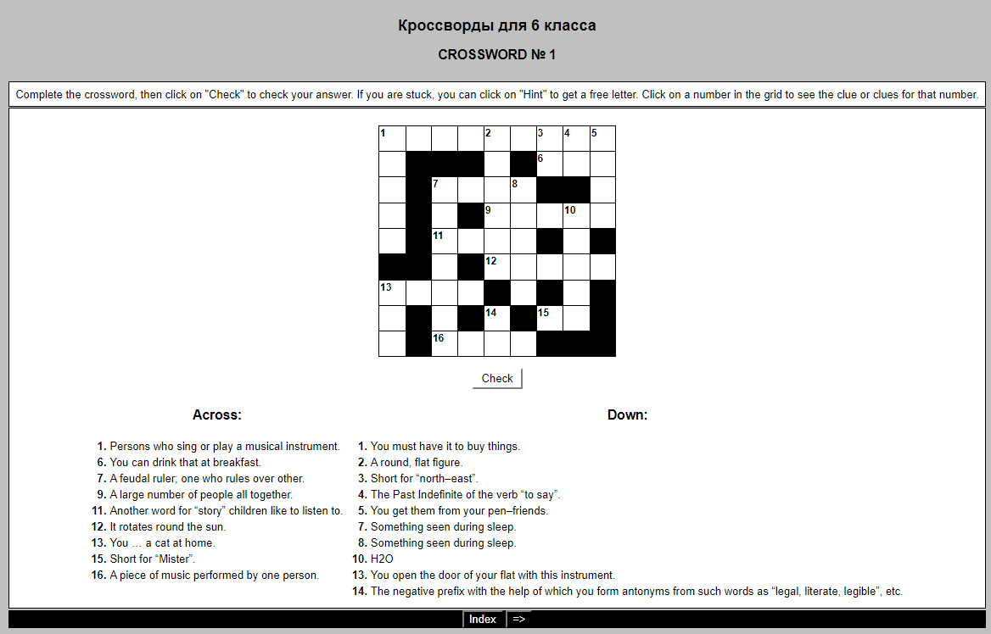

CROSSWORD № 2

 | Keys
Across:  1. The prefix, meaning “back, again”.  2. The covering of an egg.  6. A river in Italy.  7. What a coachman does to his horse to make it run faster.  8. An interjection used to express surprise, joy, doubt, triumph.  9. You will find the equivalent of the world выживание in a Russian – English dictionary.  10. Another word for “finish”.  12. Of the age of.  13. At any time.  16. Short for “Teddy”.  17. A Russian girl’s name.  18. You can form the nouns from the verb “to sail” by adding this suffix.  19. Told an untruth. | Across:  1. Re  2. Shell  6. Po  7. Whips  8. Ha  9. Survival  10. End  12. Aged  13. Ever  16. Ted  17. Vera  18. Or  19. Lied
Down:  1. A small piece of cloth torn from a bigger one.  2. Another world for “acchohol”.  3. To jump on one foot.  4. You find it in the door and use a key to open it.  5. You will use this word instead of “given” in the sentence: “Natalya Linichuk and Gennady Karponosov were given the Crystal Skates Prize in the «Les Nouvelles de Moscou» figure skating competition”.  8. Did not eat for a long time.  9. Result of having no food for a long time.  10. The aggressive imperialist bloc in South–East Asia.  12. A country in the Middle East.  14. The evening or day before some special day.  15. The suffix which forms the comparative degree of adjectives. | Down:  1. Rag  2. Spirit  3. Hop  4. Lock  5. Awarded  8. Starved  9. Hunger  10. SEATO  12. Iran  14. Eve  15. Er

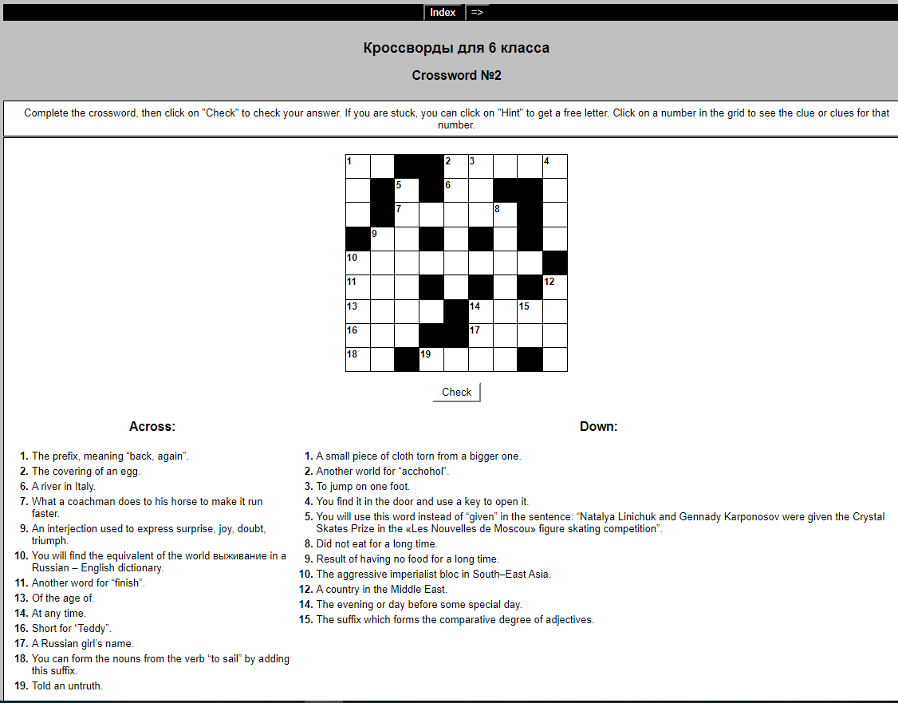

CROSSWORD № 3

 | Keys
Across:  1. To say that one is sorry.  7. Suffix with the help of which most of the ordinal numbers are formed.  8. You will add these letters to form the plural of “ox”.  9. A person who runs in a race.  10. To use one’s eyes; to turn the eyes in some directions.  12. “Better … than never” is a well-known saying.  15. One who coaches athletes for contests.  17. With the help of this suffix you can form nouns from such verbs as “govern, state”, etc.  18. To arrive at.  21. You will have to do it if you have no boat to cross a river.  22. Opposite of “far”. | Across:  1. Apologize  7. Th  8. En  9. Runner  10. Look  12. Late  15. Trainer  17. Ment  18. Come  21. Swim  22. Near
Down:  1. The practice of physical exercises, outdoor games and sports.  2. Words of Greek origin spell the sound [f] with these letters.  3. The small bird which is a symbol of early spring.  4. A traditional English form of address to men (in the singular).  5. Synonym of “hotel”.  6. To make mistakes.  11. A tributary of the Volga river.  13. The Arab Republic of Egypt (in short).  14. Come or go into.  16. A newspaper paragraph.  19. Letters which give the sounds [au] and [ou] in some words.  20. The third note in the musical octave. | Down:  1. Athletics  2. Ph  3. Lark  4. Gentleman  5. Inn  6. Err  11. Oka  13. ARE  14. Enter  16. Item  19. Ow  20. Mi

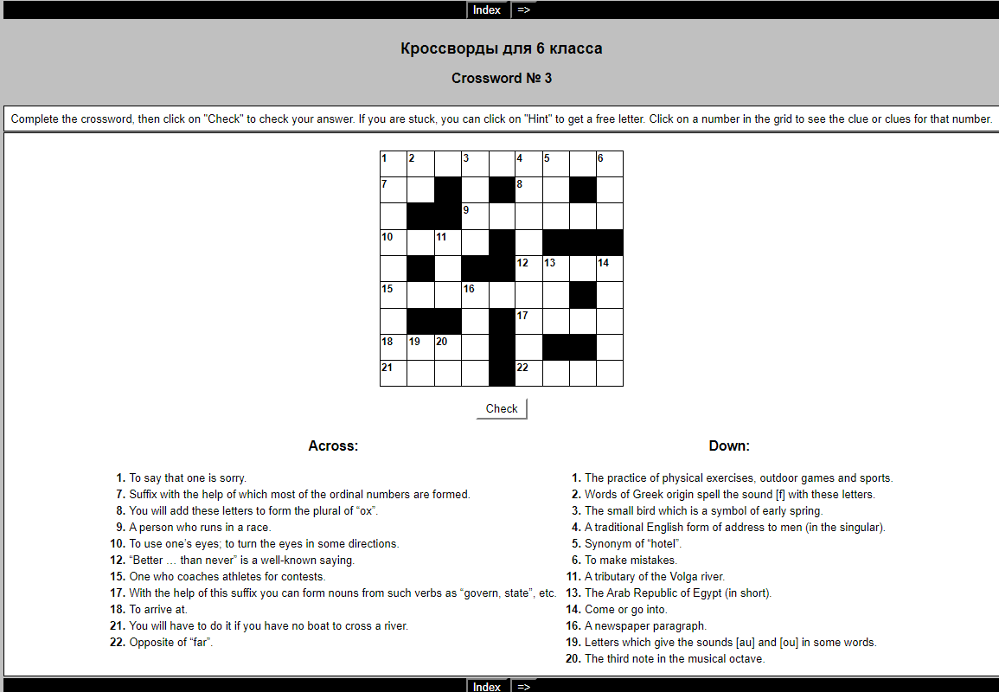

CROSSWORD № 4

 | Keys
Across:  2. The antonym of “peace”.  4. A poem in celebration of some person, event or thing.  6. The are very thick in Great Britain, especially in winter time.  8. A preposition.  9. The way from one place to another; the road which one follows.  11. Having no patience.  15. A period in history.  16. The possessive pronoun, 3rd person, singular.  17. 1,000 kilograms.  19. Not this; different from this; not the same.  20. Past Participle of the verb “do”.  21. The colour of our flag. | Across:  2. War  4. Ode  6. Fogs  8. To  9. Route  11. Impatient  15. Era  16. Its  17. Ton  19. Other  20. Done  21. Red
Down:  1. To discuss matters in order to come to an agreement as in business or in politics.  2. The word used by a speaker referring to himself and another or others.  3. The noun corresponding to the adjective “various”.  4. A preposition.  5. A girl’s name.  7. A set of clothes for a man, consisting of trousers, a waistcoat, a coat.  8. One more than nine.  10. A person who makes tests.  12. Short for “Mister”.  13. Papa (in short).  14. A slivery - white soft metal from which many articles are made.  18. Raw material from which metal may be extracted.  19. A preposition. | Down:  1. Negotiate  2. We  3. Variety  4. Of  5. Dora  7. Suit  8. Ten  10. Tester  12. Mr  13. Pa  14. Tin  18. Ore  19. On

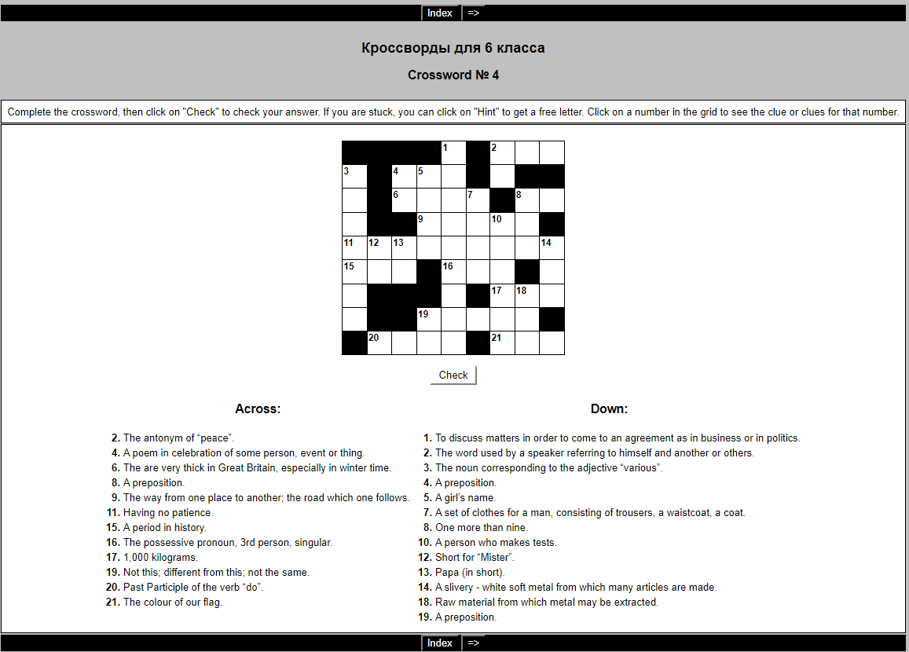

CROSSWORD № 5

 | Keys
Across:  1. To finish a university or an institute.  5. A word used to connect subjects and predicates in the 3rd person, singular, Present Indefinite Tense.  7. A ridge or rock just below or above the surface of the sea.  8. A long, thin. Straight piece of wood or metal.  9. The fourth note in the musical octave.  10. Before noon (in short).  12. You must observe them when you cross the street (in the singular).  14. Not far from.  16. You will use the word to say that the Great October Socialist Revolution took place 64 years …  17. The prefix, meaning “back”, “again”.  18. The demonstrative adjective and pronoun, the singular form of “those”.  21. The prefix, giving the word an opposite meaning. Used with such words as “mobilize, naturalize, merit,” etc.  22. An abstract noun from “just”. | Across:  1. Graduate  5. Is  7. Reef  8. Rod  9. Fa  10. AM  12. Rule  14. Near  16. Ago  17. Re  18. That  21. De  22. Justice
Down:  1. The name of the country whose capital is Berlin.  2. Not the same.  3. The objective case of «we».  4. From end to end; from beginning to end.  6. The synonym of «lazy».  11. The objective case of the pronoun «I».  12. An animal much like mouse, but bigger.  13. That which is carried in a lorry, ship, train, etc.  15. Two letters that give the sound [a:].  19. One more than 9.  20. Short for «Soviet Union». | Down:  1. Germany  2. Different  3. Us  4. Through  6. Idle  11. Me  12. Rat  13. Load  15. Ar  19. Ten  20. SU

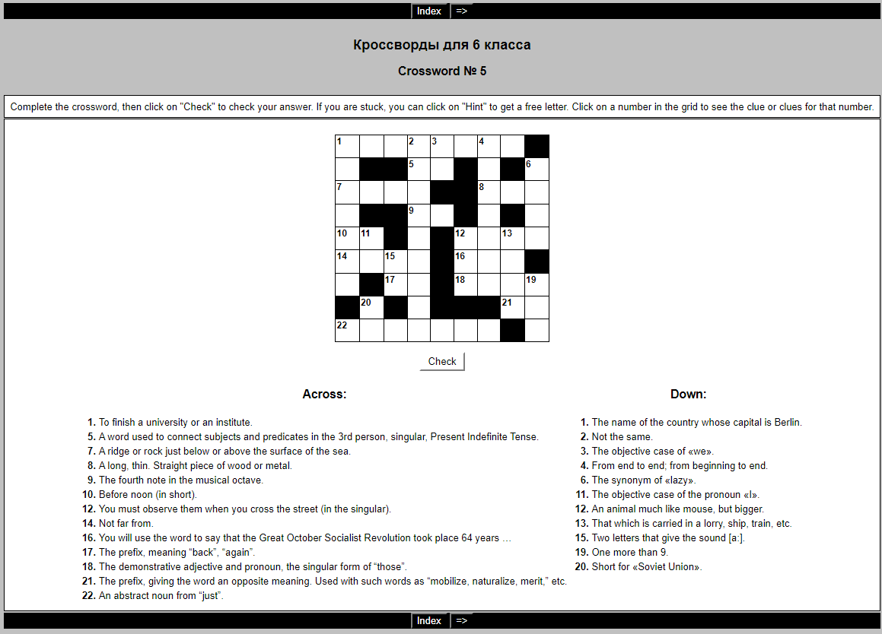

CROSSWORD № 6

 | Keys
Across:  1. An island in Italy where Napoleon lived in 1814-1815.  3. Letters, newspapers, parcels, etc. sent or delivered.  6. The synonym of “jewel”.  7. Former ruler of Russia.  9. The objective case of the pronoun “we”.  10. To own; you have as one’s property.  13. When split in produces tremendous energy.  14. Makes something new, original, different.  16. You drink it hot in the morning.  17. A preposition.  19. The evening or day before some special day.  20. The ability to do something well.  22. The personal pronoun used for a lifeless thing or an animal.  23. A fox is often described with this word. | Across:  1. Elba  3. Mail  6. Gem  7. Tsar  9. Us  10. Possess  13. Atom  14. Creates  16. Tea  17. If  19. Eve  20. skill  22. It  23. Sly
Down:  1. The noun – forming suffix showing the doer of the action expressed by the verb.  2. The deep – sounding voice that Shalyapin and Paul Robeson had.  3. The objective case of “I”.  4. Before noon (in short).  5. The comparative degree of “little”.  6. Another word for “large” in the superlative degree.  7. The particle making the infinitive.  8. Because, since.  10. Got one’s things ready for a journey.  11. A thick slice of meat or fish for broiling or frying.  12. A message calling for help usually sent by radio.  15. A preposition.  17. Opposite of “well” in the sentence: “He is well today”.  18. To move through the air as a bird.  21. The word used to connect subjects and predicates in the 3rd person, singular, Present Indefinite Tense. | Down:  1. Er  2. Bass  3. Me  4. AM  5. Less  6. Greatest  7. To  8. As  10. Packed  11. Steak  12. SOS  15. At  17. Ill  18. Fly  21. Is

