Пояснительная записка

Проект подготовили:
учителя МБОУ «Гимназия № 102» г. Казани:
- английского языка Киселева Елена Юрьевна
- учитель информатики и ИКТ Боровая Светлана Игоревна

Цели и задачи данного проекта:
- привлечение внимание и повышение мотивации учащихся
- проверка знаний учащихся по теме
- создание условий для работы в индивидуальном режиме и темпе
- выявление пробелов для их дальнейшего устранения

Структура проекта:
Проект тесты и кроссворды по темам «Путешествие» и «Выдающиеся личности» был подготовлен для учащихся 7-9 классов.
Данный проект содержит тесты и кроссворды для самостоятельной работы учащихся дома (могут быть размещены на сайте), для проверки знания терминологии по данной теме, а также для использования на внеклассных мероприятиях.

Использованные аппаратные и программные средства:
- MS Word 2016
- HotPotatoes 6

Инструкция по работе с кроссвордом:

- Запустить файл (формат веб-страницы).
- Подвести мышь ПК к цифре кроссворда, нажать левую кнопку и, в появившемся поле ввести слово, затем нажать клавишу {Enter}.
- Заполнить все поля.
- Нажмите кнопку {Chek} для проверки ответов.

Инструкция по работе с тестом:

- Запустить файл (формат веб-страницы).
- Для тестов с выбором правильного ответа из предложенных, нажмите клавишу соответствующую вашему выбору и проанализируйте ответ.
- Для тестов с кратким ответом в соответствующем поле наберите слово и нажмите кнопку {Chek} для проверки.
- Выполните все задания.

Список литературы:

  - Starlight 7, V. Evans, K.Baranova, J.Dooley, V.Kopylova, R.Millrood, Student’s Book, Prosveshenie publishers, 2017
  - Starlight 6, V. Evans, J.Dooley, K.Baranova, V.Kopylova, R.Millrood, Work Book, Prosveshenie publishers, 2017
  - Starlight 9, V. Evans, J.Dooley, K.Baranova, V.Kopylova, R.Millrood, Student’s Book, Prosveshenie publishers, 2015
  - Английская культура. Учебно-методическое пособие по английскому языку. Тула, 2016
  - Е.В.Яковлева, Е.Ю.Вершинина «Об англоязычной культуре на английском языке», Московский лицей, 2010
  - Englishdream.ru/category/kultura-anglii

Crossword № 1

Questions:
- Luxury trip by ship.
- Short journey.
- Picture for memory from trip.
- Capital of Great Britain.
- Rented house in the forest for holidays.
- What should we have in our passport for travelling?
- Students’ summer ..?.. goes on 3 month.
- What are we carrying on our back during campaign?
- What are we learning during travelling abroad?
- Where can we have meal during travelling abroad?
- How can we reach the hotel from the airport?
- What should we have for not to be lost in foreign country/city?
- It can be Red …, Black …, Mediterranean … .
- Without what can’t we travel?
- Where do trains arrive/come from?
- The most famous sight in London?
- Where can we carry our clothes during travelling?
- What is the most famous symbol of Ireland?
- The most comfortable way of movement in cities.
- What are we taking photos with?
- Where can we build a sandcastle?
- Where do planes arrive/come from?
- Which country looks like a high boot?
- What is making our skin darker?
- What do we bring to our family/friends from a trip?
- Without which gadget we can’t travel?
- What are we visiting in a foreign country to see different sights?
- Where can we stay during a trip?
- Every summer children go to a “summer ….”.
- International language.
- What do we need to stay on a plane?

Answers:
- cruise
- trip
- photo
- London
- lodge
- visa
- holiday
- backpack
- traditions
- café
- transfer
- map
- sea
- passport
- railway
- Big-Bеn
- suitcase
- clover
- car
- camera
- beach
- airport
- Italy
- sunbathing
- souvenir
- telephone
- excursion
- hotel
- camp
- English
- ticket

Crossword № 1

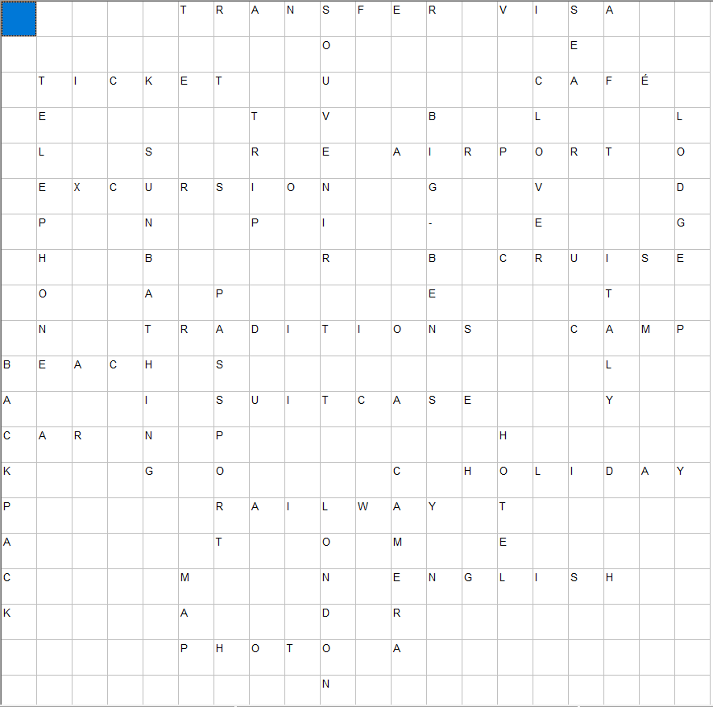
Crossword № 2

Questions:
1. The physiological adaptation to changes in climate or environment
2. A popular place among tourists, the deepest lake in the world.
3. Journey, that aims to improve knowledge about the culture, architecture, etc.
4. A place that deserves special attention because of its qualities.
5. A case with a handle, used for carrying clothes.
6. Negative effect from excessive sun’s influence.
7. The dark color of the skin after sun.
8. A long journey involving travel by sea.
9. The necessary apparatus while travelling, a device for recording visual images.
10. A long walk, especially in the country or wilderness.
11. «Dragon eye», fruit, cultivated in Southeast Asia.
12. Indian sweet fruit.
13. Thing that is kept as a reminder of a person, place or event.
14. Persons who advise or show the way to others.
15. The fastest kind of transport.
16. An establishment providing accommodations, meals and other services for travelers.

Answers:
1. acclimatizati’n
2. Baikal
3. excursion
4. sights
5. suitcase
6. sunstroke
7. tan
8. voyage
9. camera
10. hike
11. longan
12. mango
13. souvenir
14. guides
15. plane
16. hotel

Crossword № 2
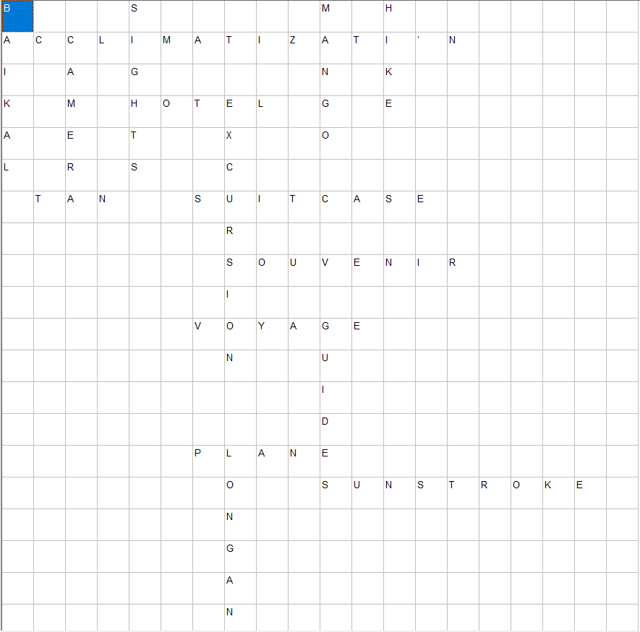

Crossword №3

Questions:
- An area of sand or rocks near the sea.
- A place where you stay when you are away from home.
- A short journey made by a group of people for pleasure in unknown country.
- A small room to sleep on the ship.
- An official mark in passport that allows you to enter or leave a particular country.
- A period of time when you are not at home but are staying somewhere else for enjoyment.
- A small piece of paper that shows you have paid for the trip.
- Someone whose job is to show interesting places to tourists.
- A place where planes take off and land, with buildings for passengers to wait in.
- Beautiful or interesting places in a city or country, that a lot of people visit.
11. Riding on the wave.
12. A ​place where ​tickets can be ​bought.
13. The units of money used in a particular country.
14. Something which you buy to your friends and family from abroad.
15. A piece of clothing that girls and women wear to go swimming.

Answers:
- Beach
- Hotel
- Excursion
- Cabin
- Visa
- Vacation
- Ticket
- Guide
- Airport
- Sight
11. Surfing
12. Booking office
13. Currency
14. Souvenir
15. Swimsuit

Crossword №3
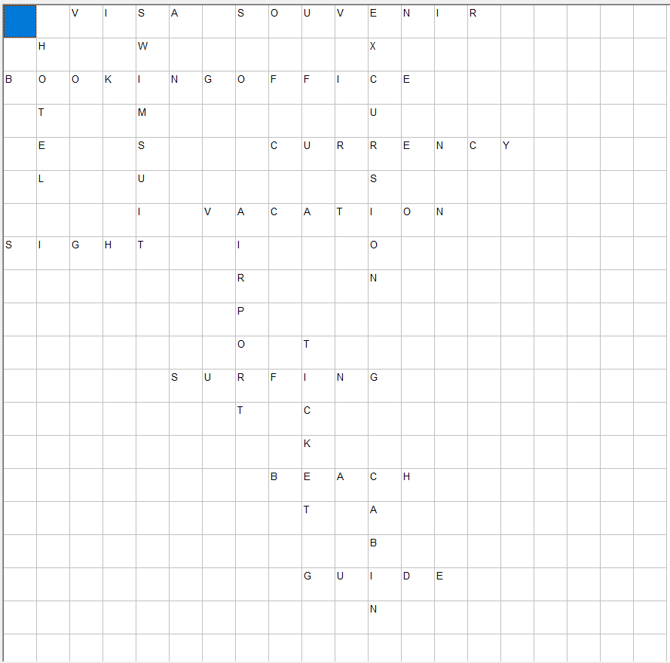
Crossword № 4

Questions:
1) The name of the largest gallery in St. Petersburg?
2) The most famous and one of the most ambitious amphitheaters of Ancient Rome?
3) Where is the great wall situated?
4) What statue is a symbol of New York?
5) What city is called the "city in the sky" or "city in the clouds", sometimes referred to as "The Lost City of the Incas"?
6) City in Mexico that is translated from the language of the Aztecs as "the city where men become gods" and one of the oldest and most major cities in the Western Hemisphere?
7) Where is Bundestag situated?
8) What is the fastest transport for long-distance travels?
9) What is the most dangerous mode of transport?
10) What is the most visited by tourists country in Europe in 2015?
11) What is the most expensive form of moving?
12) What is the oldest city in the RF territory?
13) What is the smallest country in the world?
14) What is the most southern country in the world?
15) What name of the castle of the Bavarian King Ludwig 2 is situated near the town of Fussen in the southwest of Bavaria, near the Austrian border.

Answers:
- Hermitage
- Coliseum
- China
- Liberty
- Machu-Picchu
- Teotihuacan
- Germany
- airplane
- car
- France
- cruise
- Derbent
- Vatican
- Chili
- Neuschwanstein

Crossword № 4

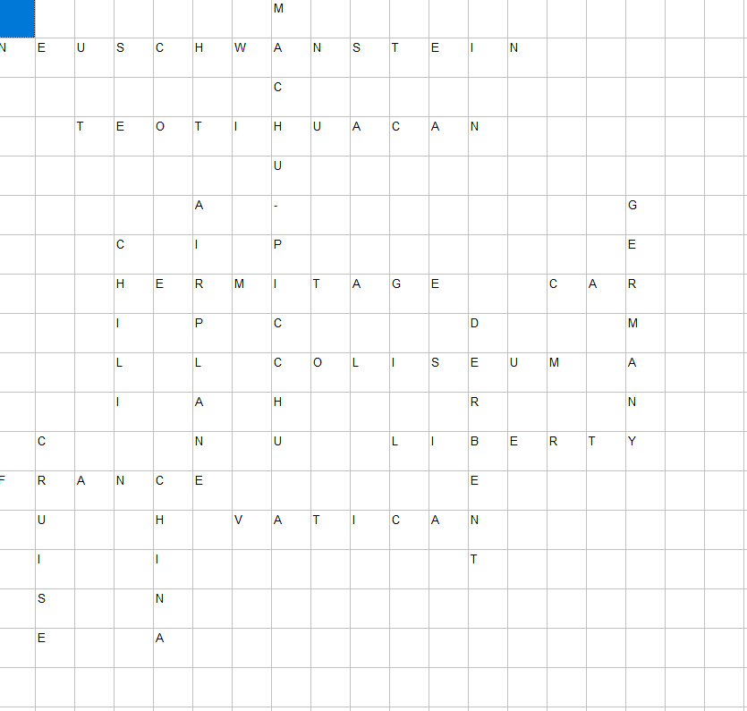

Crossword № 5

Questions:
1. A country where people speak Russian.
2. The cheapest and fastest transport.
3. The most famous Russian museum.
4. The most famous acropolis in the world.
5. What plaсe is described in the novel "Lost Horizon" by British author James Hilton?
6. All water mantle of planet or its part between continents.
7. A county where people speak German.
8. Рюкзак (перевод).
9. Vehicles traveling on rails.
10. The people speaking in Mandarin.
11. A country where you can get a fine for visiting the beach at night.
12. The most developed country in southern Africa.
13. In which city is the most famous wax museum?
14. In which country you can visit the largest botanical garden in the world?
15. Disneyland is located in... (Means USA)

Answer:
1. Russia
2. Underground
3. Hermitage
4. Tne Acropolis of Athens
5. Shangri-La
6. Ocean
7. Germany
8. Backpack
9. train
10. Chinese
11. Italy
12. RSA
13. London
14. Singapore
15. Anaheim

Crossword № 5
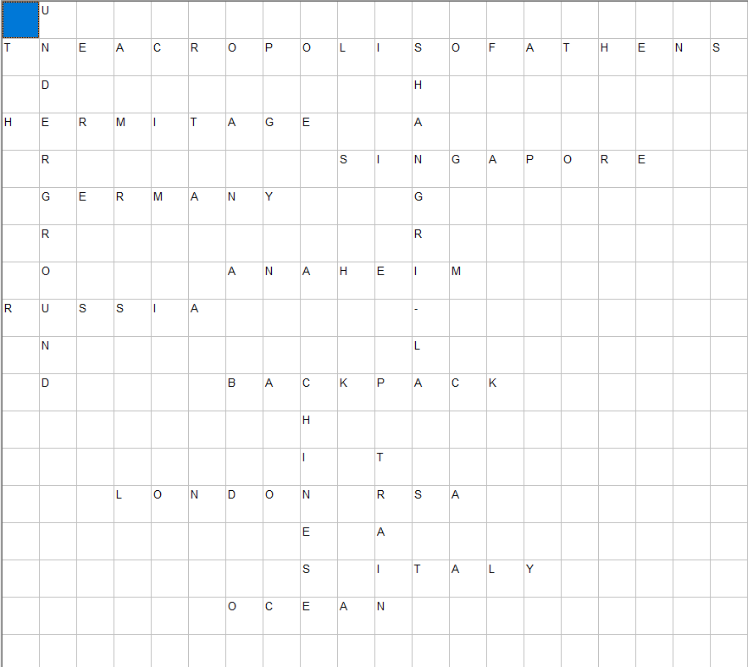

Test № 1 “Historical figures”

Choose the correct answer

1. The man who invented the first working telephone in 1876.
a. C. Monet c. A. G. Bell
b. V. van Gogh d. I. Newton

2. This I. Newton’s work describes universal gravitation and the free laws of motion.
a. The Theory c. The History
b. The Law d. The Principia

3. The most famous composer of all time who continued to compose even after he went deaf.
a. C. Monet c. L. van Beethoven
b. A. G. Bell d. I. Newton

4. Salvador Dali is a famous…
a. philosopher c. surrealist artist
b. chemist d. pop star

5. He was the creator of Theory of Relativity:
a. A. Einstein c. C. Dickens
b. S. Dali d. A. Lincoln

6. She is known as “the lady of the lamp”.
a. M. Curie c. F. Kahlo
b. F. Nightingale d. Queen Victoria

7. F. Nightingale was the person who pioneered
a. modern music c. modern literature
b. modern painting d. modern nursing

8. A. Lincoln is famous for…
a. writing novels c. the abolition of slavery
b. painting d. building temples

9. His novels have never gone out of print.
a. Ch. Dickens c. S. Dali
b. A. Lincoln d. A. Einstein

10. What was W. Shakespeare’s job?
a. a painter c. a writer
b. s scientist d. a singer

11. Where was Mozart born?
a. Germany c. Belgium
b. Austria d. Russia

12. This woman a chemist and physicist won two Nobel Prizes.
a. F. Kahlo c. F. Nightingale
b. A. Earhart d. M. Curie

13. The first president of the USA.
a. G. Washington c. A. Lincoln
b. T. Jefferson d. F. Rusvelt

14. Neil Armstrong was the first man who…
a. won two Nobel Prizes. C. discovered America.
b. walked in space d. walked on the moon.

15. What did Ch. Columbus discover?
a. America c. Australia
b. India d. Spain

Answers:

1.c 2.d. 3c 4.c 5.a 6.b 7.d 8.c 9.a 10.c 11.b 12.d 13.a 14.d 15.a

Test № 2 «Heroes of the Ancient World»

Find the right answer

1.Tutankhamun ruled Egypt…
a. 18 years c. 15 years
b. 9 years d. 5 years

2. What was inside Tutankhamun’s tomb.
a. a dog c. a gold mask
b. a cobra d. a silver mask

3. Whose words are these: ‘I came, I saw, I conquered’
a. Genghis Khan c. M. Polo
b. Cleopatra d. J. Caesar

4. How did J. Caesar die?
a. a cobra bit him c. he was old
b. senators murdered him d. he sank

5. According to many historians, Cleopatra died after…
a. a man killed her c. a poisonous snake bit her
b. she ate poisoned food d. she stabbed herself

6. Who was the last pharaon to rule Egypt?
a. M. Antony c. M. Polo
b. J. Caesar d. Cleopatra

7. Gienghis Khan started…
a. the Ottoman Empire c. the Persian Empire
b. the Mongol Empire d. the Inca Empire

8. G. Khan was…
a. a warlord c. a merchant
b. a king d. a general

9. According to legend, Marco Capac was the man who…
a. started the Inca Empire c. built Mayan temples
b. discovered south America d. started the Ottoman Empire

10. Marco Polo was:
a. a general c. a Venetian merchant
b. a pharaon d. a warlord

11. The result of M. Polo’s journey was:
a. he created new maps c. he started the Inca Empire
b. he found gold d. he built many new roads

12. When did Marco Polo return home?
a. 5 years later c. 24 years later
b. 12 years later d. 20 years later

13. Who was a Macedonian king?
a. Alexander the Great c. J. Caesar
b. M. Polo d. G. Khan

14. Which way did Tutankhamun spend his time?
a. by playing chess c. by gardening
b. by travelling d. by building monuments and temples

15. How old was Alexander the Great when he died?
a. 76 c. 32
b. 49 d. 56

Answers:

1.b 2.c 3.d 4.b 5.c 6.d 7.b 8.a 9.a 10.c 11.a 12.c 13.a 14.d 15.d

Test № 3 “The most talented persons”

Answer the questions

- Who invented the first working telephone in 1876.
- According to many historians Cleopatra died after…
- What does Vitruvian Man show?
- Whose words are these: “I came, I saw, I conquered!”
- The first man who walked on the moon.
- The first president of the USA.
- He invented the light bulb.
- Who used “mirror” writing and why?
- What is the second name of the Mona Lisa?
- Many people came to know her as “the lady of the lamp”.
- This woman created a theory of radioactivity and won two Nobel Prizes.
- He is famous for his Theory of Relativity.
- The Mongol Empire was started by…
- A Spanish surrealist artist who created unusual paintings, sculptures and photographs.
- This person managed to steal the Mona Lisa.

Answers:

- A. Bell
- A poisonous snake bit her.
- The perfect proportions of the human body.
- J. Caesar.
- N. Armstrong
- G. Washington
- T. Edison
- L. da Vinci. He didn’t want everyone to understand his notes.
- La Gioconda
- F. Nigthingale
- M. Curie
- A. Einstein
- G. Khan
- S. Dali
- V. Peruggia

