Автор: Ухова Юлия Александровна,
учитель английского языка
МБОУ СОШ № 14,
город Александров, Владимирская область
Краткая аннотация.
Данная работа предназначена для учащихся 6-7 классов общеобразовательных школ в качестве материала краеведческой направленности на уроках английского языка с дополнительными предтекстовыми, текстовыми и послетекстовыми заданиями. Текст содержит краткую информацию о жизни известной поэтессы Марины Цветаевой, ее жизни и о первом в России музеи названном в ее честь, который находится в Александрове. Содержание его призвано стимулировать познавательный интерес школьников к изучению родного края, особенно мест, малоизвестных широкому кругу людей.
Предтекстовые задания направлены на выделение ключевых слов, прогнозирование содержания и расширение лексического запаса.
Текстовые задания развивают логическое мышление и анализ, помогают запомнить новые слова.
Послетекстовые задания помогают запомнить основные события текста, их хронологию и готовят к монологическому высказыванию.

Part I. Before reading.
Task1. Work in pairs. Ask your partner and let him\her answer the question/
- what famous people of your town he\she knows;
- what these people are famous for;
- what museums in your town he\she knows;
- what museums he\she visits;
- what the text will be about.

Task 2. Here are some English words. Try to find the definitions to these words.
1 | The outskirts |  |  |  | A | A single object
2 | An exhibition |  |  |  | B | A small house at the entrance of a large house.
3 | An item |  |  |  | C | A land with some houses, owned by one person
4 | A memory |  |  |  | D | The part of a town or a city that is far from the center.
5 | An estate |  |  |  | E | One part of a country with its own government
6 | A province |  |  |  | F | The act of showing things or works of art to the public
7 | A lodge |  |  |  | G | It is something that you remember from the past.
1- |  | 2- | 3- | 4- |  |  | 5- | 6- | 7-

Part II. While reading.
Task 1. Read the text and choose the titles to its paragraphs.
- The atmosphere of the museum
- The younger sister and her life
- The first Tsvetaeva`s museum
- Tsvetaeva`s family

1
2
3
4

- Marina Tsvetaeva was a Russian poetess, prose writer, translator, one of the greatest poets of the Silver Age. She started writing poems at the age of six and not only in Russian but in German and French. Her father I.V. Tsvetaev is a famous philologist and art critic, founder of the Museum of Fine Arts (Pushkin Museum), her mother was a concert pianist.
- The younger sister of Marina Tsvetaeva is Anastasia Tsvetaeva . In the years 1915-1917 Anastasia Tsvetaeva lived with her family in a cozy house on the quiet green outskirts in the city of Alexandrov, Vladimir province. It is the small city estate which at the end of the 19th century was bought by the mathematics teacher by the name of Lebedev. Marina Tsvetaeva often visited her sister in Alexandrov and stayed with her for a long time. It is known that the months spent in Alexandrov became one of the lightest and cloudless memories in her difficult life.
- Later, this wooden building became the first Tsvetaeva`s museum in Russia. The museum was opened in 1990. Two wooden houses are a part of the museum «a Tsvetayeva's lodge"and "Lebedev' House". It has seven exhibition halls. There are twenty-six thousand items and it includes collections of materials belonging to distinguished artists, whose art was directly related to Alexandrov. Among them are Marina and Anastasia Tsvetaeva (it keeps a lot of their photos and personal things, including Marina`s piano), Mandelstam, Solzhenitsyn and many others.
- The aim of founders of the museum is not just an exhibition of personal belongings and editions, but the creation of the atmosphere of that century. It still calls «metaphor- museum». Now poetry festivals, literary evenings and art exhibitions are held regularly in this museum.
Task 2. Read the text again and choose the best title for it.
- A famous person
- The life of a famous poetess
- Tsvetaeva`s museum
- The literary and Art museum of Marina and Anastasia Tsvetaeva
Task 3. Find synonyms to the underlined words.
- comfortable
- calm
- exposition
- purpose
- things
- region
- outstanding

Part III. After reading.
Task1. Find the sentences in the text which describe the photos best of all:

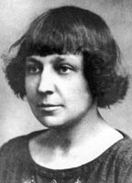 | 1.
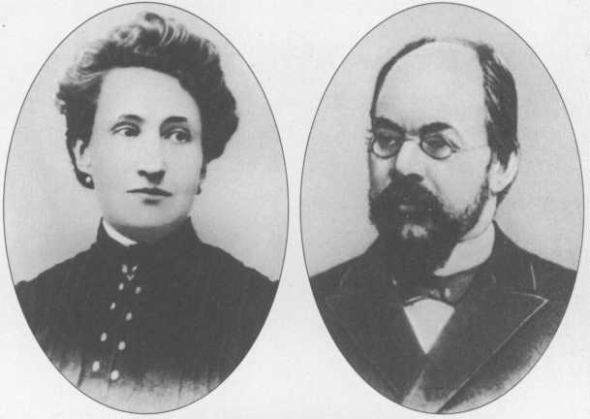 | 2.
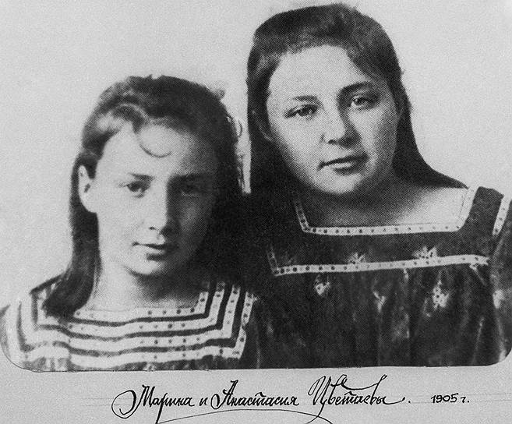 | 3.
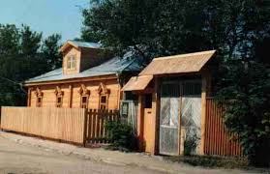 | 4.
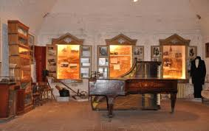 | 5.
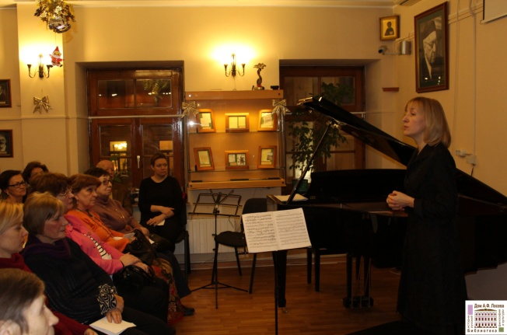 | 6.

Task 2. Answer the questions:
- Who was Marina Tsvetaeva?
- When did she start writing poems?
- Who were her parents?
- Why did Marina visit Alexandrov?
- Where did she stay in Alexandrov?
- When was the museum opened?
- What items does it include?
- What was the aim of the founders?
- What is held in the museums nowadays?

Task 3. Make a plan and try to tell about Marina Tsvetaeva.

Использованные материалы:
- http://www.mysilverage.ru/semya-cvetaevoj/
- http://www.alexandrovru.ru/Museums/tscvetaevyh.htm
- http://tsvetayevs.org/creation/anastasia_h16.htm

