Tatiana ZVONKOVA
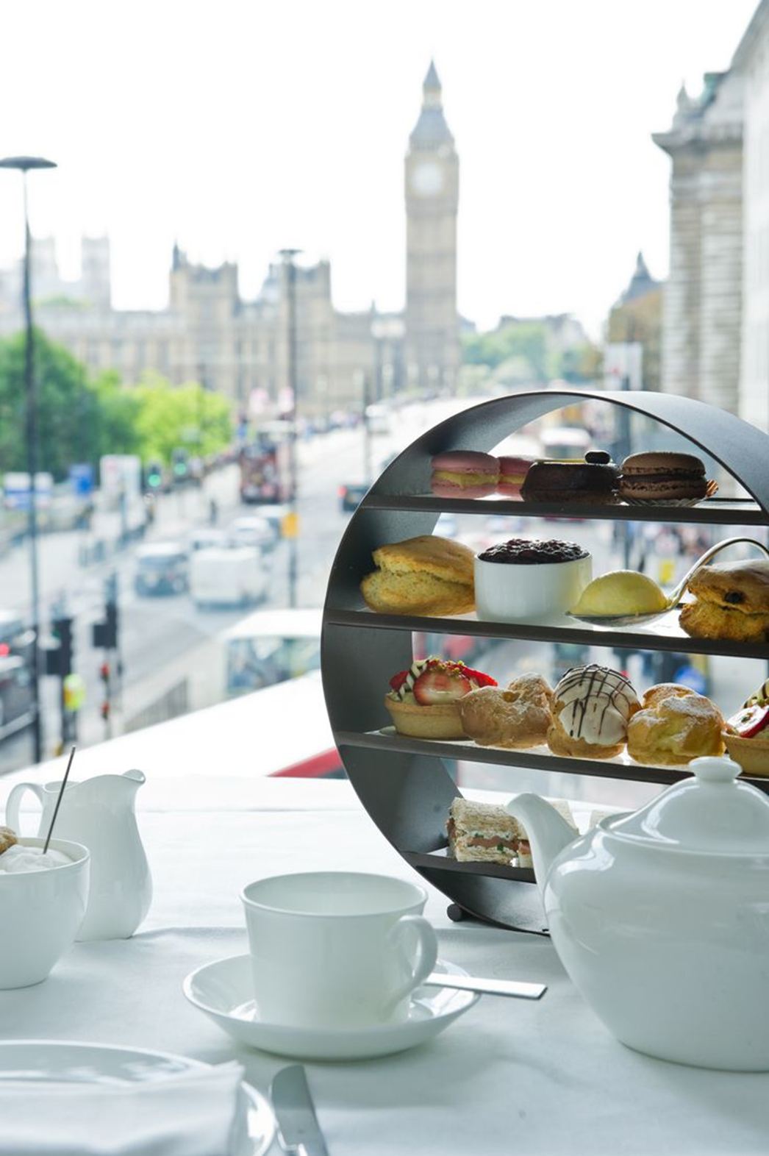

“London’s shops”
texts for analytical reading

Five of the best sweet shops to visit in London
London certainly has its share of candy shops, from stores selling classic treats to chefs with confectioneries of their own making. No matter what kind of candy you want, you should be able to find it in London, and we’ve outlined five different candy shops where you should be able to find one of your favorite candies. If your favorite candy store doesn’t appear on our list, you can let us know your own top sweet shop in the comments.
SugarSin
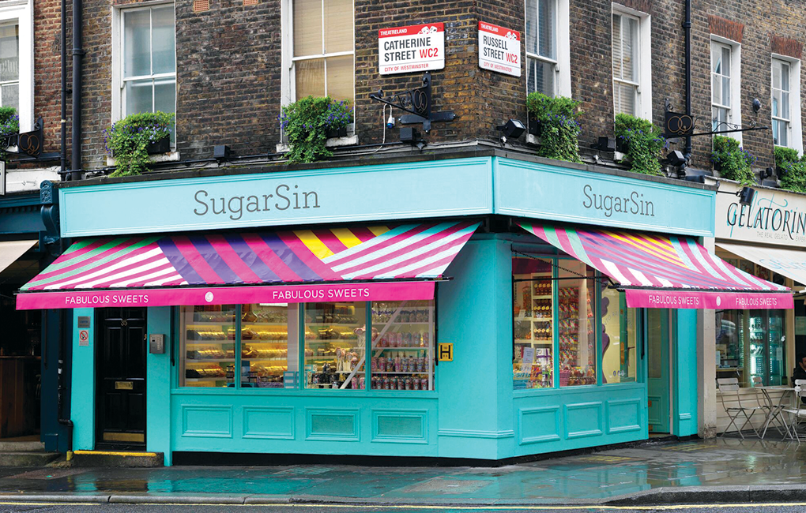

This SugarSin confectionary is consistently one of the top candy shops in London. It features a number of unique in-house candies, with the number-one seller being its cocktail gummies that come in flavors of dry gin, strawberry daiquiri, sparkling rose and more. The store also offers several flavors of chocolates, lollipops and vegan and vegetarian options. It also has one of the largest mix-and-match varieties for children of all ages, so everyone should be able to find something they like.

Rococo Chocolates
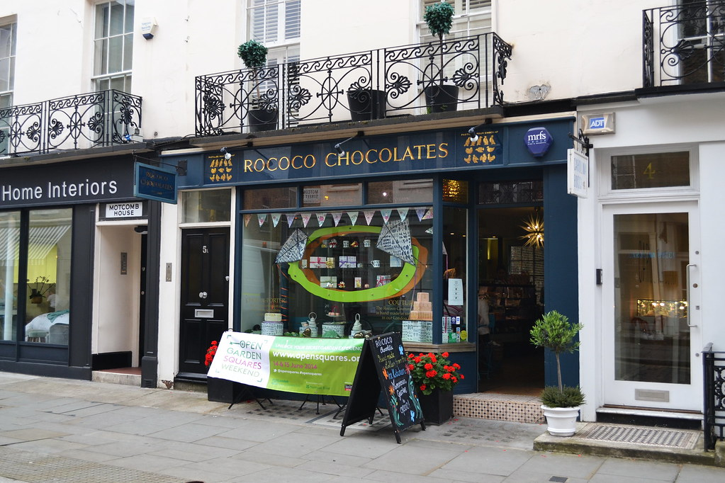

Chocolate is one of life’s greatest luxuries, and Rococo Chocolates prides itself on offering some of the most luxurious chocolates around. Chocolate-covered nuts, assorted boxes, and many flavor varieties are just some of what the shop has to offer. What’s more, Rococo offers chocolate bars featuring the artwork of Quentin Blake, the illustrator most known for his work on the books of Roald Dahl. If you want a good sampling of Rococo’s offerings or something for a picnic dessert, Rococo has chocolate hampers for all manner of occasions. If you’ve got a chocoholic in your family, this is certainly a store to visit.

Hardy’s Sweet Shop
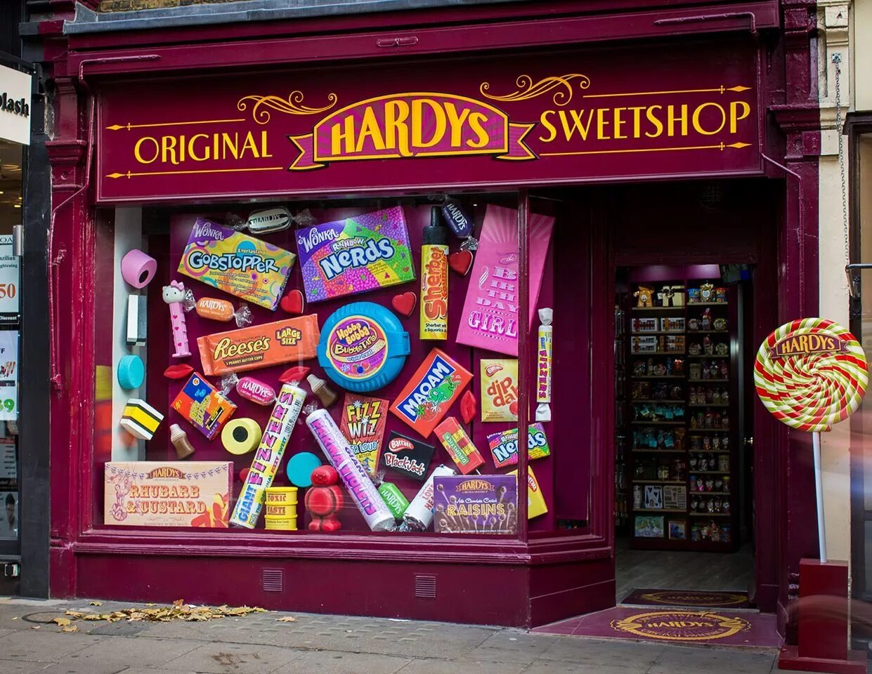

Hardy’s Sweet Shop is one of the easiest places to visit as it has several locations throughout London. It is also the top candy store to visit if you are interested in classic candies. Hardy’s sells plenty of big-name favorites from Licorice Allsorts to Nerds as well as more traditional sweets kept in glass jars. And what’s more, Hardy’s also has its own brand of sweets that you can purchase to try something new and different. It is perhaps the most old-fashioned candy stores on this list, and with several locations to choose from, there’s no reason not to visit.

Montezuma’s Chocolates
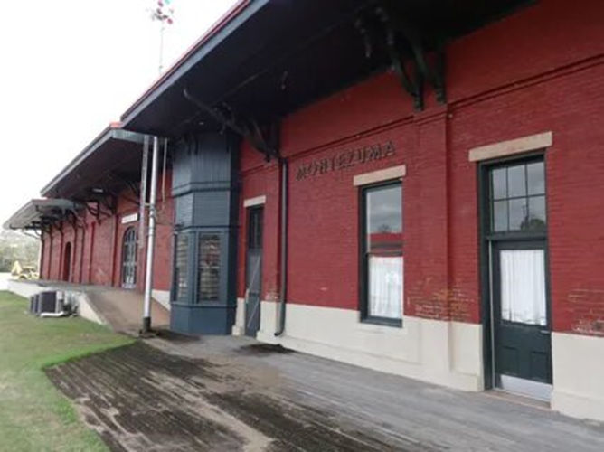

Cocoa beans have been a gift from the Americas, and Montezuma’s tries to bring the best of South American chocolate to Britain courtesy of couple Helen and Simon, who fell in love with the traditional chocolate of the region and brought it back home. This has in turn has informed their business practices, focusing on Fair Trade-procured organic ingredients to make their products. Montezuma’s has a wide variety of chocolate flavors from dark chocolate with lemon to hemp and sea salt. There’s no shortage of innovative options in the store and the fair trade and organic practices should put your conscience at ease.

Hoxton Street Monster Supplies
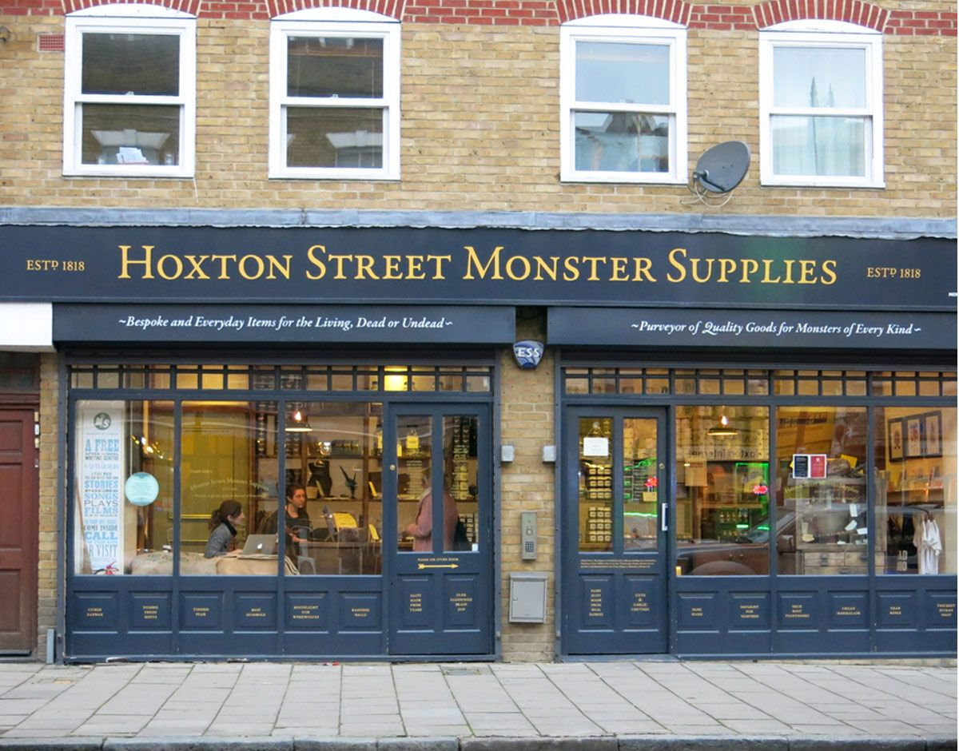
Hoxton Street Monster Supplies puts an interesting spin on your favorites from licorice Bah! Humbugs to caramel Impacted Earwax. The names might throw off some people from what are very traditional candies, though it may make some all that more curious—especially children. The store certainly gears itself to a younger type of customer and its proceeds go towards the Ministry of Stories, a nonprofit that encourages creative writing and supports a charity for youngsters. Besides candies, Hoxton Street Monster Supplies also sells a number of themed dry goods that you can be certain will help inspire young people throughout the UK.

Read the text and mark the sentences as TRUE, FALSE or NOT STATED
- SugarSin confectionary offers products for vegans and vegetarians. ______
- SugarSin confectionary sells sweets only for little children. ______
- Rococo chocolates are exclusive and expensive. _______
- Rococo chocolates are made from Belgium chocolate. _______
- Hardy’s Sweet Shop specializes on classic sweets. ________
- Hardy’s Sweet Shop is the most modern shops of all. ________
- Montezuma’s Chocolates has a great deal of new ideas for customers. ______
- Montezuma’s Chocolates uses cheap ingredients. _______
- Hoxton Street Monster Supplies has extravagant names of its products. ______
- Hoxton Street Monster Supplies sells only sweets. ______

Five of the best tea shops in London
Tea, the classic staple of British beverages. Whether one enjoys a cup for breakfast, to relax, or while enjoying a traditional afternoon tea meal, it is a drink full of flavor and culture. When traveling in London or new to the city, you may want to take the opportunity to branch out from your local grocery shop for tea and try one of the metropolis’ many excellent tea shops. From shops full of history to ones with many varied selections, you are guaranteed to find something new and enjoyable in your next cup.
Twinings – The Strand
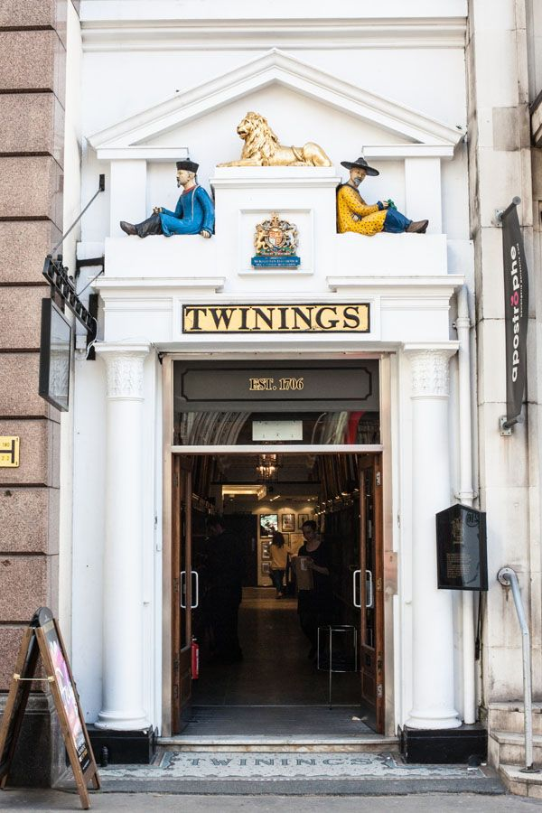

First on the list is Twining’s. Why? Because it’s the first tea room ever established in London. Thomas Twining established the tea room at No. 216 Strand in 1706 and you can still find it there today. In another first, at the time it opened, women were not allowed in London’s coffee houses, but Twining’s was open to everyone. Today, the tea room continues to sell tea for you to enjoy on premises or to take home, and there is also a small museum dedicated to the company’s success. While you can certainly buy Twinings at the grocery shop, you may find something new to enjoy while you bask in history.

East India Company – Soho
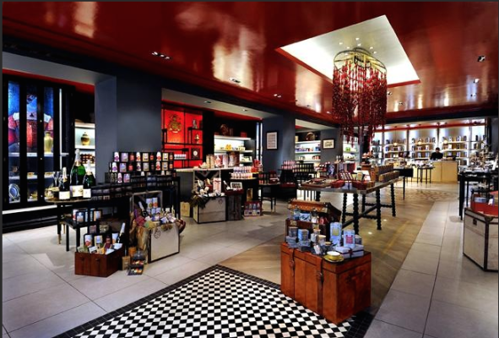

For a bit more history, it doesn’t go much farther than the East India Company. The original EIC was founded in 1600 and was one of the first publicly-traded companies in the world. It dissolved in 1875, but 135 years later, Indian businessman Sanjiv Mehta opened a new incarnation in Soho to serve all kinds of gourmet tastes—including tea. The shop is stocked with around 350 different luxury products such as chocolate, spices, mustards, and 100 varieties of tea. If you can’t make it to the flagship shop, you can also purchase their products online.

Yumchaa – Soho

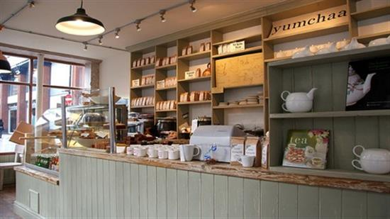

Another Soho tea shop (with additional locations in Camden and Google Street), you won’t find any tea bags at Yumchaa. The shop believes whole-heartedly in loose leaf tea and that the factors for a great cupY are “the leaf, the water, and the freedom for the two to mingle.” The shop is full of handcrafted blends and addition to classic favorites, offers interesting twists such as Chai Red, Raspberry Vanilla, Berry Berry Nice, and Chilli Chilli Bang Bang. If you want to try something new and different, Yumchaa will show you how tasty its teas can be.

Postcard Teas – Marylebone
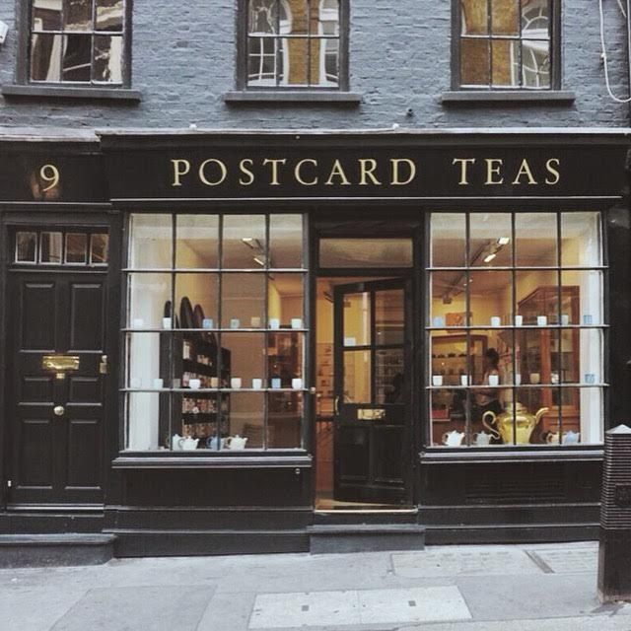

Owner Timothy d’Offay prides himself on traveling the world to find the best teas for his London shop. The shop loves to pride itself in being the only one to reveal the origin of its teas, listing every tin with the maker or estate’s name and the place of production. The shop’s name comes from one of its unique features, in which customers can send their friends tea by posting a packet in the shop’s own red postbox. Get some for yourself and send some more to your mates back home.

Tea Palace – Walham Green
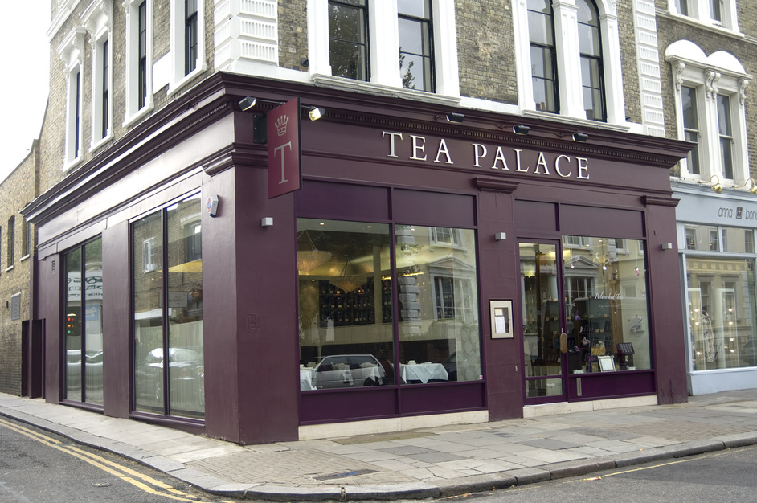

With a name like Tea Palace, you can believe that this shop is royalty. Matching the colors of its façade, each Tea Palace’s selections comes in purple tin caddies. In addition to a variety of gifts, Tea Palace creates its own variety of blends, including ones for special occasions. While a Google search will tell you that the shop is permanently closed, that only applies to the original location in Covent Garden, and the shop currently operates out of 9a-9b in Imperial Studios on Imperial Road.

Read the text and mark the sentences as TRUE, FALSE or NOT STATED
- Travel agencies offer trips to tea shops in London.
- Twining’s the oldest tea shop in London. _________
- Twining’s a famous art gallery as well. _________
- Soho offers a wide range of products except tea. _______
- Soho is the most expensive shop in London. ________
- Yumchaa uses only loose leaf tea. _________
- Postcard teas organized an interesting tradition to send tea. _________
- Postcard teas offers its production only online. ________
- Tea palace has a luxurious view. ______
- Tea palace is situated only in Convent Garden. _______

Five of the best coffee shops in London

For some of us, coffee is our life’s blood. It’s a necessary part of our morning, whether it comes from a pot, a pod, or your favorite roasters down the street. Everyone has a particular way they like their Cup o’ Joe and their barista who makes it like no one else. Coffee in London predates the national love of tea, and the first coffee shop opened in the city in 1652. Today, there seem to be as many coffee shops as there are pubs within Greater London, so it can be hard to choose which ones are the best. We have identified five of our favorite spots for the ban below, and you can let us know your favorites in the comments.
Monmouth Coffee Co. – Covent Garden
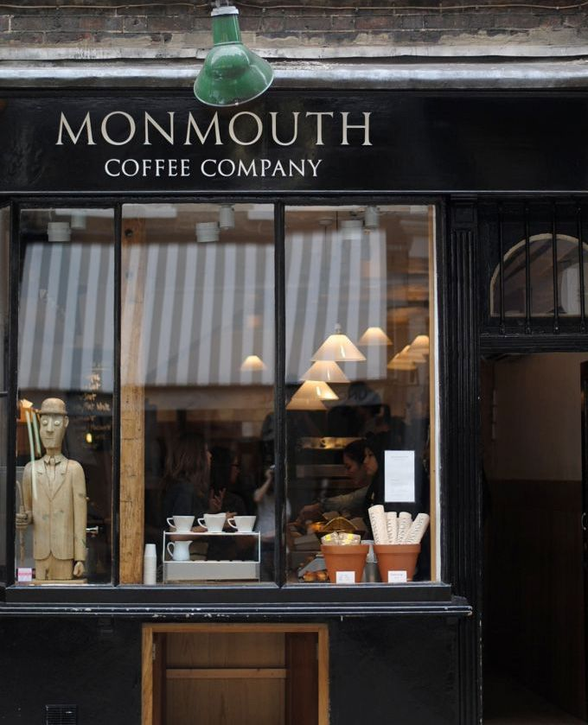
Well before artisan coffee and mustachioed baristas were on every corner, Monmouth Coffee Co. opened in Seven Dials, Covent Garden. Since 1978, it’s been a popular place in the London coffee scene and has inspired several other coffee shops whose owners started at Monmouth. Serving coffee with beans that are locally and ethically sourced, you’ll taste the difference for yourself when you visit the original location at 27 Monmouth St or their other two locations.

Prufrock Coffee – Farringdon
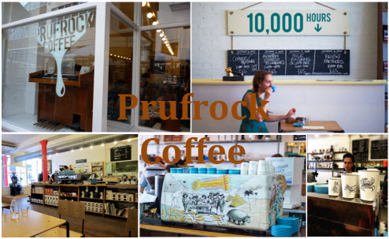

One of the best things about Prufrock isn’t that they serve Square Mile Coffee (though that’s certainly a wonderful reason to go) but they also have a barista training program to help inspire new members of the trade and help them succeed. You don’t have to be looking for a new job to give their course a try and you might find that you’ll be able to make a cup as good as any of the pros. You can also buy your own bags to make at home, so once you finish the course, you can give your new skills a whirl.

Kaffeine – Fitzrovia
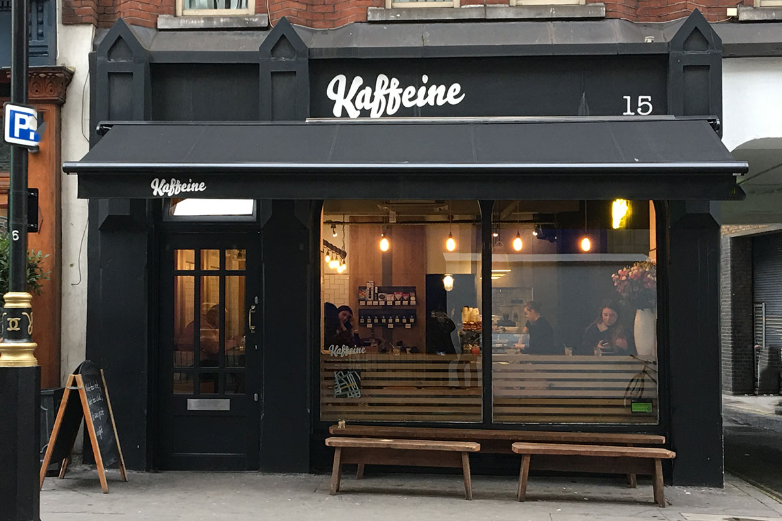

If you want to get a buzz from some Down Under coffee roasters, Kaffeine is the place for you. Both of Kaffeine’s two locations in Fitzrovia pride themselves in bringing the Aussie and New Zealander style of coffee to London. Both locations play host to guest roasters on the weekends and offer artisanal sandwiches and baked goods to go with your brew. You can also buy their coffee by the bag to take home and roast it yourself.

Ozone – Shoreditch
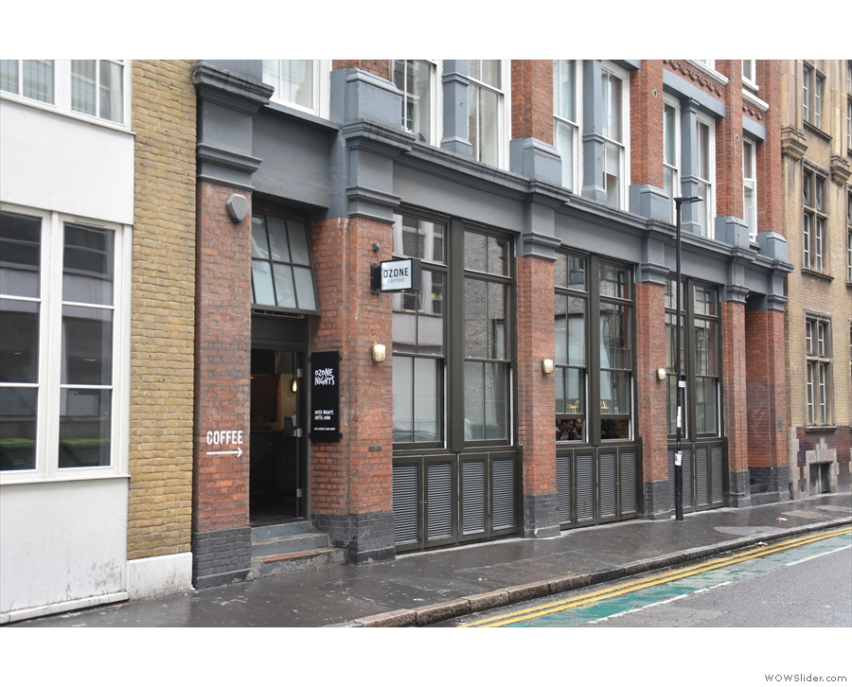
While Monmouth may have started the craze long before there was a demand, Ozone got on board when the artisanal coffee kicked off in the 1990s. Ozone has been a part of Shoreditch’s coffee scene since 1998 and offers not only a variety of coffee beans, but brewing methods such as aeropress, syphon, and its own roastery. What’s more, they don’t just sell you the beans, but you can also purchase your own coffee-making kits from them to make Ozone’s coffee when you get home. And much like Monmouth and Square Mile, they supply other coffee shops with their beans.

Federation Coffee – Brixton
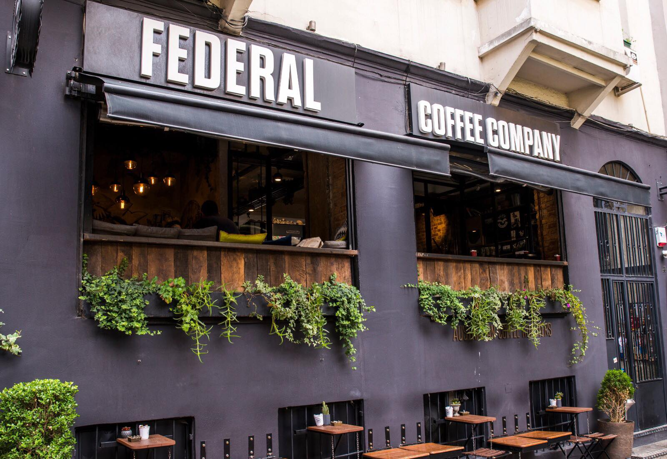
Certainly one of the draws to Brixton Village Market, Federation Coffee is a place for people who want their coffee to look as good as it tastes. Federation offers its own house blend, and the foam artistry is some of the best in London. The interior is simple, but that’s because all the energy is put into producing the best coffee around. Of course, that’s not all Foundation is known for and its bakery offers a number of delectable treats including sourdough toast with any number of quality toppings. Plenty reviewers believe the food alone is worth going to, even if you don’t drink coffee.

Read the text and mark the sentences as TRUE, FALSE or NOT STATED
- The first coffee shop opened in London in the seventeenth century. ________
- Monmouth Coffee Co. became an inspiration for other coffee shops. ______
- Prufrock is the shop only for rich people. _______
- Prufrock has its own school for barista. _______
- Kaffeine shop offers only coffee to its guests. _______
- Ozone use different methods of brewing. _______
- Ozone sells coffee abroad. ________
- Brixton village Market has a rich interior. _______
- Brixton Village Market has its own bakery. ________
- All coffee shops in London organize publicity campaigns form time to time. ______

Resources
www. londontopia.net

