Класс:11
Дата: 14.02
ТЕМА: “Дня Святого Валентина”
Цель урока: ознакомление учащихся с обычаями и традициями празднования “Дня Святого Валентина”
Задачи урока:
обучающие:
1) познакомить учащихся с традициями и обычаями празднования дня святого Валентина
2) способствовать формированию у учащихся навыков лингвострановедческой компетенции
3) активизировать лексику на тему “День Святого Валентина”
4) познакомить с фольклорным и поэтическим наследием англоязычных стран
развивающие:
1) развивать творческую фантазию, познавательный интерес, инициативу в осуществлении иноязычной речевой деятельности
2) развивать умение читать и воспринимать на слух информацию, развивать монологическую и диалогическую речь учащихся, развивать способность к анализу, к догадке
воспитательные:
1) воспитывать у учащихся чувство прекрасного и уважение к культуре и традициям других народов
2) воспитывать чувство взаимной ответственности, прививать навыки работы в коллективе
3)развивать социокультурные знания
Ожидаемые учебные результаты:
предметные
- расширение словарного запаса;
- развитие устной речи в четырёх видах речевой деятельности;
метапредметные
- формирование коммуникативной компетентности;
- формирование навыка планирования и регуляции своей деятельности;
- формирование и развитие компетентности в области использования информационно-коммуникационных технологий;
личностные
- формирование осознанного, уважительного и доброжелательного отношения к другому человеку, его мнению; готовности и способности вести диалог с другими людьми и достигать в нём взаимопонимания:
- формирование представления об английских праздниках.
Методы и приёмы обучения:
Системно – деятельностный подход
Технология личностно ориентированного обучения
Здоровьесберегающие технологии
Метод критического мышления
Игровые приёмы
Информационно-технологические материалы (средства ИКТ и ЭОР) - компьютер, раздаточный материал учителя, мультимедийный проектор, компьютерная презентация.
Ход урока
1. Организационный этап
T: Good morning, students, I’m glad to see you at our lesson today. You’ll have an unusual lesson; you have a lot of guests today. Let’s turn around and say them ‘’Good morning’’. How are you? Are you tired, bored, excited, happy, worried?
2. Определение цели занятия, мотивация учебной деятельности
Look at the screen and define the topic of our lesson. VIDEO
1.15 What do you think is in the box?
2.17 What is going to happen next?
3.16 Will she say “Yes”?
And what do you think the theme of our lesson is?
Today we are going to revise all you know about the St.Valentine’s Day. Today, we have an excellent chance to plunge into the atmosphere of love, to take part in games, to practice the use of some pleasant words and expressions on this special occasion.
What do you want to learn at our lesson?
Pupil: I want to learn about St. Valentine’s history, traditions, symbols, play games, do interesting tasks, watch videos and listen songs about love.
You should remember our rules: don’t be afraid be active and polite!
- Речевая разминка в виде коммуникативной ситуации.

Activity 1
Teacher: Now, let's remember what you know about Saint Valentine’s Day. Answer my questions, please.
Teacher: Valentine’s Day is one of the most favorite holidays not only in the UK and in the USA, but also in Russia, isn’t it?
Pupil 1: Yes, it is.
Teacher: When is Saint Valentine’s Day celebrated?
Pupil 2: Saint Valentine’s Day is celebrated on February 14.
Teacher: Who celebrates this day?
Pupil:3 Loving cuples, lover, family
Teacher: What do people send to their lovers and friends on St. Valentine’s Day?
Pupil3: People send valentines to their lovers and friends.
Teacher: What flower is one of the symbols of this holiday?
Pupil5: A red rose is one of the symbols of this holiday.
Teacher: What presents are the most popular on St. Valentine’s Day?
Pupil 6: Roses, cards, chocolates,
2. Основная часть урока.
1. Работа с лексикой.
Dear friends, now let’s remember some words, which we’ll need during the lesson.
Activity 2
What things do you associate with St. Valentine's Day? What is it for you? What are the symbols of St. Valentine’s day? Let’s go to the blackboard complete the scheme and translate this words .
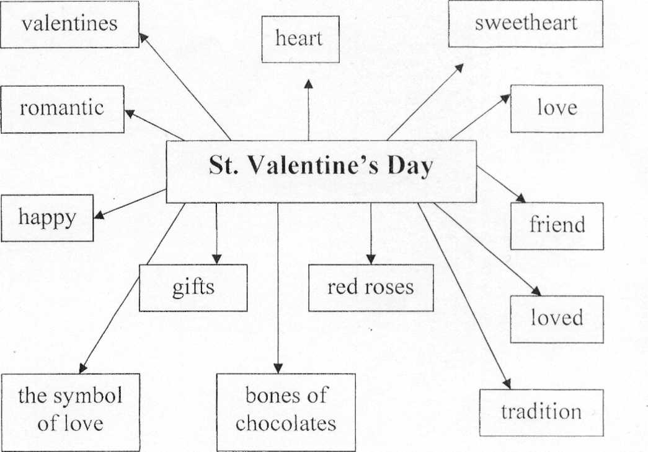

2. Развитие навыков устной речи (монологическая речь)
There are a lot of symbols of St. Valentine’s Day. And now I would like you to speak about them.
P1- I would like to tell about the heart. Many years ago, people believed that all the emotions were found in the heart. In later years, they thought only the emotion of love was connected with the heart. The heart is still a symbol of love, and it is also a symbol of Valentine’s Day.
P2 - I would like to tell about the rings. In some countries, men and women exchange rings when they become engaged or marry. Valentine’s Day is a popular day for giving an engagement ring. An engagement ring usually has a stone or jewel set in it.
P3 - I would like to tell about the doves. Doves were thought to be favorite birds of Venus. They remain with the same mates all their lives. The males and females both care for their babies. These birds are symbols of loyalty and love. They are also symbols of Valentine’s Day.
P4 - I would like to tell about the gloves. Years ago, when a man proposed marriage to a woman, he “asked for her hand”. The hand became a symbol of marriage and love. Soon gloves also became a symbol of love.
P5 - I would like to tell about the Cupid. Cupid is a son of Venus, goddess of love. He could cause people to fall in love by piercing them with one of his magic arrows.
P7 - I would like to tell about the ribbons. Ribbons go back to the days when ladies gave ribbons to their favorite knights when they went to war.
P8 - I would like to tell about the red rose. The rose was the flower of Venus, the Roman goddess of love. Red is a color that stands for strong feelings. This is why the red rose is a flower of love.
P9 Red Roses - Love and passion,
Yellow Roses - Friendship
White Roses - True love and purity of the mind
Orange Roses - Enthusiasm and desire
Pink Roses - Friendship or Sweetheart
Black Roses - Farewell
What another Symbols of holiday do you know?
3. Работа с лексикой.
Activity 3
Activity 4
Match the English proverbs and their Russian equivalents:
1 - Love and a cough cannot be hidden.
2 - All the world loves a lover.
3 - All’s fair in love and war.
4 - Better to have loved and lost than never to have loved at all.
5 - Love is blind.
6 - Love me, love my dog.
7 - Love is harder to accept than to give.
8 - Faint heart never won fair lady.
9 - Far from eye, far from heart.
10 - A merry heart is a good medicine.

a - Любишь меня, люби и мою собаку.
b - Лучше любить и потерять, чем не любить никогда.
c - Влюблённого любит весь мир.
d - Робкое сердце никогда еще не завоевывало прекрасной дамы.
e - Счастливое сердце - лучшее лекарство.
f - Любовь и кашель не утаишь.
g - Любовь труднее принять, чем дарить.
h - С глаз долой, из сердца вон.
i - Любовь слепа.
j - В любви и на войне все средства хороши.
4. Формирование навыков аудирования
Просмотр видео
Activity 5,6

Activity 7

5. Совершенствование навыков чтения с пониманием основного содержания текста, формирование контекстуальной догадки.
Read the text and find differences in celebrating Saint Valentine’s day in your country and in the UK.
Saint Valentine's Day in the UK
Valentine’s Day is celebrated in the UK on February 14th. It is a feast of love between husbands and wives, boyfriends and girlfriends and even just friends. Here are some of the ways in which people celebrate Valentine’s Day in England.
Many people exchange greeting cards on this day. Sometimes people who are shy and cannot tell about their feelings, send letters to their beloved ones. Cards can also be sent to children or to friends to show their love.
People can also find some love poems written inside a Valentine’s card. You can buy cards with a poem already written inside, or some people make them up to describe the special love between them and their partner. Poems are often used to express love.
Even from a young age, children write poems for Valentine’s Day. There is a popular poem which begins, ‘roses are red, violets are blue’. The next line changes and the last word must rhyme with ‘blue’.
You can create romantic versions, such as: Roses are red, violets are blue, Sugar is sweet, and so are you!
Traditionally people in the UK give flowers (especially red roses) and chocolates to their beloved ones. However, recently, teddy bears have become a popular gift from boys to girls, and balloons, too, are seen everywhere on Valentine’s Day!
 | In the UK | In your country
Presents
Poems
Greeting cards
Flowers
1. When do you celebrate the lovers' day in your country? 2. How do you (other people) celebrate it? 3. Is the feast of Saint Valentine popular among teenagers? 4. Have you ever fallen in love? 5. Have you ever sent greeting cards with a love confession in it?
6. Проектная работа
Today we are celebrating the most romantic holiday. It is connected with beautiful poems.
“Love is wonderful
Thing though it’s sad.
Love makes you happy
And goes to your head.
Love keeps you warm
On a cold winter night.
Love makes you day-dream
Makes things seem all right.
Here is love poem that you can complete yourself. All you have to do is insert some words and phrases of your own, following the guide. Try to be as poetic and romantic as you can!
For (name) ______________
When look into your eyes
I see (color) _________ (season) _________ skies.
When I see your walking past
My (part of the body) _________ starts (verb) ___________ fast.
You are like sunshine in the (opposite of sunshine) __________ .
The (noun) _______ that soothes the pain.

I love the way you (action) _________
And the (noun) __________ that you wear.
Your lips taste like (drink) __________ .
You make me (verb of adjective) ____________, you make me (verb of adjective) _________.
Please say me you’ll be mine.
When I look into your eyes
I see blue spring skies.
When I see you walking past
My heart starts beating fast.
You are like sunshine in the sunrise.
The laughter (painkillers) that soothes the pain.
I love the way you smile (move)
And the dress (clothes) that you wear.
Your lips is like a wine.
You make me happy (proud) , you make me crazy (feel better).
Please say you’ll be mine.
And now I propose you to do some project. Make valentines card for your beloved or friend, you can use your poems, pictures or draw something.
3. Заключительная часть урока
1. Рефлексия.
Evaluate your work at our lesson
Finish the sentences:
Now I know…
Now I can…
It was interesting…
It was difficult …
That’s all for today. Thank you very much for your work. It’s lovely that you know so much about our holiday. And also I prepared some presents for you. You have worked well today. Thank you. Our lesson is over.
2.Оценивание. Your marks are …
3. Домашнее задание
Write a short essay about your first love using the words mentioned below
Words to use: first love, to fall in love with, to kiss, to date, flirt, ask out, love at first sight, hug, break up, start a relationship with.

