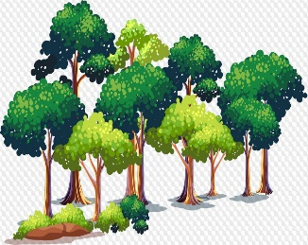

________________

________________

________________

________________

________________

________________

________________

________________

________________

________________

________________

________________

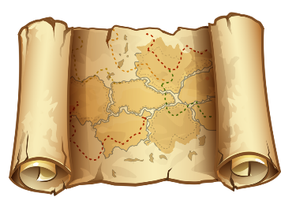

________________

________________

________________

________________

________________

________________

________________

_______________

________________

________________

________________

________________

________________

________________

________________

________________

________________

________________

________________

________________

________________

________________

________________

________________

________________________________________________

________________

________________

________________

________________________________

________________

________________________________________________

________________________________________________

________________________________________________

________________________________________________

________________________________________________

________________

________________

речи,

которая

часть

Самостоя

тельная



кот

***Москва***

город

***Мурзик***

Что?

________________

Кто?

________________

предмет

обозначает