Card 1 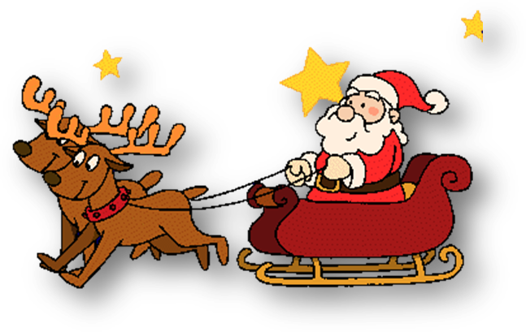
Unfreeze the letter:
M*, n*, n*me, n*ne, tr*, st*dent
P*pil, f*ve, g*, h*, t*ke, fl*
L*ke, sh*, fl*, c*ke, st*dent, p*pil
N*ne, n*se, fl*, sn*ke, p*pil, b*
F*ne, st*dent, st*ne, d*y, tr*, w*.
Card 2
Unfreeze the letter:
M*, n*, n*me, n*ne, tr*, st*dent
P*pil, f*ve, g*, h*, t*ke, fl*
L*ke, sh*, fl*, c*ke, st*dent, p*pil
N*ne, n*se, fl*, sn*ke, p*pil, b*
F*ne, st*dent, st*ne, d*y, tr*, w*.
Card 3
Match the letters with their sounds:
Aa [ai]
Ii [ǝu]
Ee [ei]
Oo [ai]
Uu [i:]
Yy [ju:]

Card 4
Match the letters with their sounds:
Yy [ju:]
Aa [ai]
Ii [ǝu]
Oo [ai]
Uu [i:]
Ee [ei]

