Modular Test 3

1. Fill in missing letters:



1. ****Colour and sign these products:

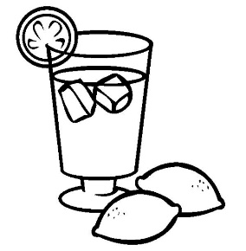

___________________ ________________________



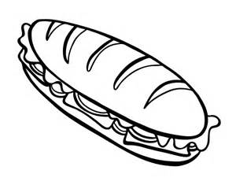

______________________ _______________________________

1. Answer the questions:
2. What is your favourite food?

_____________________________________________________________

1. What is your favourite drink?

_____________________________________________________________

1. Read and choose the correct word:
2. I have got **some / any** bananas.
3. We haven’t got **some / any** milk.
4. Have you got **some / any** eggs?
5. She hasn’t got **some / any** meat.
6. Can I have **some / any** water, please?

Список литературы:

1. Students Book Spotlight 3. Н.И. Быкова, Дж.Дули, М.Д. Поспелова, В.Эванс.
2. Test booklet Spotlight 3. Н.И. Быкова, Дж.Дули, М.Д. Поспелова, В.Эванс.