|  |  |  |  |  |  |  |
| --- | --- | --- | --- | --- | --- | --- |
|  | |  |  |  |  |  | | --- | --- | --- | --- | --- | |  |  |  |  |  | |
|  | |  |  |  |  |  | | --- | --- | --- | --- | --- | |  |  |  |  |  | |
|  | |  |  |  |  |  | | --- | --- | --- | --- | --- | |  |  |  |  |  | |
|  | |  |  |  |  |  | | --- | --- | --- | --- | --- | |  |  |  |  |  | |

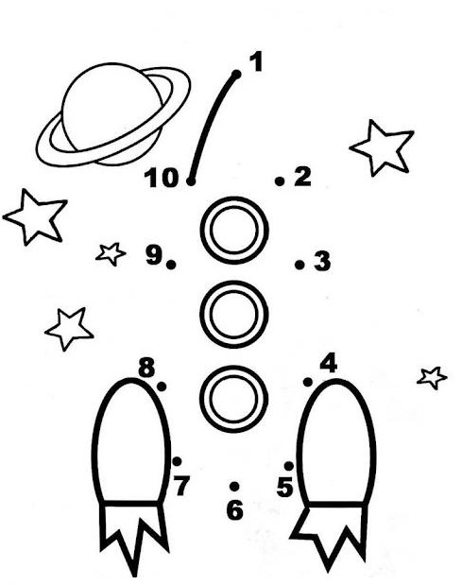

|  |  |
| --- | --- |
| **1** | **2** |
| **2** | **1** |

|  |  |
| --- | --- |
| **6** | **1** |
| **5** | **2** |
| **4** | **3** |

|  |  |
| --- | --- |
| **5** | **1** |
| **4** | **2** |
| **3** | **3** |



|  |
| --- |
| **2 5** |
| **7 4** |
| **7 7** |
| **8 4** |
| **3 9** |

|  |  |
| --- | --- |
| **7** | **1** |
| **6** | **2** |
| **5** | **3** |
| **4** | **4** |

|  |  |
| --- | --- |
| **4** | **1** |
| **3** | **2** |