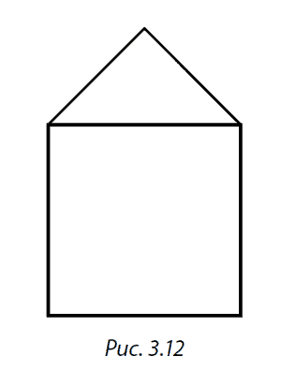









|  |  |  |
| --- | --- | --- |
| C:\Users\semch\Desktop\5ка.jpg | C:\Users\semch\Desktop\5ка.jpg | C:\Users\semch\Desktop\5ка.jpg |
| C:\Users\semch\Desktop\5ка.jpg | C:\Users\semch\Desktop\5ка.jpg | C:\Users\semch\Desktop\5ка.jpg |
| C:\Users\semch\Desktop\5ка.jpg | C:\Users\semch\Desktop\5ка.jpg | C:\Users\semch\Desktop\5ка.jpg |



**0**

**7**

**8**

