Приложение 1
https://docs.google.com/forms/d/e/1FAIpQLScKWhGAVteOeb8_TGzshIdxrDnjmsQSeWkrdDE7rbg-P6r8JA/viewform?usp=sharing

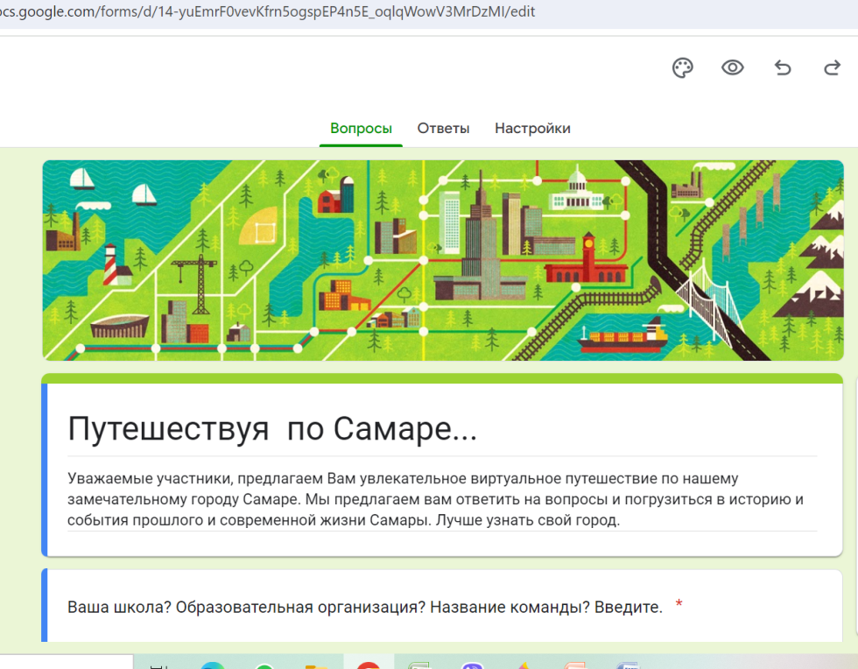
Приложение 2
https://docs.google.com/forms/d/e/1FAIpQLSecdMSKKuorZtU4og67qFhhK9YctNJfebSRoRylVd24vfRBuQ/viewform?usp=sharing

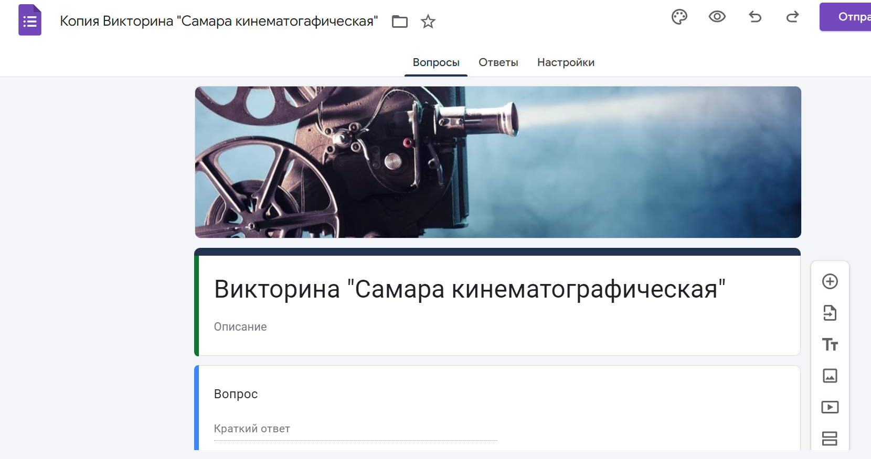

Приложение 3
