Предисловие
Данная книга состоит из небольшого рассказа, заданий и правил. Надеемся, что книга поможет при изучении английского языка всем, кто его изучает.
Все иллюстрации можно раскрасить и дополнить.

Once upon a time in the office
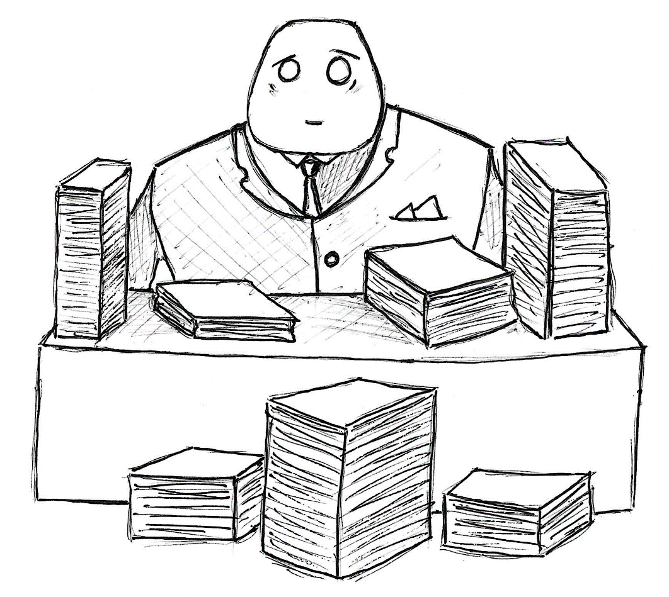

- Who is this man?
- Does he like his job?
- What do you think about paper?
Middle-aged man is sitting in the office and sorting papers. Sorting papers – skill, as he gets in the university. He is so lucky, because a lot of people have not got any special skills. University is very important, and people talk about it every time. 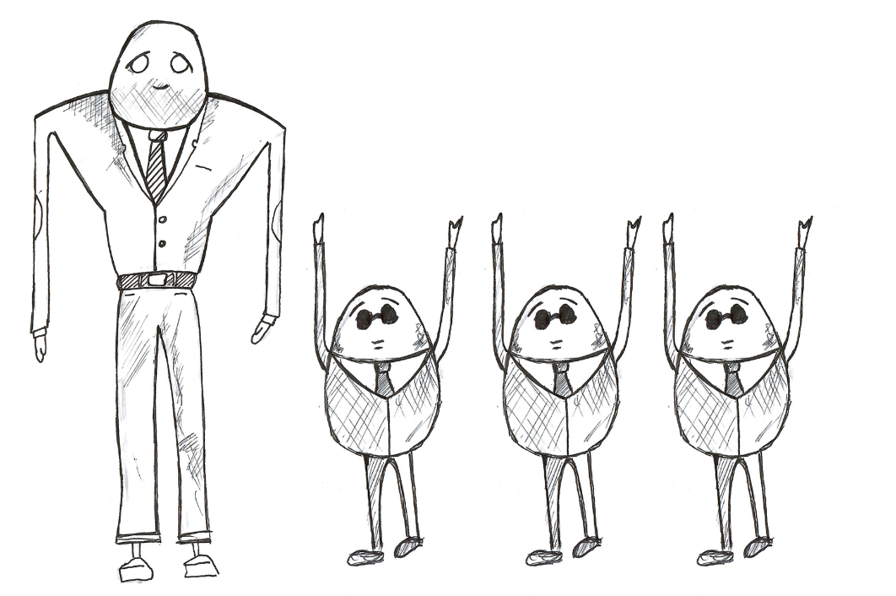
University such as school, but is bigger and more difficult. Mostly people like University more, than school. In school, people study all kinds of science, but in University people study special sciences and professions. Some people study medicine to be a doctor. Some people study pedagogy to be a teacher. Some people study paper to be an office man.
His job isn’t difficult, but, sometimes it’s very boring. He wants to be a doctor or firefighter, but he is an office man. The man has a lot of money, more than a doctor or firefighter.
When the man works, he has a lot of time to think. He thinks about his life, childhood, parents, neighbors, home, food, drinks, job at last. But, he forgets every thought when worktime is over. And he starts thinking about all minds on the next working day.
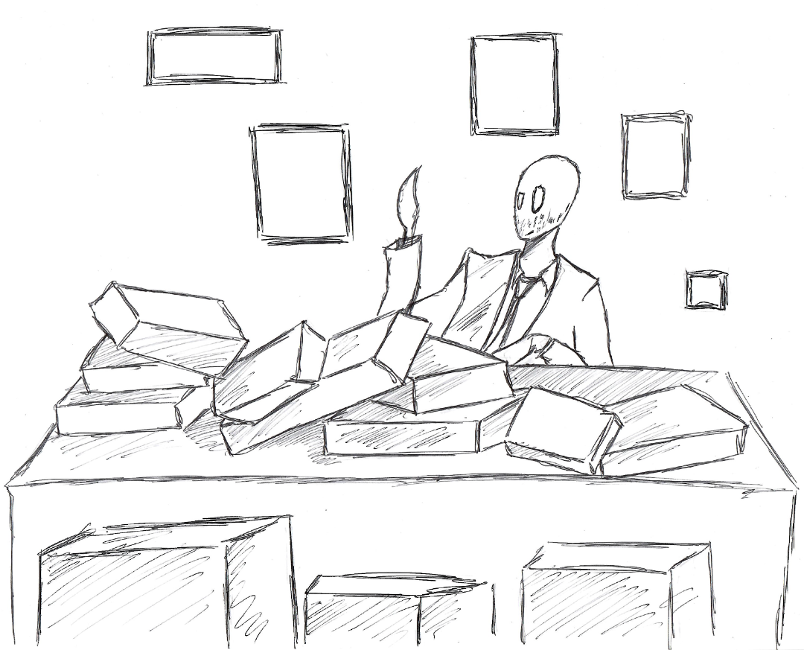Now, the man is thinking about papers. Papers may be green, orange, red, blue, brown, white. His job is very important, because he must be sorting papers by colors. After that, special men take papers away. Different special men bring him colorful papers. Different special men called deliverymen. Office men always think they are better than deliverymen, but it isn’t true.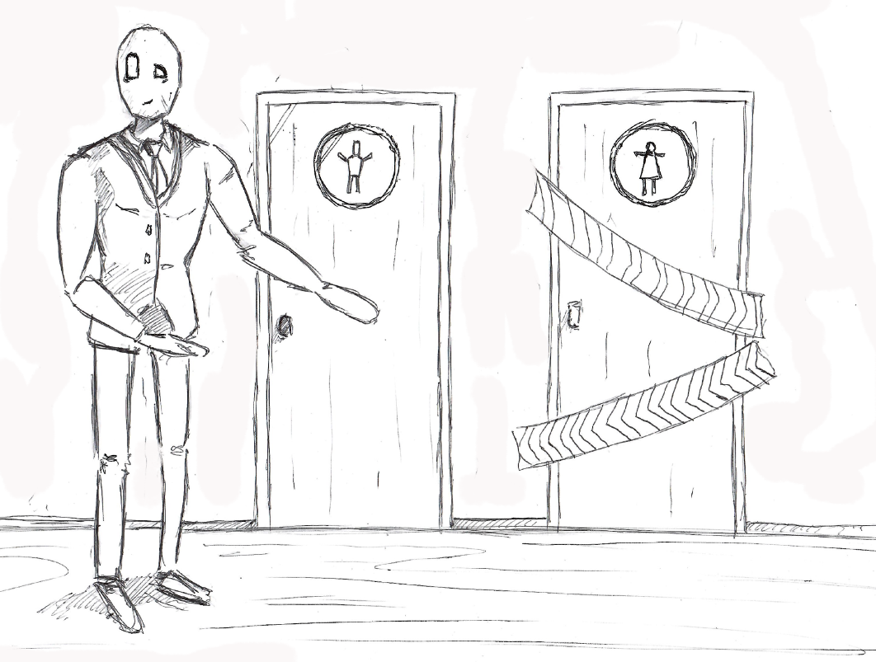
Only men work in this industry. It is traditions. The man doesn’t think about traditions, but, women, for his opinion, can do some job responsibilities better. A lot of men think the same, but master can’t hire women. If master does it, he won’t be a master. 5 years ago, old master hired woman for this job, but she worked better and some men were sad.
Day by day, the man works with colorful papers. He has two days in a week for rest. The man works from nine o’clock am to six o’clock pm. He has time for lunch at twelve o’clock. The man and other men eat tea and f-bread.
Men like bread so much, but some big people, bigger than other, make a law. Factories can’t cook bread, it’s a low. People can cook bread for themselves or their friends, but not for sale. F-bread it is like traditional bread, but with taste of meat, vegetables and sugar. Some f-bread has taste of pepper and milk. It is universal food for mostly people.
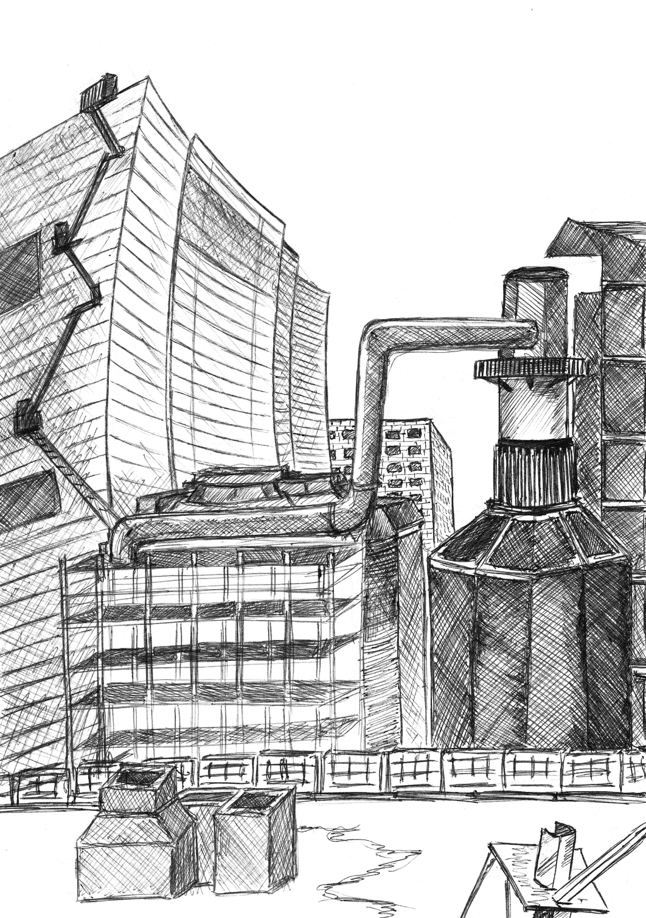
Some years ago, resources ended for the most people on the planet. Also, some industries, like agriculture, were in decay. One clever man, mostly clever than other, created new technology. This technology can make all kinds of products from one product – soy. It is not tasty, but a lot of people are not hungry.
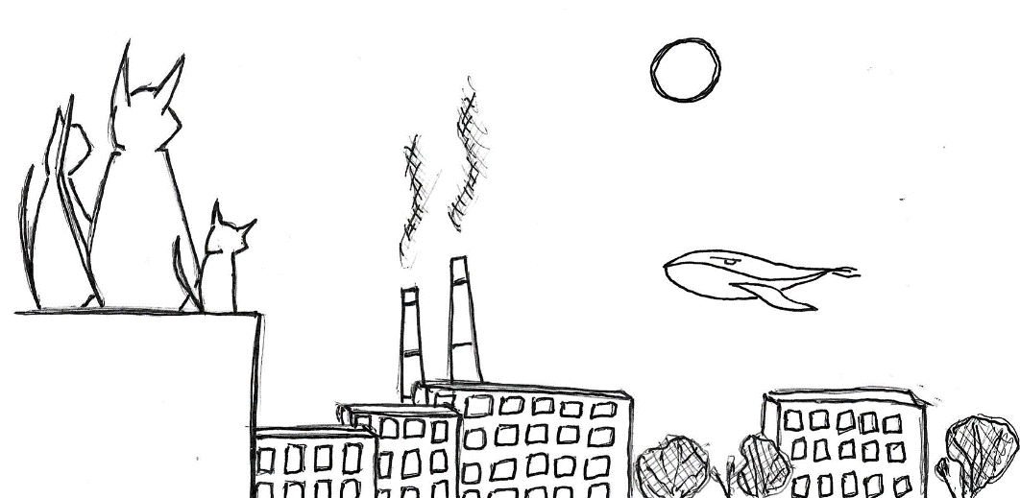
After this finding, most resources are restored. But, some industries disappeared too. Big companies don’t create a new products or grow something. Only one company makes food from soy for citizens. In the countryside, people make food and grow traditionally. Sometimes, they sell it in the cities, but a lot of people are not interested in. Also, the law created a long time ago, and most people forgot any information about cooking bread.

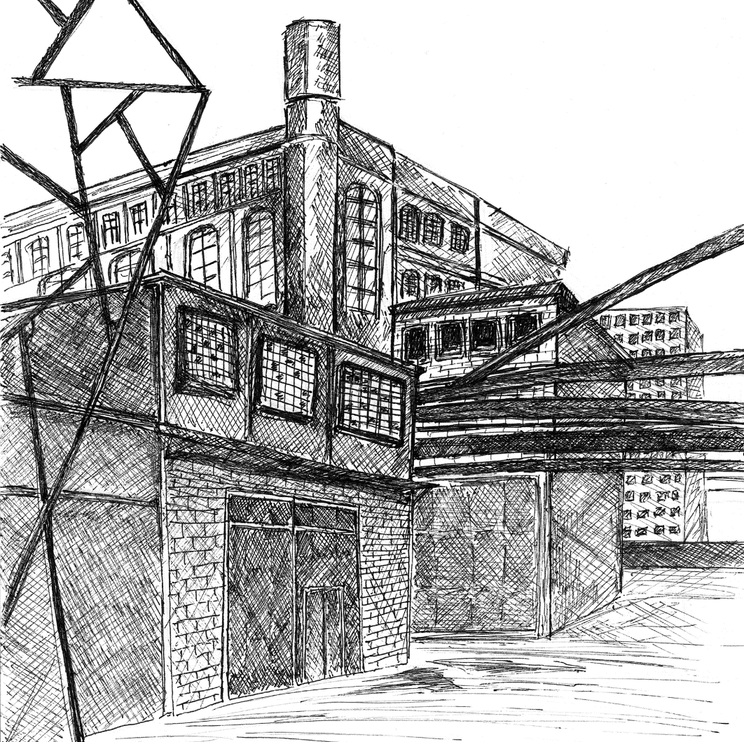
Today is a special day, because the man completes his papers early. All men complete early. If one man complete early, he must wait for all men. If all man complete early, they go home.
Now, all men and our man are going to go home. They are talking about their stuffs, especially about trees. All people in this city like talking about trees. And they don’t know why.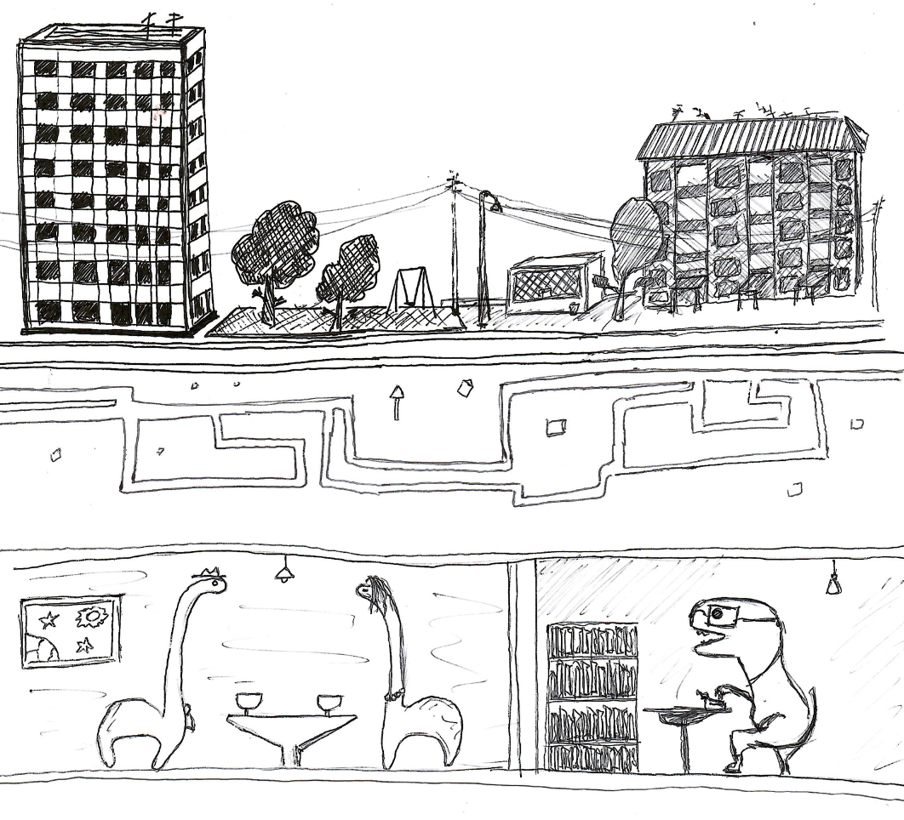

Exercise 1.
Say true or false:
- Papers may be only white.
- Man works in laboratory.
- Master can hire women.
- F-bread is a real bread.
- People can cook bread for yourself or their friends, but not for sale.

A long way home
- What kind of public transport does he prefer?
- Why is he not going home?
- Does he read often?
After work, the man is waiting for his tram on tram stop. His colleges usually go home by car, train or bus, but man likes only trams, especially red trams.
Red trams are faster. He knows, it is not true, but he likes this thinks. If he can, he buys personally tram. But he can’t. Only government can have trams. 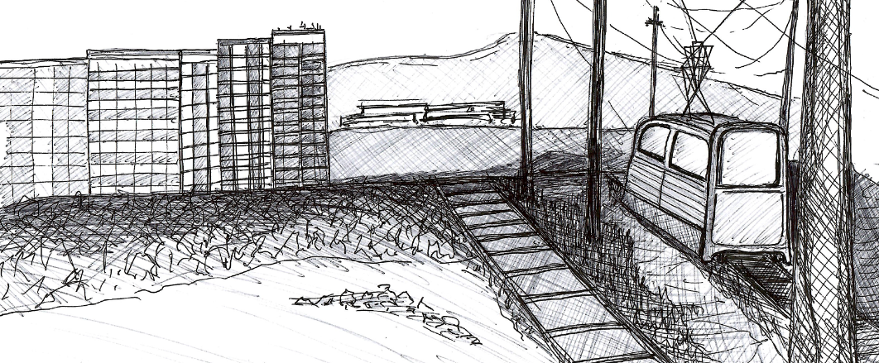
In the tram, the man is looking on streets and buildings. 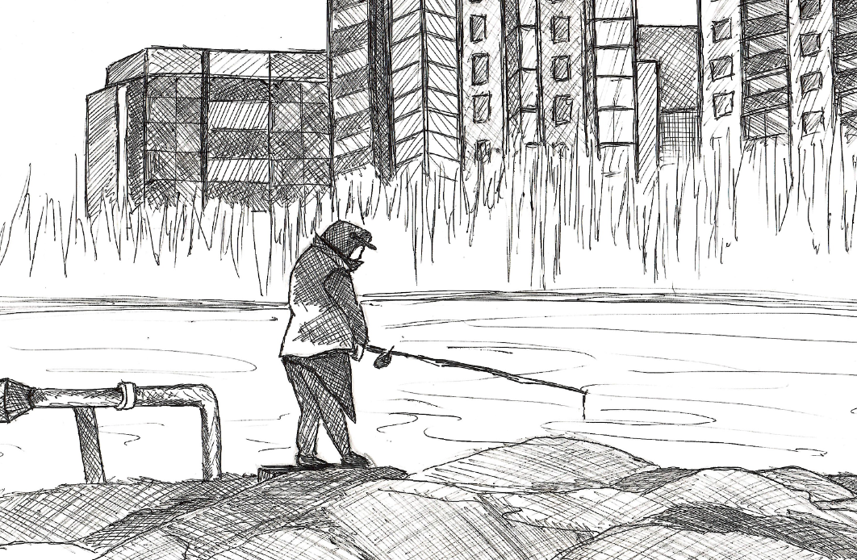
Usually, he is so tired, and doesn’t think about them. But now, he is not tired. He thinks about buildings, their color.
Some buildings are used for living. Some buildings are used for factories. Some buildings are used for offices. Some buildings are used for government needs. But, he doesn’t know why people use some buildings. 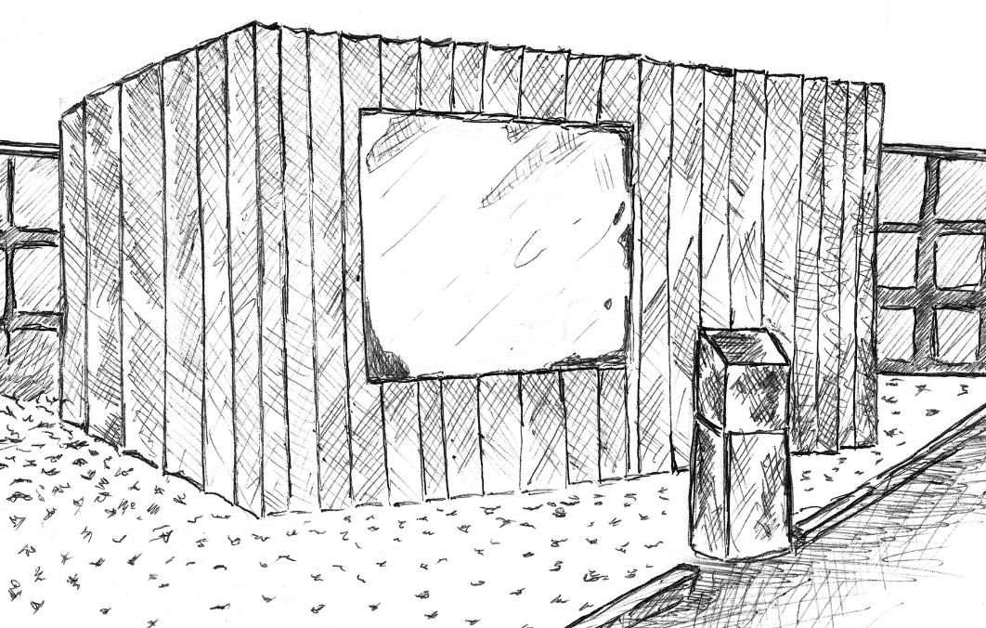
Today, he is getting out from the tram, and going to this nobody needs building. This building called Library. It is a very quiet, peaceful and interesting place. Man’s meeting a library worker. She was so happy to see him. Here, man recognizes, that library is home for books.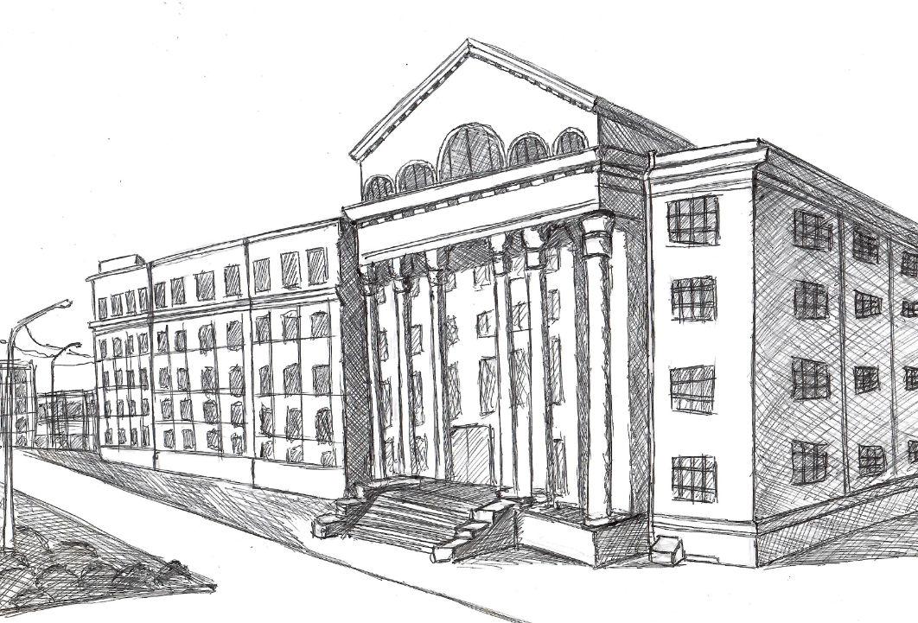
Books are like a paper, but in paper houses. A long time ago, people liked reading books. But now people don’t read anymore, they like working and traditions. It is not necessary to read books. All information for living, people get from old people or instruction. Also, they have been knowing information from schools, universities, newspapers, jobs.
The woman, who called librarian, asked the man a simple question, ‘Are you going to read books?’ the man thinks about it. He chooses the book about bread, because he likes bread, and he can tell it in office. Of course, he likes a lot of things, but he doesn’t know anything about bread. He must go back home.
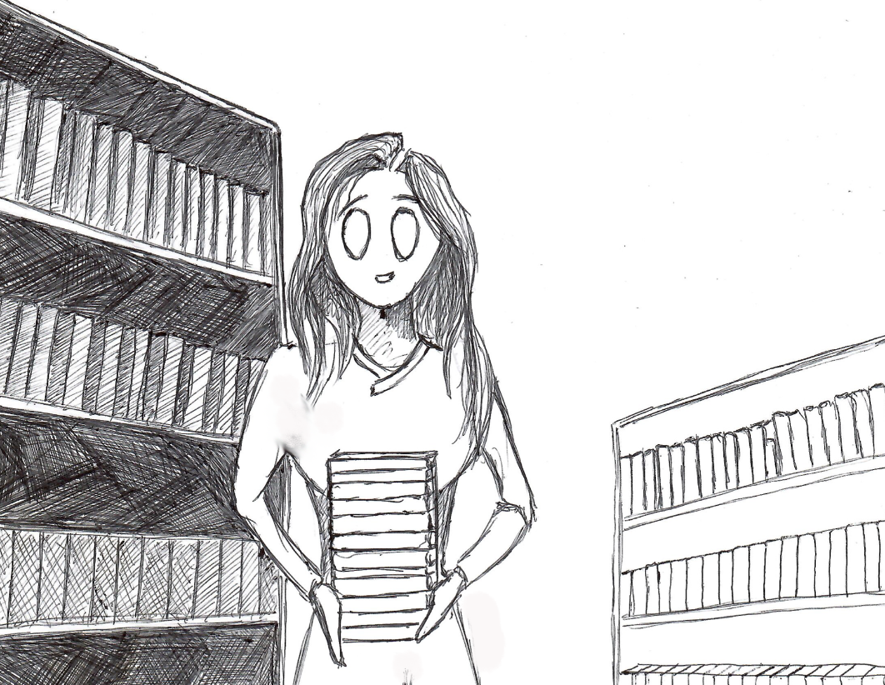
His journey is not long, maybe 2-4 bus station’s. Man must buy some products. There is a supermarket, near his home.
In the supermarket, he can buy some different things. He is buying some f-bread, some f-milk, some f-meat. 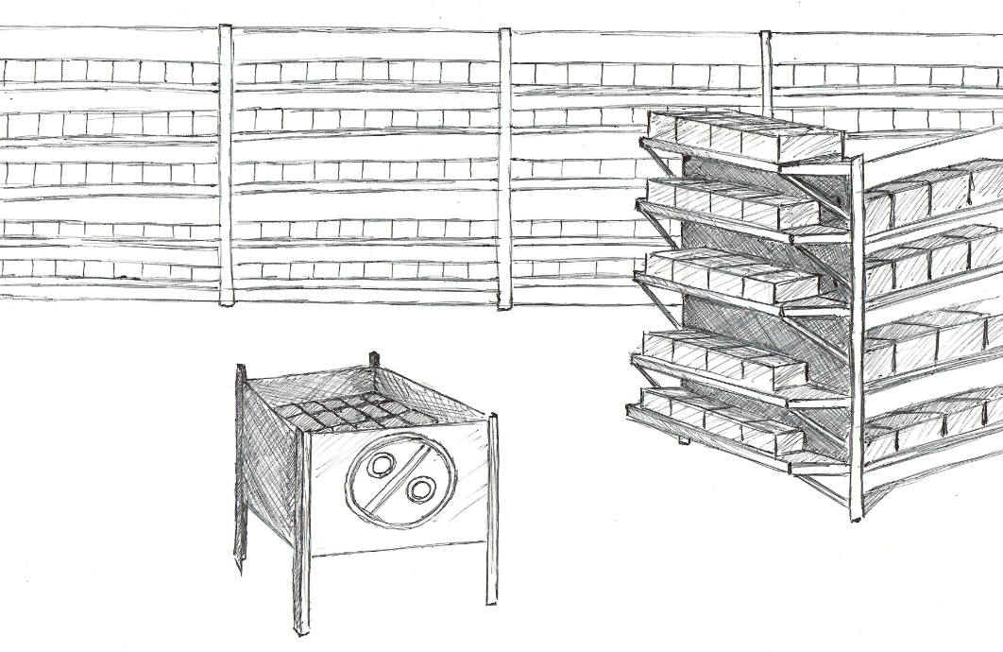Natural products he can’t find in the supermarket.

Exercise 2.
Open the breakers.
- There __ (to be) a supermarket, near his home.
- He ________ (to choose) the book about bread.
- The man _______ (to meet) a library worker.
- Some f-bread _____ (to have) pepper and milk tasty.
- Some buildings ___ (to be) used for living.
- He ____ (to like) a lot of things.

Немного полезных правил употребления артиклей
В английском языке перед существительными ставят артикли. Всего у нас есть три артикля: a\an the zero.
- a (ставим перед словом, чья первая буква согласная)
- an (ставим перед словом, чья первая буква гласная)
Мы используем эти артикли только с существительными в единственном числе, которые мы можем посчитать. Когда мы ставим a\an:
- It is a car (Это (какая то каких много) машина) - Говорим о чем-то общем;
- Give me a cup of tea, please (Дайте (одну) чашку чая, пожалуйста) - Говорим о чем-то, подчеркивая единственное число;
- This is a note. The note is red (Это записка. Записка (уже конкретно) красная) - Слово в тексте встречается впервые;
- I want to be a doctor (Я хочу быть доктором) - Профессии.
Артикль the мы можем поставить перед существительным в единственном и множественном числе, а также исчисляемым и не исчисляемым. Когда мы его ставим:
- It is the Moon (Это (единственная в мире) луна) - Когда говорим о чем-то уникальном;
- This is a note. The note is red (Это записка. Записка (уже конкретно) красная) - Когда говорим о том, что ранее упоминали;
- Перед словами: same (такой же), whole (целый), right (правый), left (левый), wrong (неправильный), only (только), main (главный), last (последний), next (следующий), previous (предыдущий);
- Today is the first day (Сегодня первый день) - Перед порядковыми числительными;
- My mum is the best (Моя мама самая лучшая) - С прилагательными в превосходной степени;
- We are going to go to the cinema (Мы собираемся в кинотеатр (кино смотреть там будем)) - Перед словами, обозначающими место действия
Нулевой артикль (артикль которого нет) мы ставим (ничего мы не ставим) перед:
- I want some water (я хочу водички) - Неисчисляемыми существительными;
- These are some cats (тут есть кошки) - Исчисляемыми во множественном числе;
- Russia is the Russian Federation - Имена собственные, страны, чье название состоит из одного слова;
- Со словами: school, church, bed, hospital, college, university, court, prison, home
- Перед названиями видов спорта, игр (football), напитков (juice), блюд, языков (French), цветов (blue), болезней (flu), городов, улиц, парков (Times Square), любых заведений, которые содержат имя (Teddy’s Bar).
Попробуем закрепить:
- This is __ garden. In __ the garden we grow __ flowers. We like __ flowers so much.
- We must go to __ hospital.
- We are living in __ America. America is in __ United States of America.

Better place for living
- Is his family big?
- Does girl usually help her father?
- What does cat usually do?
The man lives in old building. Most buildings in the city was old. Most governments buildings were older that other buildings. New buildings were built in new areas or new cities, but man live in older part of city, then others. There are 25 streets. The man lives on baker’s street. Mostly streets named of old heroes, but no one knows why his streets called baker’s street. Also, there aren’t any bakers.
The man cannot read a book, because he has got some deals. He must give food for his daughter and his cat. The man has been living with cat and daughter for a long time. They have not got a mother. It is difficult for them, but they have been trying to make a good family.
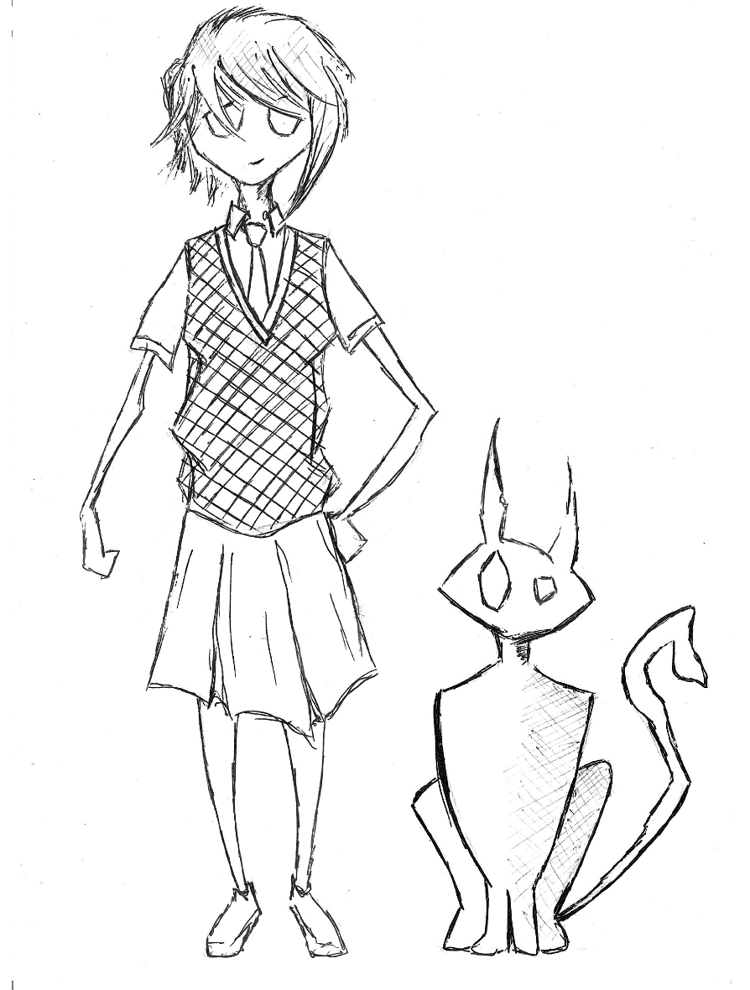
His daughter is a good girl. She is a pupil. She goes to school and has only good marks.
After suffer, they are cleaning their flat and sitting in girl’s room. Everyone is interested in the book, and the man is reading for them. The girl and the cat have their toys and a TV-set. The man has his armchair. Usually they use their things every evening. But, they haven’t any books, only boring student books.
The book was interesting, but it was so boring only to read it. The girl asked the man, ‘Can they cook some bread from the book?’ He thinks and says, “It can be interesting, but today is late”. They are going to sleep. 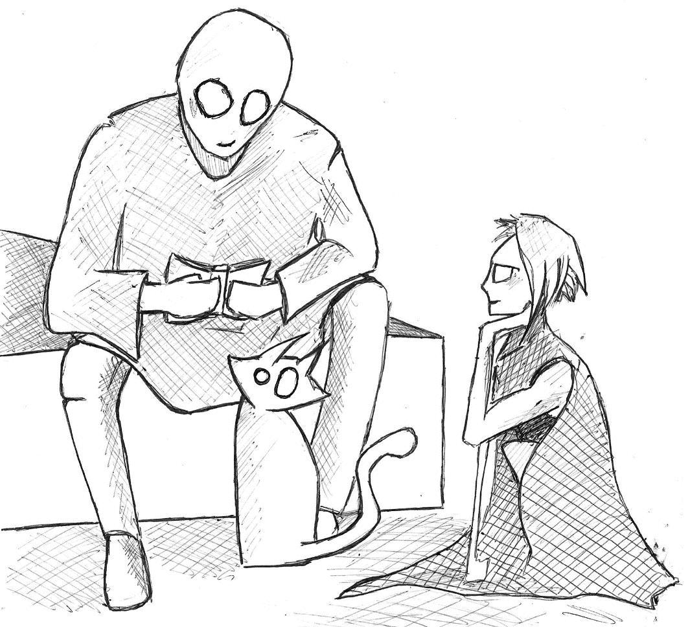
There are three rooms, a kitchen and a bathroom in their flat. It is a good place for living. The man tried to sell this flat and bought the flat, which would be better and bigger in more comfortable area, but girl did not allow it. This place has been remembered about her mum, who can’t live with them.
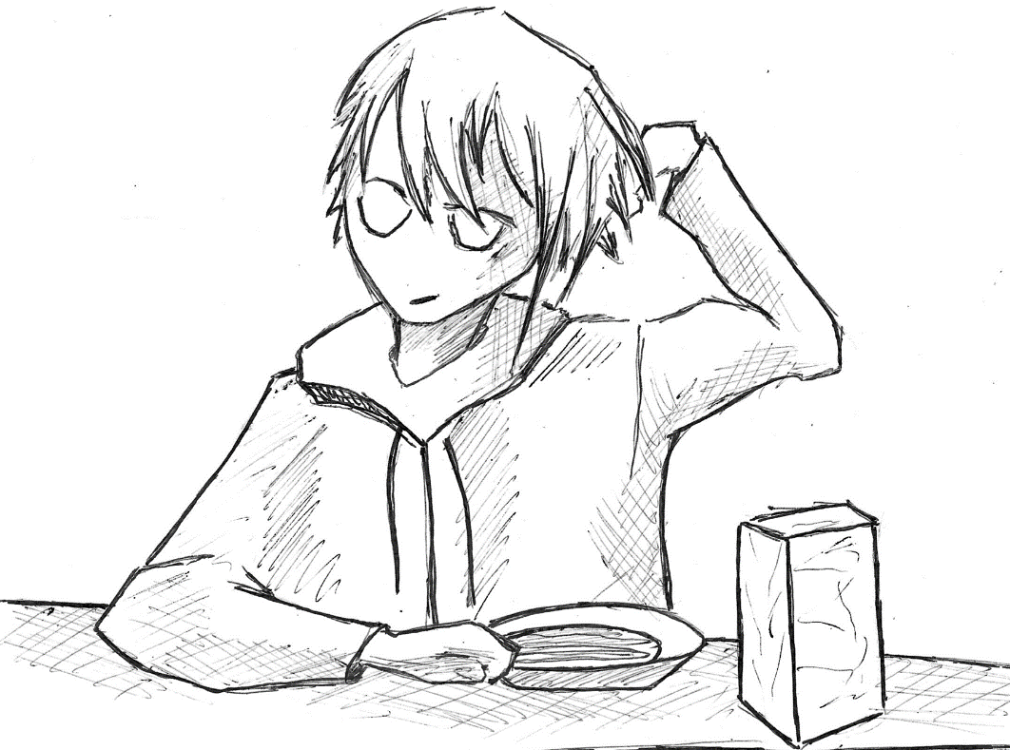The girl goes to school every weekday. She likes studding, but some subjects are boring. Some subjects are interesting. She likes Art, History, PE, Math. She is going to be a doctor, or an astronaut. She doesn’t know exactly. Girl can’t be an office man like her dad, because it is only for men.
But now, she tries to help his father, because children must help their parents, and parents must help their children.
The cat doesn’t go anywhere. He likes eating and sleeping. Also, he likes watching to whales. He doesn’t understand, why cats can’t fly, but whales can fly. Some cats talk that whales could swim in the oceans, but now the oceans are disappeared. Whales started flying. Now, they are flying and sleeping on the fields. People like watching on whales, but cats like watching more.

Exercise 3.
Find all missing words.
- Man ____ on baker’s street.
- He must ___ food for his daughter and his ___.
- There are _____ rooms, kitchen and _______ in their flat.
- The ___ doesn’t go anywhere.
- Some cats ____ that whales could swim in the oceans, but now ______ are disappeared.
Немного полезных правил tenses
Английский язык отличается от русского языка (не может быть). Так, в английском языке нет окончаний (ну ничего себе). Но как-то надо определять время в предложении и добавлять разные смыслы. Для этого в английском языке есть tenses. Это такие «времена». Рассмотрим их коротко:
Present Simple – действие происходит регулярно; говорим о мыслях чувствах и эмоциях.
- I think about cats. Я думаю (мысли/чувства/эмоции) о котах. Глагол не изменяется.
- He thinks about cats. Он думает (мысли/чувства/эмоции) о котах. Глагол изменяется в 3м лице (he/she/it) в утвердительных предложениях. Добавляем -s (-es).
- We have lunch every day. Мы обедаем каждый день (регулярно).
- Do you have lunch? В вопросах ставим вспомогательный глагол do перед подлежащим для 1 и 2 лица (I, We, You, They). Yes, I do. No, I don’t.
- Does he go to school? В вопросах ставим вспомогательный глагол does перед подлежащим для 3 лица (He/She/It). Yes, he does. No, he doesn’t.
- I don’t go to school. В отрицательных предложениях ставим между подлежащим и глаголом don’t (я не хожу в школу).
- She doesn’t go to school. В отрицательных предложениях ставим между подлежащим и глаголом doesn’t (она не ходит в школу).
Past Simple – действие произошло в прошлом, не в конкретный момент, оно закончилось.
- I played a game about cats last week. Я играл в игру о котах на прошлой неделе. Глагол, если он правильный, получает в конце слова –ed.
- He bought a game about cats. Он купил игру о котах (когда-то там). Глагол изменяется в соответствии с таблицей неправильных глаголов.
- Did you have lunch? В вопросах ставим вспомогательный глагол did. Сам глагол не изменяется. Yes, I did. No, I didn’t.
- I didn’t go to school. В отрицательных предложениях ставим между подлежащим и глаголом didn’t (я не ходил в школу).
Future Simple – действие произойдет в будущем, в неопределенный момент.
- I will play a game about cats next week. Я буду играть в игру о котах на следующей неделе. Глагол не изменяется.
- Will you have lunch? В вопросах ставим вспомогательный глагол will. Сам глагол не изменяется. Yes, I will. No, I won’t.
- I won’t go to school. В отрицательных предложениях ставим между подлежащим и глаголом won’t (я не буду ходить в школу).
Present Continuous – действие происходит сейчас (в период настоящего времени).
- I am playing a game about cats last week. You (We/They) are playing. He (She/It) is playing. Добавляем глагол to be в нужной форме (в зависимости от лица) и к глаголу –ing.
- Are you (we/they) having lunch? Is he (she/it) having lunch? В вопросах ставим вспомогательный глагол перед подлежащим. Все остальное сохраняется. Yes, I am. No, I am not. Краткий ответ зависит от лица.
- I am not going to school. You (we/they) aren’t going. He (she/it) isn’t going. В отрицательных предложениях ставим между подлежащим и глаголом вспомогательный глагол am/is/are + not.
Past Continuous – действие происходит в конкретный момент в прошлом; длительное действие в прошлом прерывается коротким действием.
- I was playing a game about cats at half past four last Monday. You (We/They) were playing, when your mother came into the room. He (She/It) was playing a football, when rain started. Добавляем глагол to be в прошедшем времени в нужной форме (в зависимости от лица) и к глаголу –ing.
- Were you (we/they) having lunch? Was he (I/she/it) having lunch? В вопросах ставим вспомогательный глагол перед подлежащим. Все остальное сохраняется. Yes, I was. No, I wasn’t. Краткий ответ зависит от лица.
- I wasn’t going to school. You (we/they) weren’t going. He (she/it) wasn’t going. В отрицательных предложениях ставим между подлежащим и глаголом вспомогательный глагол was\were + not.
Future Continuous – действие точно будет происходить в будущем (запланировано).
- I will be playing a game about cats at quarter to six pm next week. Добавляем will be и к глаголу –ing.
- Will you be having lunch? В вопросах ставим will be перед подлежащим. Все остальное сохраняется. Yes, I will. No, I won’t.
- I won’t be going to school. В отрицательных предложениях ставим между подлежащим и глаголом won’t be.

Пока что достаточно.

New Hobby
- Could he find some ingredients in a supermarket?
- Did a master give him a rest?
- Did people eat his bread?
Five days ago, the man took the book from the library. Three days ago, the girl brought the book back, and started to take any different books.
Three days ago, man started to search some ingredients for bread from the book. The man and the girl decided to make natural bread from the book. The cat was happy about it.
Every day, after job man tried to search some ingredients. It was very difficult, because he couldn’t find it in a supermarket. Also, he wanted to find special cooker for it.
When he worked, he was thinking about bread. His master saw it, when he completed all papers for his and colleagues, because he tried to go back home early. Finally, he worked better and better, and his master gave him holidays for two weeks.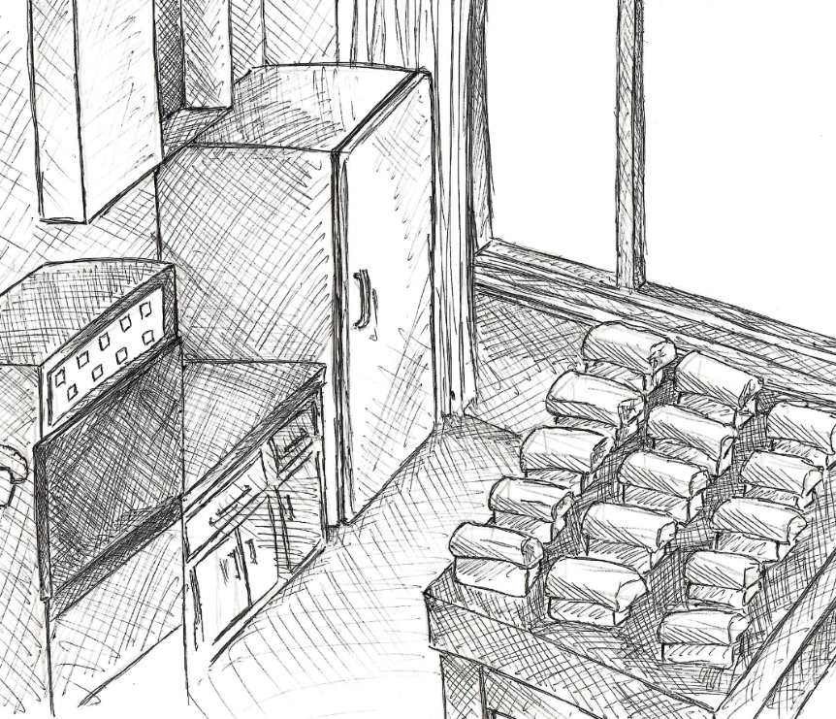
The man couldn’t find things, and he wanted to go to the market. The market is interesting, but illegal place. Some years ago, government banned markets, because they didn’t pay taxes. But, in his city was one. Here, the man could find a lot of interesting stuffs, also, he could find all ingredients and cooker.
First bread was created for one day. The man, the girl and the cat were trying so much. They liked it. Bread had a different taste such as f-bread. Bread was better. Bread was tasty. Bread was interesting. After first bread, they made some new bread, a lot of bread.
But, bread is tasty when it is fresh, and they couldn’t eat all bread. The girl contrived to give bread for neighbors and colleagues, like a present. All people like presents.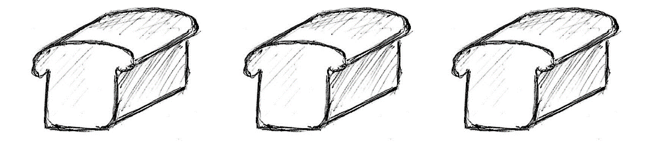
On next day, the man brought a lot of bread to his colleagues, the girl brought a lot of bread to her friends, the cat stayed at home. People were very happy, but some of them didn’t trust new meal. These people always have a bad expectation about something new in their life. But, some of them braver than other. They ate new bread and gave good recommendations. After it, more and more people decided to eat the new product.
The man and the girl don’t think about profit or something else. They are very kind. They like making some bread, eating it and giving it to other good people. All people, after eating, are very thankful.
Pigeons like bread so much.

Everybody wants to be my customer
After holidays, the man must come back to job. It was very important, because he needed money for his family.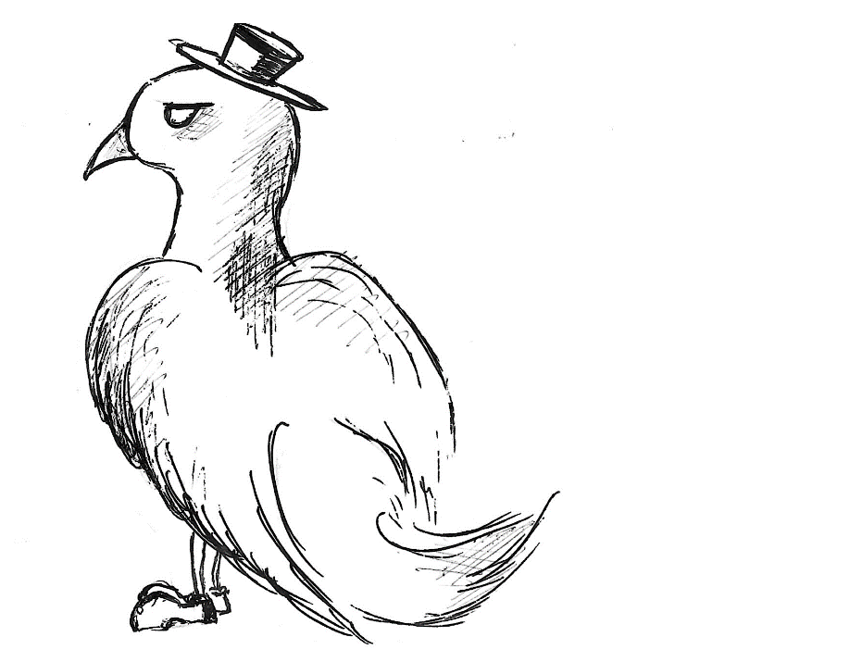
All people work anywhere and get money for it. Some people work hard, some more easily. But usually, people who work easily have more money.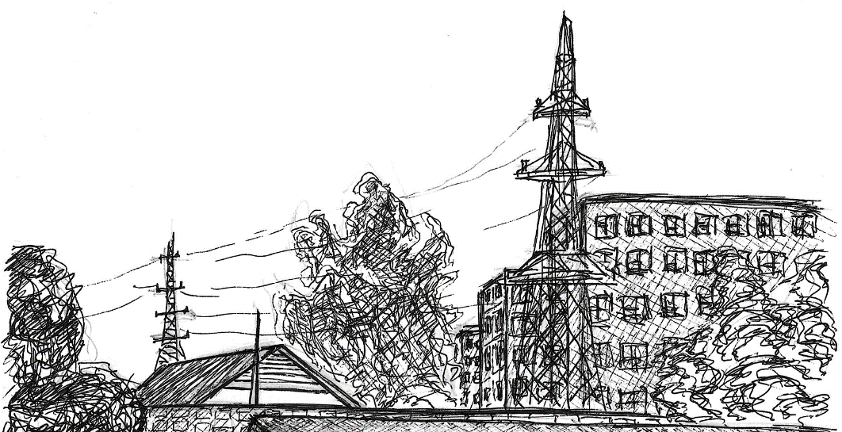
Rich people live in big buildings, work in governments organizations and they can be elected in votes because they have enough money for it. Also, they built some new rich big cities. There aren’t pure people, because all rest people have not got enough money to be rich. All pure people try to be rich people. Pure people can be elected in votes too, but it is more difficult. Anyone don’t know why, but it is some kind of tradition. 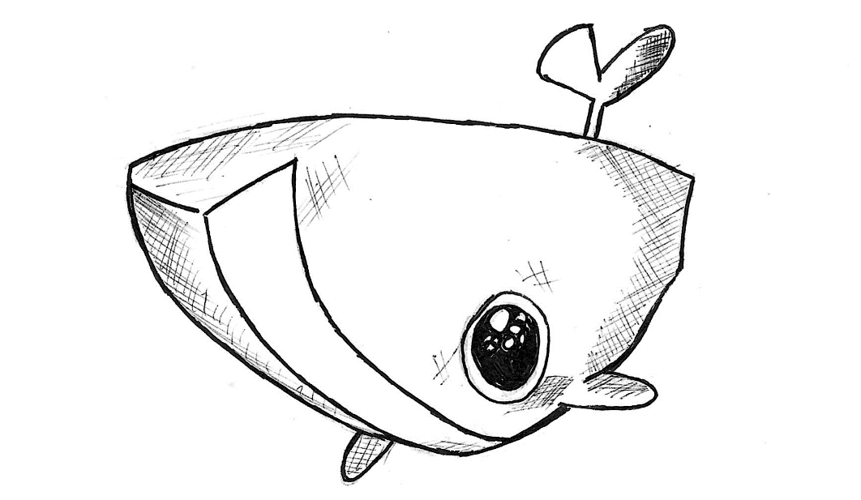
Money – difficult problem for most people in their city at least. A lot of people work all life, but they don’t like their job. Maybe they can do what they really like, but they have not got time to do it or they do not know how. The man is a very happy person, because he knows what he really likes, and he can do it with his daughter. But, he must come back to job.
The man doesn’t think, how important was his work for city. Right color papers are important for all organizations. And all organizations send some other color papers. And all papers mix. A lot of men try to work in this industry. It is important and easy. For all important and easy jobs employers must have got diploma from university.
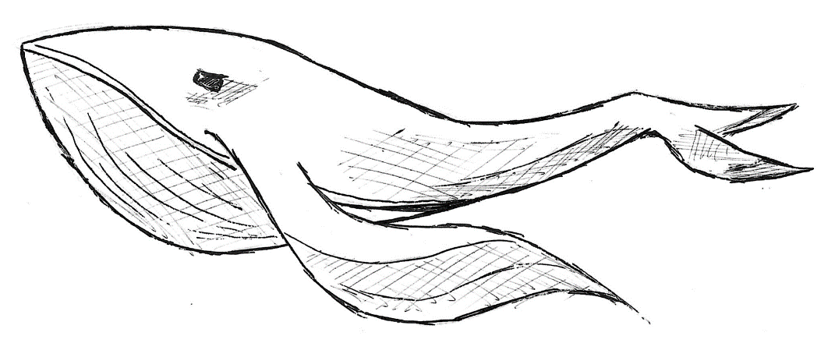
But, a new hobby was very important too. Papers are needed for the city, but, they don’t make people happy. Real bread was very tasty, and it made people happy. Maybe, it is more important. But not many people can make this happiness. This hobby makes man more unique than other men or women.
Colleagues and the master understand it, and they created a plan for man, how he could be happy, and made happy the other people in their city.
When the man came back to job, all men were happy to see him. They were meeting him with new man, who was younger, and he worked very well. This man worked for our man all time long.
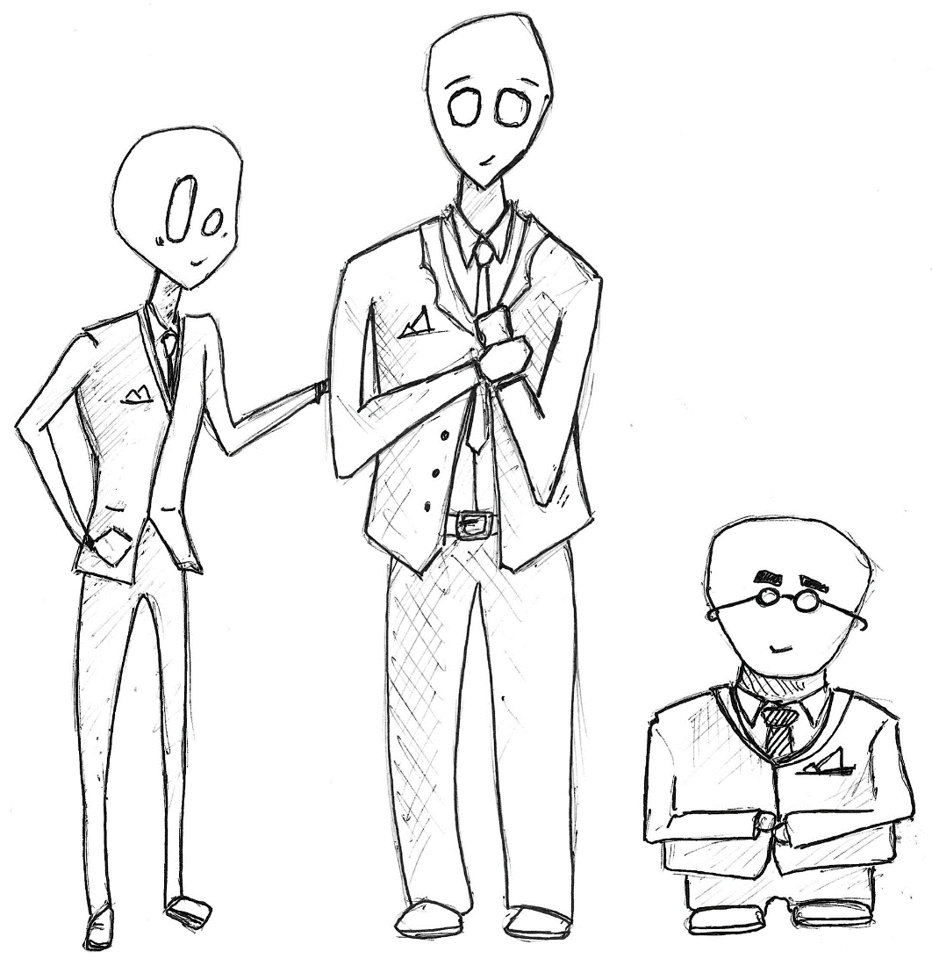
After it, the master was talking with our man about his future. He asked, what the man was really want. Man said, that he would be happy to spent more time with his daughter and to bring people happiness. The master understands, and gave man a pension.
Usually, only very old people can have pension, but, the man was very good worker and everyone agree with it. If you have a pension, you can do everything you need and have some money for living. The man agreed.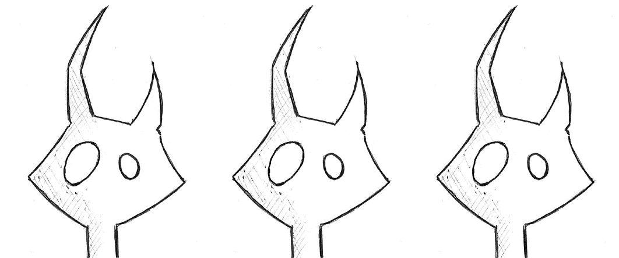

Exercise 4.
Find all mistakes.
- Every day, after library the man tried to search some ingredients.
- First kebab was created for one day.
- The cat contrived to give bread for neighbors and colleagues, like a present.
- Bright color papers no need for all organizations.
- This girl worked for our man all time long.
- The master understands, and sells man a pension.
- He asked, what woman was really want.

New life
- How do people in the city start calling the man?
- Does the cat help him?
- Do people like changing?
The man cannot make some bread and sell it, because it is illegal. But, man can make some bread and give it like a present.
On pension, the man makes some bread, and sends it to people like a present. The girl helps him after lessons. The cat helps him all the time. The man is very happy. People in the city are happy too, and send him and his family different presents.
It can be some socks, meal, juice, flowers, toys, fish, money.
And all people in the city started to call the man a Backer. He was a very important person in their city, and this hobby gave him a name. He was interested in something new, and he could find a way to bring people good food. Good food makes people happy.
The man has enough money and things. Most presents he with the girl gave poor people, who have not got anything. His system of presents could help a lot of people. Finally, one man could find the best way to live for all people, and cats.
The most people in their city live simple life. Sometimes, they change something in own life. They like changing, but not so much. People forgot, that they can do positive promises. Our man can do positive promises for all the city. People remember about themselves and another people, and help the man. After helping, they start changing their city another way. Soon, this city will be changed. But, it is a different story.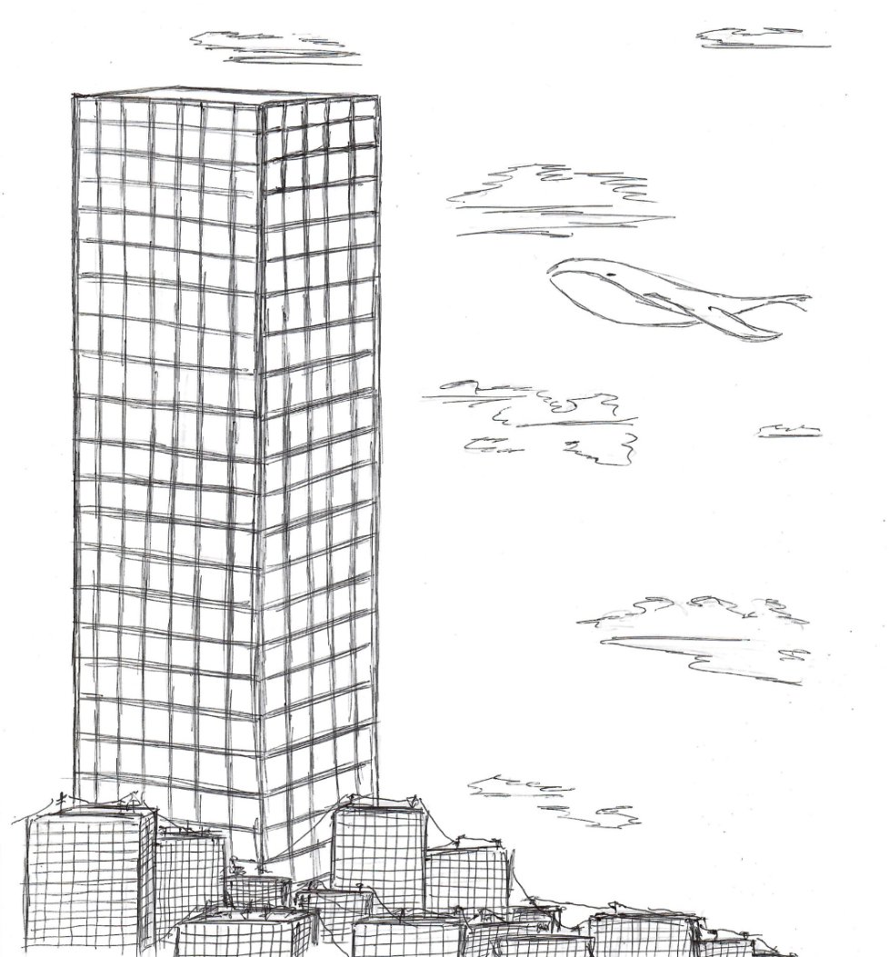

Exercise 5.
What will happen next? Write 7 sentences:
The baker will ______________________
The girl will ________________________
The cat will _________________________
Papers will _________________________
Whales will _________________________

Правила чтения
Правила чтения в английском языке зависят от многих факторов. Не стоит забывать о большом количестве исключений. Ниже представлена небольшая информация о том, как произносить английские звуки в соответствии с каждой буквой английского алфавита.
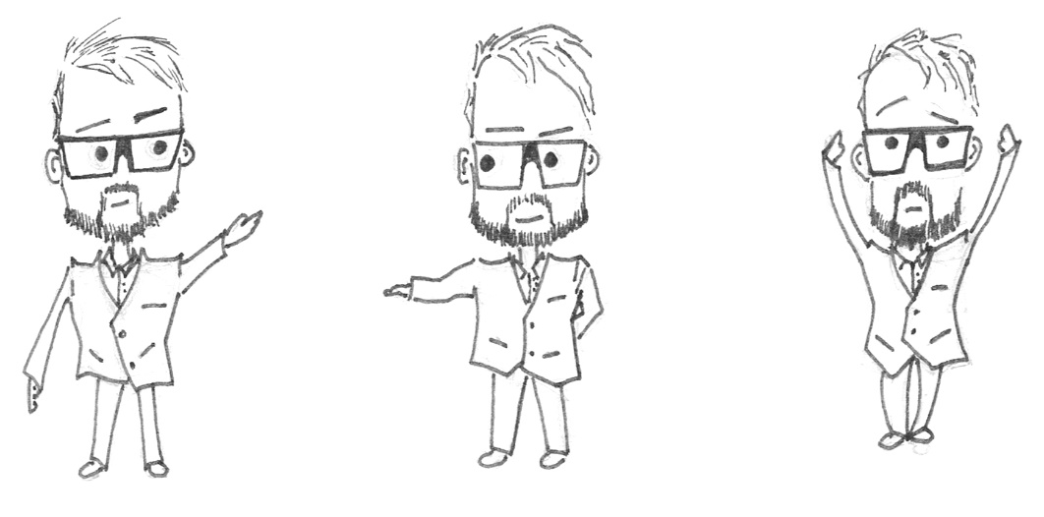

Аа
[эи] открытый слог: way.
[э] закрытый слог: man.
[эа] are, air, aer: fair.
[о] al, war, quar, au, aw: talk, ball, warm, towards, quarter, autumn, law.
[а] aff, aft, ant, ance, anch, ask, ar, ath: giraffe, after, plant, dance, chance, answer.
Bb
[б]: mobile, bring.
Сс
[к]: cat, car.
[с] после c стоит e, i, y: face, cycle.
[к] ck: clock, rock.
[ч] ch: chair, chicken.
[ш] ch: machine.
[ш] после буквы стоят ion, ial, ean, ian, ient: social, ocean.
Dd
[д]: red, leader.
[т] ed, слово заканчивается на глухой звук: watched.
Ее
[ии]: eat, please.
[и]: believe, ticket.
[и] ei, ey: foreign, hockey, money, monkey, journey
[э] er, ent, ence, ency: writer, student.
[иэ] era, eer, er: zero, clear.
[эи] ei, ey: weight, they.
[ю] eu, ew: new.
[у] eu, ew: blew, jewel.
Ff
[ф]: frog, sofa.
Gg
[г]: game, bag.
[дж] ge, gi, gy: age, page.
Hh
[х]: hello, he.
Ii
[аи] после идёт согласная, а потом гласная: like, surprise.
[аи]: pie, tie.
[и]: political, big.
[аиэ] ire, iar, ier, ir: fire, pirate.
Jj
[дж]: job, jacket.
Kk
[к]: book, speak.
[н] kn: know, knight.
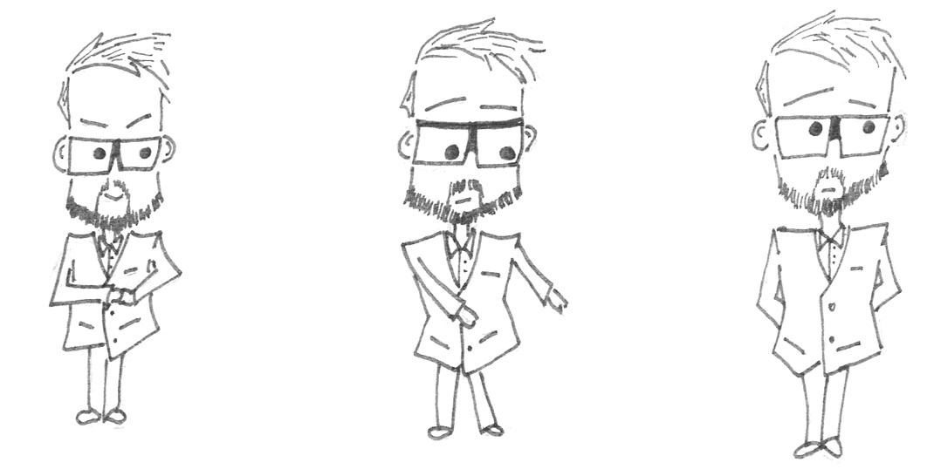
Ll
[л]: ball, twelve.
Mm
[м]: time, mother.
Nn
[н]: nice, orange.
Оо
[о]: doll, sorry.
[a] on, om: London, comfortable.
[y] оо: zoo, room.
[ои] oi, oy: noise, boy.
[ау] ou, ow: about, brown.
Pp
[п]: pan, please.
[ф] ph: phone.
Qq
[кв] qu: queen.
Rr
[р]: red, rose.
В основном не читается в словах.
Ss
[с]: ask, desk.
[з] после звонкой согласной: eggs, boys.
[ш] sh: she, wish.
Tt
[т]: city, water
[з] th: the, they.
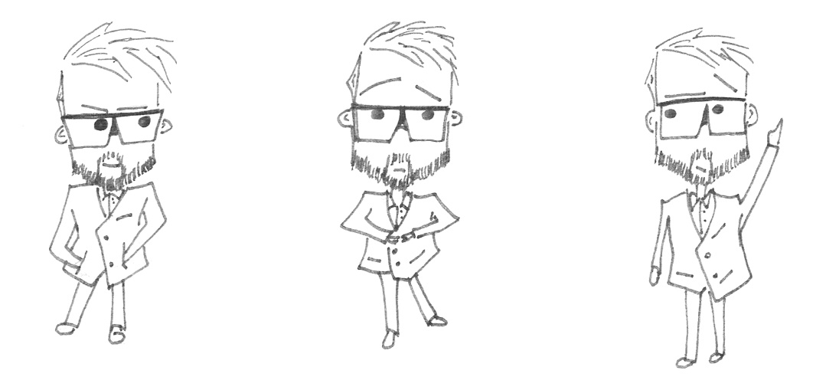
Uu
[ю]: usually, computer.
[у]: full, put.
Vv
[в]: give, very.
Ww
[уэ, что-то похожее]: why, where.
Xx
[кс]: box, six.
Yy
[аи]: my, sky.
Zz
[з]: zero.

