Самостоятельная работа для учащихся на материале книги для чтения "Jack and the beanstalk" ("Джек и бобовое дерево"), являющейся частью УМК Spotlight 5.

Автор: Хафизова Лейсан Саматовна

Name______________________

1. Do the crossword.



**2. Translate into English.**

1. Они очень бедные. _________________________________________

2. Он продает корову и покупает хлеб и молоко.

__________________________________________________________________________________

3. Великан живет в волшебной земле в большом замке.

__________________________________________________________________________________

4. У великана есть волшебная курица. Она несет золотые яйца.

__________________________________________________________________________________

**3. Complete the sentences.**

**Sleep, poor, lazy, scary, work, fairy tale, magic, golden**

“Jack and the Beanstalk” is an old English …………….. Jack Trott and his mother are very ………… Jack is a ……….. boy. He likes to …………. He doesn’t ..…………. The Giant lives in a .....................land. He is very.………… His favourite thing is a hen that lays ….....................eggs.

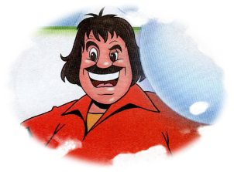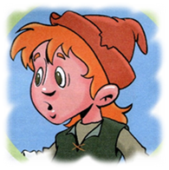

**4. Match the antonyms**

|  |  |
| --- | --- |
| 1. Rich____ | a. to buy |
| 1. Small____ | b. lose |
| 1. To start___ | c. poor |
| 1. Exciting___ | d. young |
| 1. Old___ | e. clever |
| 1. To sell___ | f. big |
| 1. Silly___ | g. boring |
| 1. Find___ | h. to finish |
| 1. Lazy___ | i. sad |
| 1. Happy___ | j. hard-working |

**5.** **Make the sentences negative (Use don’t V/doesn’t V).**

1. Jack helps his mother

_____________________________________

2. They live in a big city.

_____________________________________

3. The giant lives in a small castle.

_____________________________________

4. Jack and his mother buy a cow.

_____________________________________

**6. Label the pictures.**











*This is …… He is a …….. boy.*

*He is .…. and likes to ……..*

*He doesn’t ……. and help ………….*

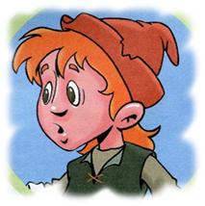

That is the …… He lives in ..............

He is very.………. and most of all likes to eat small ……..

His favourite thing is a hen that …....



Poor, fairy tale,

Jack and the Beanstalk is an old English …. Jack Trott and his mother are very ….