**Ребенок №1(newsreader):** News review from BBC World channel Kuybishev. Hello, I`m Valerya Zimina and I welcome to News review. (музыка)

Today we are going to talk about the most urgent ecological problems of the world. Ok, now let`s listen to the BBC news report. **Заставка-экологические данные со всего мира.**

And I`d like to present scientists from all around the world. (мордочки).So, Michel from the USA.

**Ребенок №2:** Many Americans are concerned about their ecology today. They are concerned about protecting the environment from pollution, overcrowding, and destruction of natural resources.

**Ребенок №1 (newsreader):** Thank you Michel. And how about Australia?

**Ребенок №3:** Hello**!** I`mVasilisa Tereshina, an ecologist. In Australia and New Zealand, we have seen a lot of dead fish and birds in the sea because a large oil tanker spilled tons of oil into the water. Nearly half of the lakes in our countries are polluted. Often, companies dump chemical wastes into water. But scientists are finding a solution to this problem.

**Ребенок №1 (newsreader):** Thank you Vasilisa.Advert`s on TV(реклама)

**Ученик идет по школе, двору школы, городу и подбирает за людьми, бросившими обертку, банку из- под колы, пластик**



**Ребенок №4 -** Don’t kill the world!- поднимает бумажку, появляется знак ,

а потом появляется красивая поделка из бумаги. И так делают все пять участников( взять поделки у Попенко)

**Ребенок №5** - Don’t let the Earth down!- поделка

**Ребенок №2**- Don’t destroy the ground!-поделка

**Ребенок №3** - Don’t kill the world!-поделка

**Ребенок №1** - Don’t let the Earth die! –поделка



**Все**- Help her to survive!

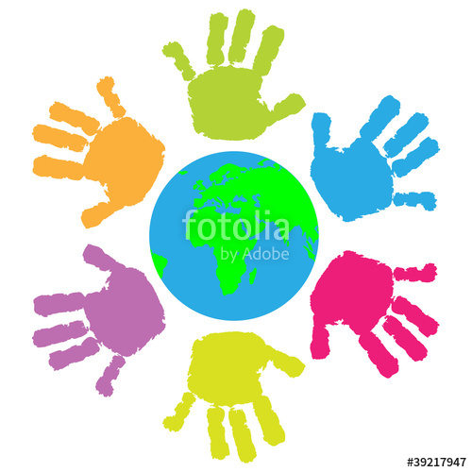

Don’t kill the world! ( все участники изображают руками планету, музыка «В мире животных»)

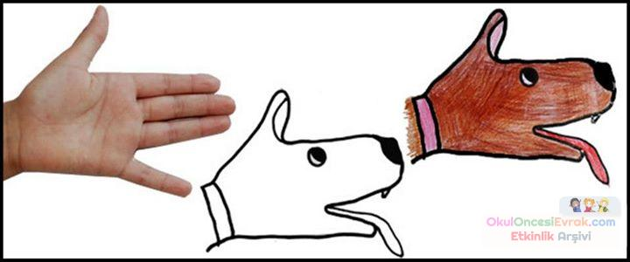

**Ребенок №1 (newsreader)** Hi again! We are at the BBC studio with news review from all over the world.



Let’s focus on our topic and try to answer the main question of our dicussion. The earth is in danger.

But who is to blame? Where does pollution come from? Who is the main litterer? Let`s great our partner from Canada**:**

**Ребенок №5**:( from Canada) ( на улице, в саду) Hello? I`m Anastasiya! Today we are speaking about a very urgent problem: environmental pollution and ecological catastrophe. We will look at what should be done to stop the pollution of our planet.

**Ребенок №4:** (идет по городу)Hi, dear friends! I`m Nataliya, Russia! Kuibyshev greats you! Nowdays people face with lots of different ecological problems. Certainly, the new advanced technologies give an opportunity for the development of science and another important things. But the big problem is really bad influence with these new technologies runs on our environment: water, atmosphere and even on our own health.( показать как дымит ГРЭС)

Most people think aboutthis problem and try to do something special for our planet. Let`s ask what teenagers think about it

**1 child** - ( в школе) -

**Ребенок №4**  -Hi

**1 child** -Oh, hi

**Ребенок №4**  -Can you tell me some words about pollution

**1 child** - Oh, Yes, of course.I think that environment is really important for us

-People unwillingly contaminate the environment

- We must care about nature and animals, we must care about green clubs, reduce pollution

-For example, I never throw trash on the ground. Also, I plant trees

**2 child** --As for me I plant flowers and make flower beds

-We must protect our planet

-Do not throw litter

-I think that what nature gives to us we have to give it twice( поливает цветы в школе)

**Ребенок №4**  -Hi, can I ask you some questions about pollution?

**3 child( где-то в городе)** (Зимина, жительница Куйбышева)

-Hello, of course. To begin with, I should say that the ecological situation in the world is so difficult and serious. The fact is that the water we drink and the air we breathe are polluted.We have many plants, factories which pollute the environment. Even ordinary people do harm the nature. For example, they pick up flowers, kill animals and birds, they throw litter everywhere. Fortunately, the governments of different countries think about this problem and they also try to find out the solution. I suppose if people see the problem , the situation with the environment will improve.

**Ребенок №4** - We are proud that young people are worried about ecological problems and together we will save our planet

**Ребенок №1 (newsreader) ( в студии снова) –**

**-BBC** News review

Thanks for your excellent work

and I wish us all success in preserving our nature

and keeping our planet clean. Do your best! Good bye, see you!

Финальные плакаты