CLIL – RED AND GREEN CIRCLES
CLIL is an abbreviation for Content and Language Integrated Learning. It is a way of teaching where subject content, e.g. history, geography, physics, etc. are taught in another language (often English).
CLIL is a dual focused educational approach in which an additional language is used for the learning and teaching of both content and language. That is, in the teaching and learning process, there is a focus not only on content, and not only on language. Each is intrewoven even if the emphasis is greater on one or the other at a given time.
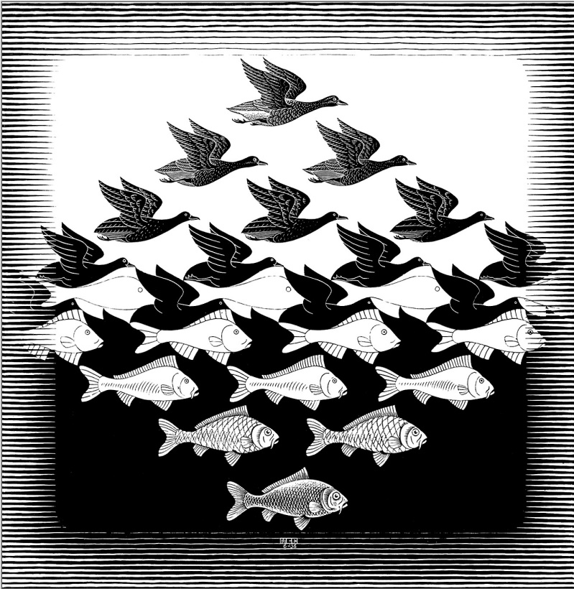
M.C. Escher’s famous wood cut print entitled Sky and Water I (1938) offers and excellent pictorial representation of this idea of interwovenness that characterises the CLIL approach. In CLIL, you can imagine the birds to be the subject elements and the fish to be the language elements. Sometimes as a teacher you focus on the birds – the content of your lesson- and sometimes you focus on the fish – the language. But sometimes you are focused on both, and the birds and the fish – the content and the language – are more intertwined and connected. CLIL deals with teaching a subject at the same time as teaching language.
Red and green circles
Procedure
- Give each learner one red and one green cardboard circle.
- Read your true/false statements out, one by one.
- The learners each have to decide if the statement is true (green circle) or false (red circle), and once the statement is read out, hold up a green or red circle.
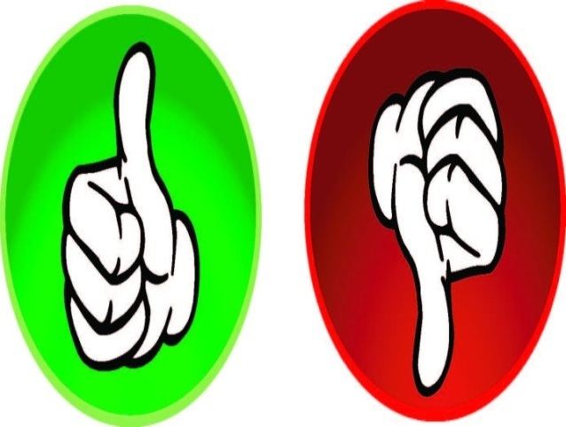
- After each statement, you can discuss their answers, or leave them open and repeat the activity once the lesson is over. In this (latter) way, you can check learning.

Subject examples.
Science: classifying animals
- A dog is an insect. (F)
- A spider is an insect. (F)
- A crocodile is a mammal. (F)
- A fish is a reptile. (F)
- A whale is a fish. (F)
(Learners can write their own true/false statements for each other.)
Шкуркина Татьяна Александровна,
филиал «МОУ СОШ №8 » в п.Радищево

