5Акласс28.04
Темаурока:"Present Simple and Present Continuous".
Тип урока: повторение и обобщение изученного материала
Цель:развитие грамматических навыков
Задачи:
образовательные: тренировка настоящего простого и настоящего длительного времён;
развивающие: способствоватьразвитию внимания, памяти, воображения, мышления, смекалки;
воспитательные: способствовать формированию интереса и положительного отношения к языку, формированию положительного отношения к образу мыслей одноклассника
.
Оборудование: компьютер, проектор, презентация, аудиозапись для зарядки, карточки с заданиями
Ход урока
- Организационный момент. (слайд 1)
Good morning! I am glad to see you! Sit down, please. What date is it today? What day of the week is it today? What season is it now? What’s the weather like today? Will you read the poem about rainy weather? Listen to me and read after me, please.
II. Речевая зарядка. (слайд 2)
The rain is raining all around,
It falls on field and tree
It rains on the umbrella here
And on the ships at sea.

1) What tenses are used in this poem? Name them.
2) What is the topic of our lesson today? (We are going to speak about the difference between Present Simple and Present Continuous) (слайд 3)
III. Фонетическая зарядка. (слайд 4) For the beginning - Let’s do Phonetic exercises.
- [s] walks, eats, makes, keeps
- [z] goes, finds, reads, smells
- [iz] watches, misses, washes, mixes
[ŋ]sleeping, talking, playing, writing

IV. Актуализация изученного материала. (слайд 5 )
1)What do you know about Present Simple? (Перевод, использование, образование, сигнальные слова). When and how do we use it?
2)What do you know about Present Continuous ? (Перевод, использование, образование, сигнальные слова)
3) What is the difference between Present Simple and Present Continuous?
To answer this question, please do some tasks. I’ll give some cards with different exercises.
Раздать карточки.
Карточка 1
Pinocchio prepared a table for us. Is it right? Try to correct mistakes.
(слайд 6-7)

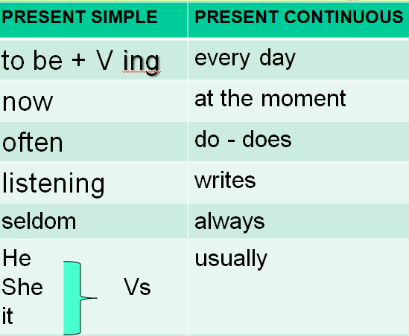

I’m going to show you a sentence. And I want to know if it is in Present Simple or Present Continuous? (слайд 8)
Learning Apps. https://learningapps.org/display?v=pt2e9k1kj22

1. I never work very hard.
2. I’m sitting at home.
3. Are you having dinner?
4. He doesn,t know.
5. Do you live here?
6. She isn’t coming home today.

True Or False
- Both Present Continuous and Present Simple can be used to talk about the future. (True) (слайд 9)
Present Simple and Present Continuous can be used for Future:
Present Continuous - future Arrangements (I’m having dinner with my friends tomorrow)
Present Simple - timetabled Events (My flight leaves at 6.30 tomorrow)
- Present Simple can be used with Present Continuous meaning. (True) (слайд 10)
When we use Stative Verbs. Stative Verbs cannot be used in Continuous.
I need your help (Yes) / I am needing your help (No)

Тренировка окончаний -s/-es (Карточка 2) (слайд 11)
Карточка №2. Расскажите правило прибавления окончаний -s/-es к глаголам в 3 лице ед.ч.?
Поставьте глагол в 3 л.ед.ч. Распределите слова на 3 столбика: -s; -es; -ies.
Go, try, feed, miss, help, watch, stay, fry, skate, cry.
(goes, tries, feeds, misses, watches, stays, fries, skates, cries)
LearningApps. https://learningapps.org/2943549

Карточка №3. Расскажите правило добавления окончания –ing. (слайд 12)
Подумайте и распределите слова на 5 столбиков.
Take, drink, lie, play, come, fit, die, skate, dry, work, get, smash, tie, win, fly,
- Naming, coming, skating,
- Drinking, working, smashing,
- Lying, dying, tying,
- Playing, flying, drying
- Fitting, getting, winning
LearningApps. https://learningapps.org/display?v=p7nnzuh5321

Do you like watching serials? I’m going to show you some episodes from the serial “Friends”. Your task is to answer the question - What are the friends doing? (слайд 13)
https://youtu.be/3lvNu_9WOwQ
- They are dancing.
- She is making a dessert.
- They are playing football.
- They are running.
- They are speaking French.
- They are boxing.
- She is singing now.
- He is eating now.
- She is riding a bike.

V. Повторение и закрепление изученного материала.
Тренировка настоящего простого и настоящего длительного времён в упражнениях.
1. Составление отрицательных и вопросительных предложений. (Карточка№4)
- He goes to school every day.
- She is listening to music now.
- Ted likes swimming very much.
- We play football very well.

2.Найди ошибку. Wordwall – Find mistakes and correct them! Are the sentences True or False? (слайд 14)
https://wordwall.net/ru/resource/31856697/present-simple-present-continuous
1. He go to school every day.(False)
2. She is listening to the radio now. (True)
3. Does he like swimming? (True)
4. I is a student. (False)
5. She don’t live in Moscow. (False)
6. Kate is swim in the swimming pool. (False)
7. It is snowing. (True)
8. You aren’t reading a book now. (True)

3. Аудирование. Do you like cartoons? (слайд 15)
https://youtu.be/GLF0lHOrTls

Let’s watch the cartoon about the hamster and write out the sentences in Present Simple and Present Continuous.
- On Fridays we always go the cinema.
- We usually watch a comedy.
- And we eat pizza and drink lemonade.
- I love Fridays with Max and Anna.
- We aren’t watching a comedy.
- We are watching the cartoon.
- We aren’t eating pizza now.
- They are eating burgers. And I am eatng chips.
- I don’t like burgers.
- We are drinking milk.
- I hate Friday with Fluffy.

4. Опишите картинку одним предложением. Describe the picture in one sentence! (слайды 16-21)
- She is drawing now.
- They clean the room every Sunday.
- The penguin is playing the guitar.
- She is sleeping now.
- He usually does his homework.
- He often read books.

- Present Continuous is used to express our future plans. Now you are going to listen to the dialogue. It’s called “What are you doing this weekend?” Your task is to think about the ending of the dialogue. (слайд 22)
https://youtu.be/fkkDZWnIQNs
-What are you doing this weekend? Do you want to go shopping with me?
- That sounds great! When do you want to go?
- How about Saturday morning?
-Oh, I’m making breakfast for some friends at nine. Then I’m doing laundry from 11 to noon.
- Saturday afternoon?
- I’m taking an Art class from 1 to 3. How about 3.30?
- No, I’m exercising with a friend from 3 to 4. Then I’m going to the movies at 5 with my sister.
- Sunday morning?
- I’m visiting my parents until 10. Then I’m meeting a friend at the Art Museum until 1. Sunday afternoon?
- I’m going to a baseball game with Bob at 1. How about late afternoon?
- Around 5?
- Great!

VI. Подведение итогов. Рефлексия

