Тема урока: Special Occasions. Project «Making a film with the programmer Stop Motion Studio»  Цель: обобщить материал, повторить праздники и как люди празднуют их. Способствовать свободному говорению, говоря о собственном опыте и знаниях, упражняться в выражении идей по теме, повторить слова по теме, расширять словарный запас, развивать креативность, воображение, способность работать в команде.  Литература – учебник Spotlight 9 класс Модуль 1d (Ваулина Ю.Е.)  1.Warm up  -What topic are we talking about this week? (Holidays and celebrations)  - Look at the screen and answer the questions in pairs  2. Введение темы урока  - What can you see? (photos).  - Where are they from? (from the album)  - They’re from my photo album.  - Why do people keep photos? (to recall the exciting events that happened to them in the past, they help remember the best moments in their life)  - These photos are connected with the theme of our lesson. What are we going to talk about? (about special days)  - In my opinion, photos are good to keep memories but videos are better because they show our emotions and people in action.  - So, what is the goal of our lesson? (at the end of the lesson we will be able to make a video clip about a special day).  - What should we do for it? What is our plan? (to revise the words, grammar (Past Simple), create a story and make a film)  a) Повторение лексики  - I consider you know a lot of words related to this theme. Now let’s check  You have a sheet of paper with some words. Tick if you know them in column 1.  - How many words do you know? More than a half? Less than a half? Is it enough for the lesson? What words are unfamiliar to you?  b) Изучение новой лексики  - Look at the screen and Match the pictures to the phases. Then use the phrases to describe the picture.  How do you think the people in the pictures feel? Make sentences  -What tense did you use? How do we form it? What special about this Tense? (irregular words)  c) Повторение неправильных глаголов (Past Simple)  Now, let’s play a game in pairs. Who knows more irregular words and there Second form. You only have 30 seconds. Who names more words is the winner.  3) Работа в группах. Создание проекта  Now, it’s time to make a video clip with the help of your phone app «Stop motion Studio»  We’re going to work in groups of 4.  (выбирают группу)  Put your hand into the bag and take a sweet. The colour of the sweet is the colour of your team.  Now, make groups according to the colour and sit together.  Take one of the envelopes to know a special day you are going to make your film about.  (The students are choosing one of the envelopes with pictures in it. The pictures are related to a special Day)  Look at the plan and rules.  - You have to start your story with the words «It was one of the best days in my life»  - Make 10-12 sentences.  - Use new vocabulary, don’t forget about emotions and feelings.  - Use linking words  - Your story must be in Past Simple  Now, you have 20 minutes to make your film. Move the pictures and make shots. While demonstrating your film you are telling your story  4. Просмотр фильмов  -Let’s watch your videos and check if you followed the rules properly.  - What did you like in the cartoon? Did you use the Past Simple? Did you have enough time? What would you like to add? To change?  5. Рефлексия  - Take the sheets with words and tick the words in column 2 if you know them.  - What words have you learnt? Access yourself how well you can talk about a special day from 1-10.  -What can you do to improve the results? | 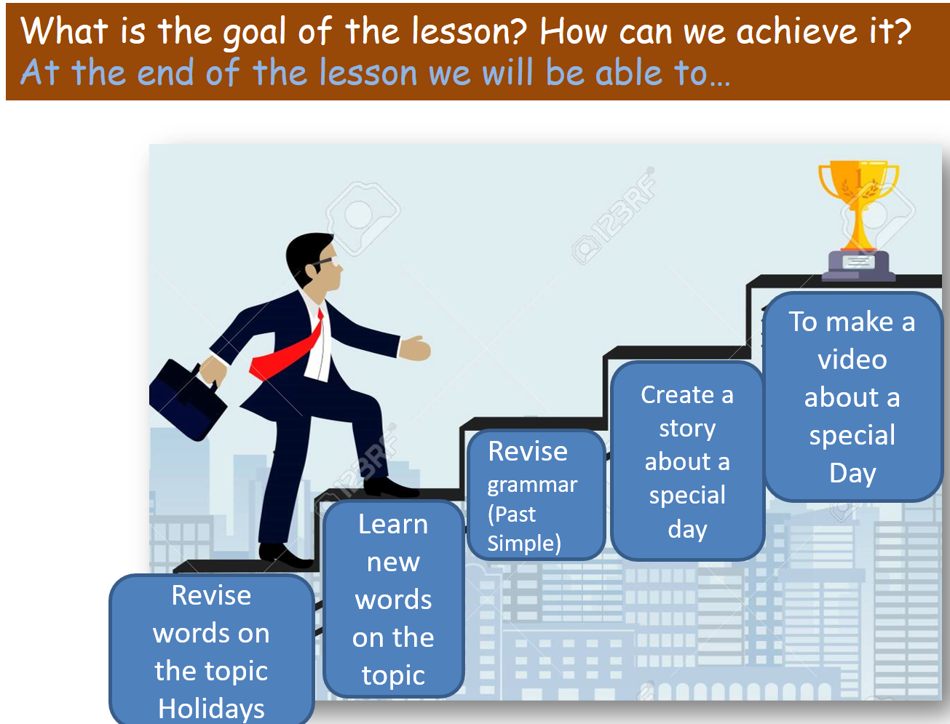  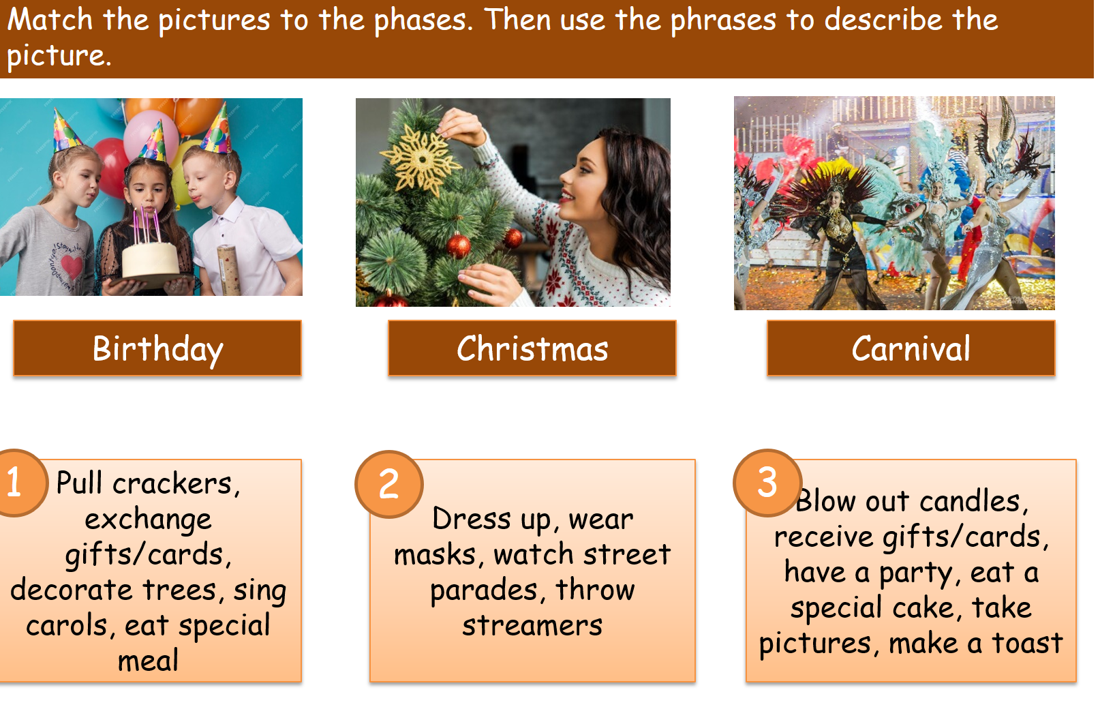  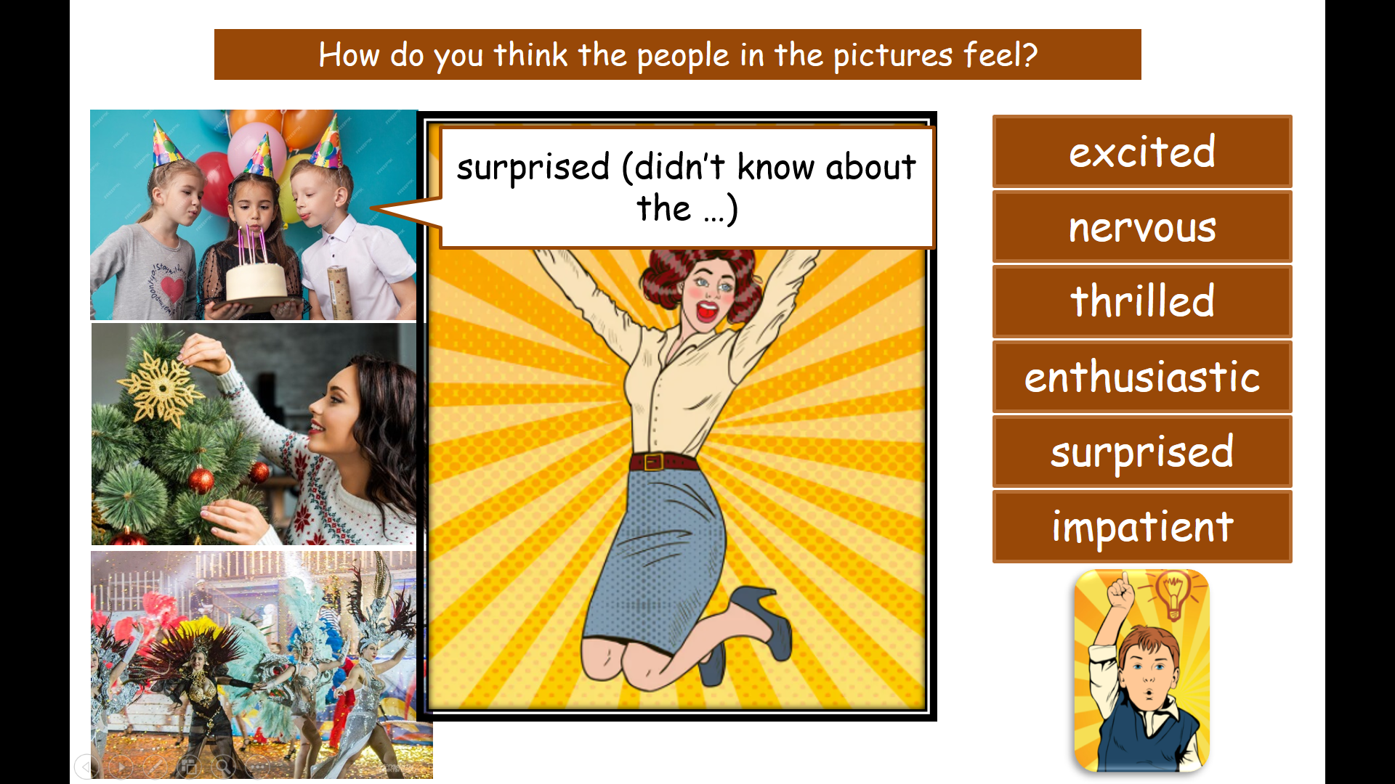  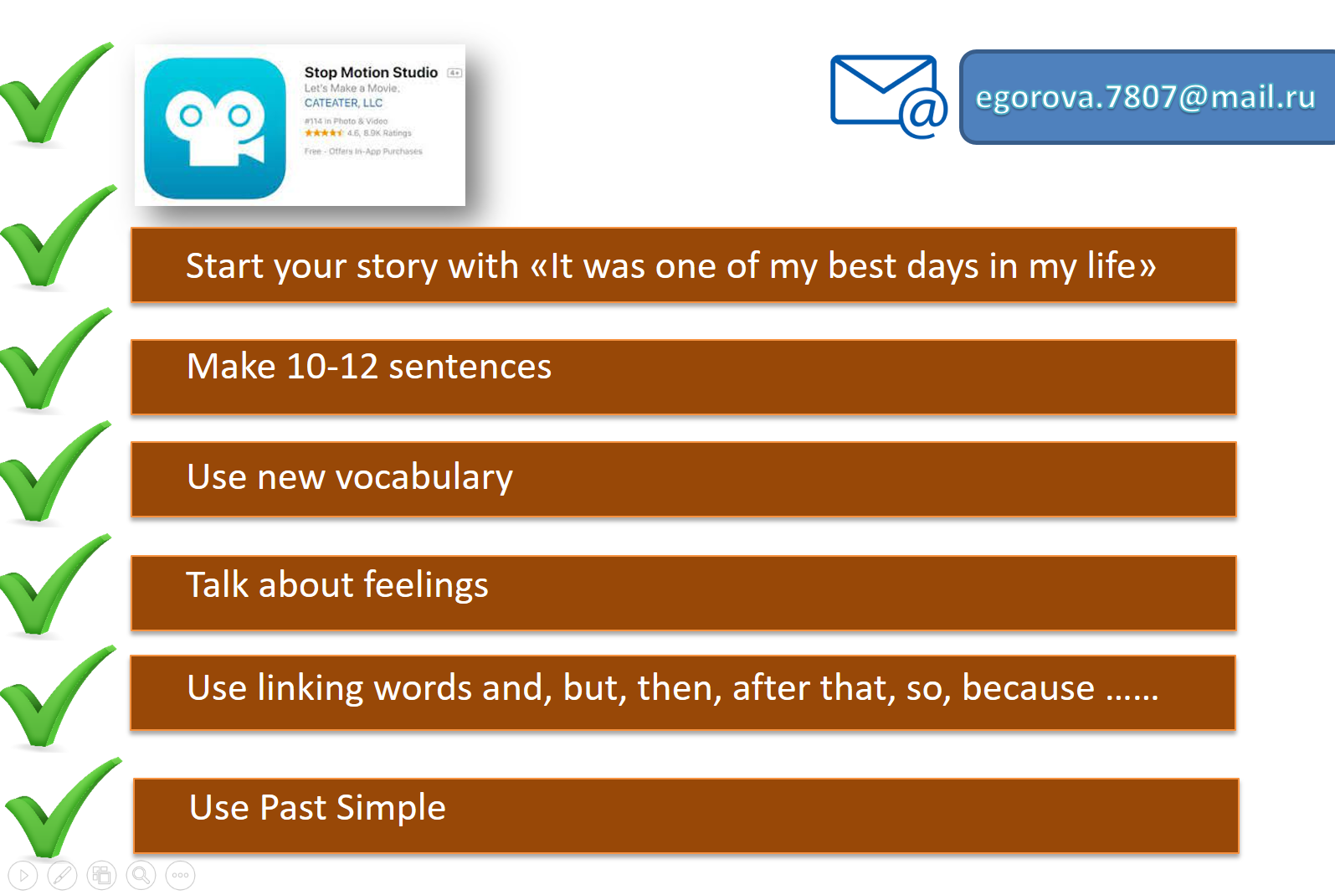
Работы учащихся:
https://drive.google.com/file/d/1I-Drn-ewNWyfj_YWHLQs-g9wZeqbCgDT/view?usp=drive_link

https://drive.google.com/file/d/1SsbaBYRwl_7hSm1MBEhpIzx14dlzMQrU/view?usp=drive_link
https://drive.google.com/file/d/1Dw51FW75vv2YACnNyGogT3UraIUlinLV/view?usp=drive_link
Team 1 – Knowledge Day
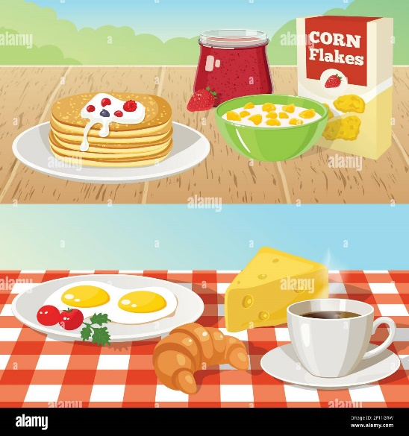
Team 2 - St Valentines’ day

Team 3 - Birthday
Team 4 New Year’s Day

Team 5 – Maslenitsa

