Сценарий методической разработки в рамках курса “Business English” на тему “Saving and Investing”, 8 класс.
Цели занятия:
- научить обучающихся различать виды сбережений, увеличивающих стоимость денег;
- научить обучающихся выполнять действия, связанные с расчётом процентных ставок и будущей стоимости денег на основе анализа полученной информации как на родном, так и на иностранном языке;
Задачи занятия:
- рассмотреть альтернативные способы роста денежных средств за счёт сбережений;
- отработать применение простых математических инструментов для вычисления будущей стоимости денег;
- изучить и отработать основные английские финансовые понятия по теме занятия;
- отработать навыки спонтанной устной речи на заданную тему с использованием клише для выражения собственного мнения (in my experience, based on information received, from what I know, personally, that sounds reasonable / brilliant to me because).
ИКТ: комплекс мультимедийных интерактивных упражнений, разработанных на платформе LearninApps.org.
ТСО: компьютерный класс, интерактивная доска SMART-BOARD, мультимедийный проектор.
Key phrases (word list):
- Financial Institutions;
- Interest Rates;
- money values;
- savings accounts;
- trading stocks;
- a stock simulation game;
- penalties;
- compound or single interest rates;
- limited withdrawal.
Time: 45 minutes
Ход занятия.
- Good afternoon, my dear friends! Today we will imagine ourselves as depositors and investors and try to understand the essence of such financial instruments as saving and investing.
I. Before the start of our lesson, match the English words with their Russian equivalent (exercise 1, LearninApps.org).
https://learningapps.org/watch?v=pm0y2159k22
- Good job!
II. Let’s talk about financial institutions.
Look at this picture (teacher is showing it on the smart-board)
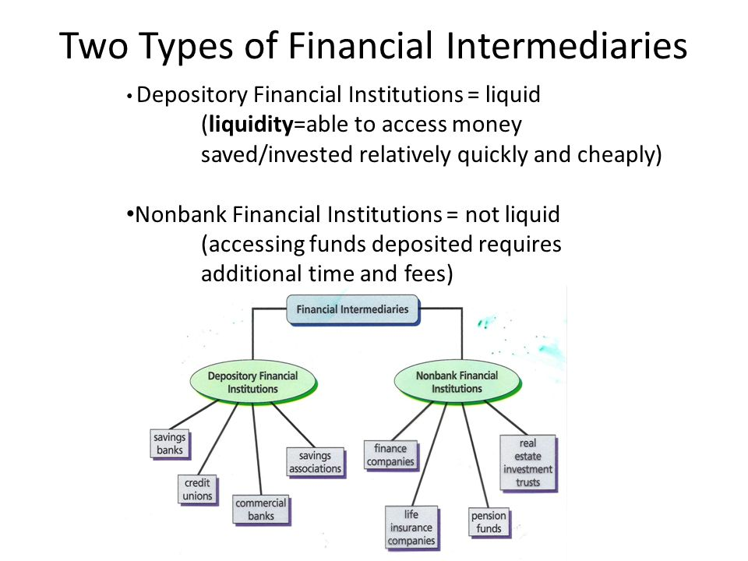
-There are many different places where we can put our money so that it earns interest (local financial institutions):
- banks;
- credit unions;
- other.
Please give me examples our Russian financial institutions.
Children are listing our institutions.
- Now we should discuss the differences between accounts and institutions.
Some savings account choices make it easier to withdraw their money if they experience a money emergency. Other accounts have penalties for taking money out for emergencies.
Exercise 2 (LearninApps.org)
https://learningapps.org/watch?v=p0mxhf7ek22
Let's imagine that you are depositor and analyze the websites of the largest Russian banks. Then fill in the following chart so you can compare the accounts.
Web sites:
https://www.vtb.ru/personal/vklady-i-scheta/
https://www.sberbank.ru/ru/person/contributions/depositsnew
https://www.tinkoff.ru/deposit/
https://alfabank.ru/make-money/
https://www.rshb.ru/natural/deposits/dohodniy/action_vesomyj/#
After doing this exercise students should discuss their results with the teacher.
III. Interest rates.
Well, now we should practice our math skills to determine the amount of money earned from different interest rates.
Exercise 3 (LearninApps.org).
https://learningapps.org/watch?v=pr11v94ft22
Instruction:
- Calculate the future value of one dollar ($1) placed in a saving account for 1 year. Calculate the interest using different interest rates (5%, 8%, 10%). Assume simple interest rates.
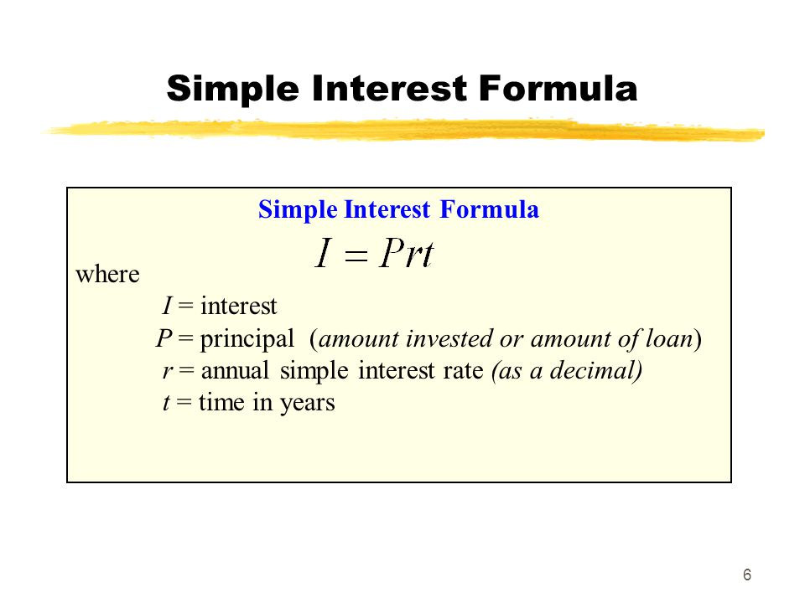
- Calculate each account balance based on length of time held in the account.
- Calculate the amount in each percentage column for three years, five years, and ten years.
After doing this exercise students should discuss the importance of long-term saving to provide money for future needs.
IV. Stock ownership (this activity introduces students to the riskier world of investments through stock ownership).
- Dear children, buying a share of stock is another way to increase your money's value. When you buy a share of stock, you own part of that company.
When the company makes money, you receive part of the profit as a dividend.
Another way your money increases (or decreases) in value is when the price of a share of the stock changes.
- Please fill the list of your preferences (Appendix 1)
- Try to identify the stocks and symbols associated with your favorites.
Now let’s play! (Appendix 2).
1) divide into teams.
2) each team should pick one stock from the list and pretend to purchase it.
3) each team should take a ₽1,000 account (on paper) to purchase stock.
4) each day, record the price of one share of stock for each company selected.
5) use the information from https://smart-lab.ru/q/shares/
6) comment your results according to the risks of investments.
V. Quiz.
https://learningapps.org/watch?v=pncsxatyn22
VI. Summing up the lesson.
My dear children!
The value of savings increases differently depending on how the money is managed.
I hope, when you become adults you will have control over where you invest your money for retirement. It is very important to understand how to get the best growth for own money
Thank you for your work! Goodbye!

Список используемой литературы.
- Бошкоева, Н. С. Использование игр в обучении английскому языку / Н. С. Бошкоева. – Текст : электронный. – URL: https://www.elibrary.ru/item.asp?id=44731183.
- https://learningapps.org/display?v=pncsxatyn22.
- https://smart-lab.ru/q/shares/.
- https://моифинансы.рф/.
- https://rg.ru/2021/07/08/kak-shkolniki-budut-izuchat-finansovuiu-gramotnost.html.
- https://study.com/academy/practice/what-is-economics-quiz-worksheet-for-kids.html.
- https://www.forbes.com/advisor/banking/difference-between-bank-and-credit-union/

