Test «Living Things Around Us»

Exercise 1. Correlate 1 and 2 forms of verbs

slept
got
had
met
took
was/were
ate
drank
went
fell
- be –
- eat –
- drink –
- go –
- sleep –
- take –
- have –
- get –
- meet –
- fall –

Exercise 2. Add the missing verb form

blow |  | blown
draw |  | drawn
fly |  | flown
know |  | known
let |  | let
make |  | made
pay |  | paid
put |  | put
stand |  | stood
tell |  | told

Exercise 3. Select and write don't or doesn't
Example: Carla (don’t/doesn’t) doesn’t ride a bicycle.
1. Carla (don’t/doesn’t) ride a bicycle.
2. We (don’t/doesn’t) live in a big city.
3. They (don’t/doesn’t) read news.
4. I (don’t/doesn’t) go to bed late.
5. Dan (don’t/doesn’t) enjoy winters.
6. It (don’t/doesn’t) rain here a lot.
7. I (don’t/doesn’t) wear jeans at work.
8. Lily (don’t/doesn’t) play the piano.
9. Jim and I (don’t/doesn’t) rent a flat.
10. Sam (don’t/doesn’t) have any pets.

Exercise 4. Name who is depicted

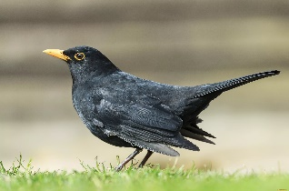 1 | 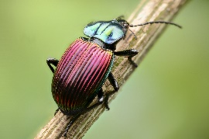 2
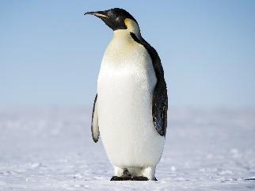 3 | 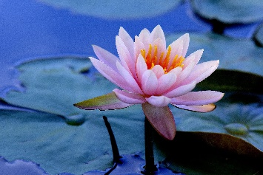 4
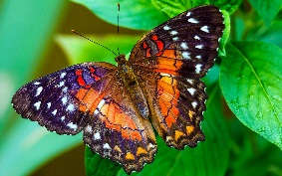 5 | 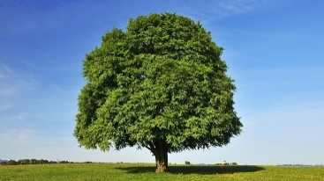 6 (бук)

Exercise 5. Choose the correct answer according to what is shown in the picture
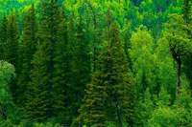 | - It is a meadow covered with flowers.  - It is a dense forest. The trees are bright green.  - It is a thin forest. The trees are dark brown.
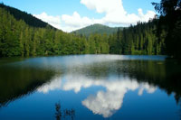 | - We see a wide clear lake and a green forest.  - We see a flowing river and a yellow forest.  - We see a wide lake and a field.
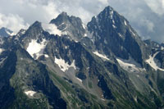 | - We see high mountains. They are covered with snow in some places.  - We see a deep cave. It is covered with snow.  - We see a valley between the high mountains.
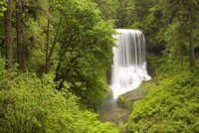 | - Here we can see a huge waterfall and a green meadow.  - Here we can see a small stream in the forest.  - Here we can see a small waterfall in the forest.
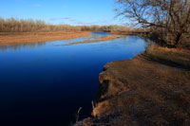 | - It is a still river. The water is clear and blue.  - It is a rough sea. The water is dark green.  - It is a swamp. The water is dark brown.
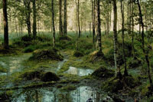 | - We see a rapid stream in the mountains.  - We see a swamp in the forest.  - We see a rapid swamp in the forest.

