ОТКРЫТЫЙ УРОК
"It's strange for me to discuss my own success. Why?":
Vladimir Menshov's rules of life, which we can all learn.
Мне странно обсуждать свой собственный успех. Почему?”:
Правила жизни Владимира Меньшова, которым мы все можем научиться.

(11 класс)
Цели урока:
образовательная:
- формирование коммуникативной компетенции обучающихся;
- расширение и отработка словарного запаса по теме.
деятельностная:
- использовать лексику на уровне говорения.
воспитательная – привитие любви к кинематографу, любви к своей Родине.
Основные задачи:
образовательные:
- совершенствовать умения и навыки практического владения английским языком по теме “Кино” по всем видам речевой деятельности: аудированию, говорению, чтению, систематизировать ранее приобретенные знания;
развивающие:
- повышение мотивации к изучению английского языка;
- развивать навыки чтения с извлечением нужной информации;
- развивать умения организовывать информацию по теме;
воспитательные:
- воспитывать потребность в расширении, приобретении знаний.
Личностные результаты:
- формировать мотивацию учебной деятельности, уметь проводить самооценку, формировать интерес к отечественному кинематографу, уважение учащегося к творчеству великого русского режиссёра, актера, народного артиста СССР Владимира Меньшова. Понимание возможностей английского языка в передаче величия В. Меньшова, как гениального режиссёра с мировым именем, мастера кино.
Метапредметные результаты:
- уметь оценивать результаты своей деятельности, проводить контроль и коррекцию, анализировать собственную работу, планировать свое действие в соответствии с поставленной задачей, определять цель учебной деятельности (этапа), планировать, прогнозировать, формировать волевую саморегуляцию;
- уметь анализировать: синтезировать, сравнивать, устанавливать причинно-следственные связи, систематизировать материал, рассуждать, доказывать, ориентироваться в любом материале, развивать смысловое чтение, находить нужную информацию, находить основную мысль, сворачивать учебный материал.
Техники и технологии: ИКТ, технология критического мышления, интерактивные технологии.
Методы: активные методы обучения, тренинговые методы, интерактивные методы, метод парной работы.
Межпредметные связи: литература, музыка.
Организационный момент.
Teacher: Good morning! Dear students! I hope we are in a good mood and you are ready to be attentive and active?
Today we have an unusual lesson. It is unusual in that we will consider the topic of the lesson "Cinema" on the example of the outstanding Soviet director and actor Vladimir Menshov. I'm sure you know who it is? On September 17, Oscar-winning director Vladimir Menshov would have turned 82. This is the first birthday on which he is not with us, but he remains alive in his films, acting works, including quotes, sayings and wise thoughts.
Teacher. The first part of our lesson is called the life and biographical data of Vladimir Menshov. Please look at the board.
Практическая часть урока.
(Вниманию учащихся предоставляется презентация
о жизни Владимира Меньшова)
Vladimir Menshov was born on September 17, 1939 in Baku. Father Valentin Menshov studied at a seafaring school, after graduation he served on the ship as an assistant captain, then left to serve in the NKVD. Antonina Menshova's mother (Dubovskaya) came from a wealthy family. In 1937, she left her native village in order not to become a victim of repression and dispossession. I found a job as a maid on a ship that plied the Baku-Iran route. This ship became a meeting place for two young people, and soon they got married. The happy couple immediately had a son, Vladimir, and in 1941, a daughter, Irina. His parents' hometown was Astrakhan, and the Menshov family ended up in Azerbaijan after his father's next appointment.

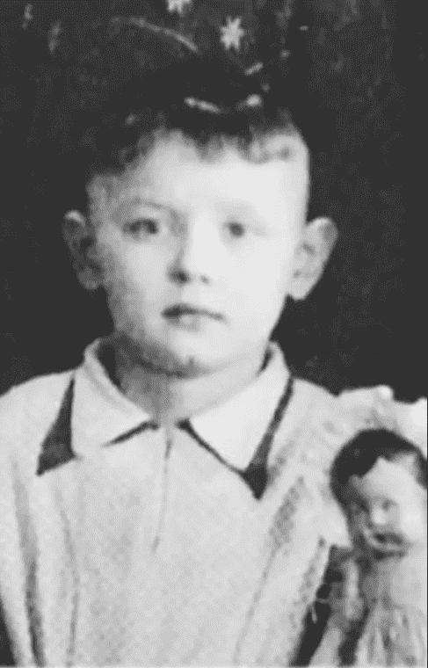
Vladimir Menshov spent his early childhood in Baku, and two years after the victory, the family moved to Arkhangelsk, again at his father's place of service. Vladimir saw for the first time the majesty of the North, the harsh beauty of these places, and his soul forever stuck to these edges. In this city Menshov went to the first grade.
In 1950, the Menshovs moved again, this time to their parents' homeland, Astrakhan. Growing up, Volodya began to take a keen interest in cinema. He tried not to miss a single movie in the cinema, he memorized almost all of them by heart. The hobby was so serious that the boy even read special literature, magazines in which there was a lot of information about the filming process itself and people who are directly related to this process – actors and directors. It was at this time that he decided on the choice of his life path, and decided to become an actor. The parents were not at all pleased with their son's decision. The father secretly hoped that the guy would follow in his footsteps and become a military man. But Menshov was determined, so the family did not particularly object. In 1957, Vladimir made his first attempt to become a student at VGIK, but nothing came of it. He failed the entrance exams and went back to Astrakhan.
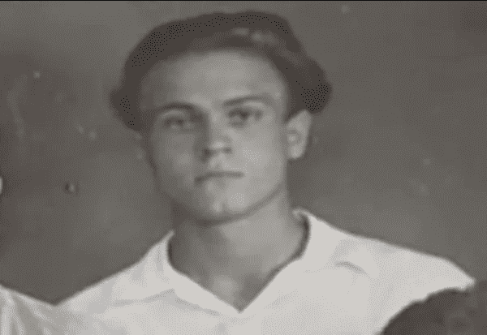

This failure did not discourage the young man from entering a theater university. Rather, on the contrary, he was even more strengthened in his desire to achieve his goal. Returning to his hometown, Menshov went to work at the factory as a turner. At the same time, he is looking for a job that would be closer to the world of art, and would allow him to prepare for admission next year. And Menshov found such a place – the city drama theater, where he was taken to the auxiliary staff. During the year, the guy gained experience, but this time he decided to wait for admission. Vladimir decided that life experience would not hurt him, and he needed to earn some money, so he immediately went to work at the mine, then as a sailor. This lasted for four years, until in 1961 Menshov realized that he was ready to storm the capital. This time there were no problems with admission – he is a student of the acting faculty of the Moscow Art Theater Studio School.

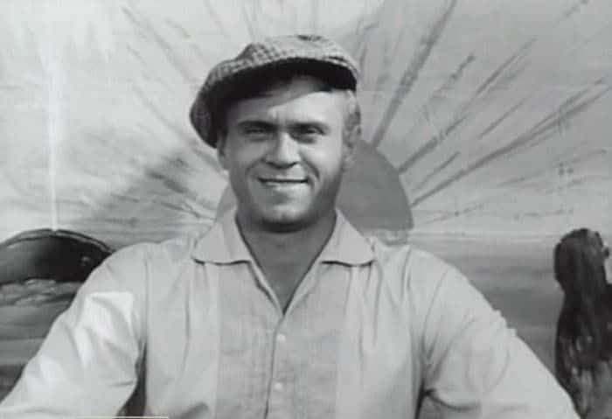
Menshov received his diploma of education in 1965, but he did not find a place in Moscow theaters. They were ready to take him only to the Stavropol Drama Theater, where he soon went. Vladimir shone on the stage of this theater for two years, and all this time he dreamed of returning to Moscow. In 1970, Menshov completed his postgraduate studies at the Department of Directing at VGIK, and only then moved back to Moscow.
His cinematic biography began in the same 1970. He starred in a picture of his classmate Pavlovsky, which was called "Happy Kukushkin". In 1971, Alexey Sakharov invited Vladimir to his tape "A Man in his Place", where he entrusted him to play the main character. For this work, Menshov was awarded the first award in his life – the Almaatinsky Festival Award, in the nomination best acting work. This tape opened up new broad horizons for Menshov. Now there are much more offers, and they did not have to wait for years. The first fame came, followed by demand. The 70s brought him work in the films "Ar-hi-me-dy!", "Salty Dog", "The Tale of how Tsar Peter married a Blackamoor", "The Last Meeting".
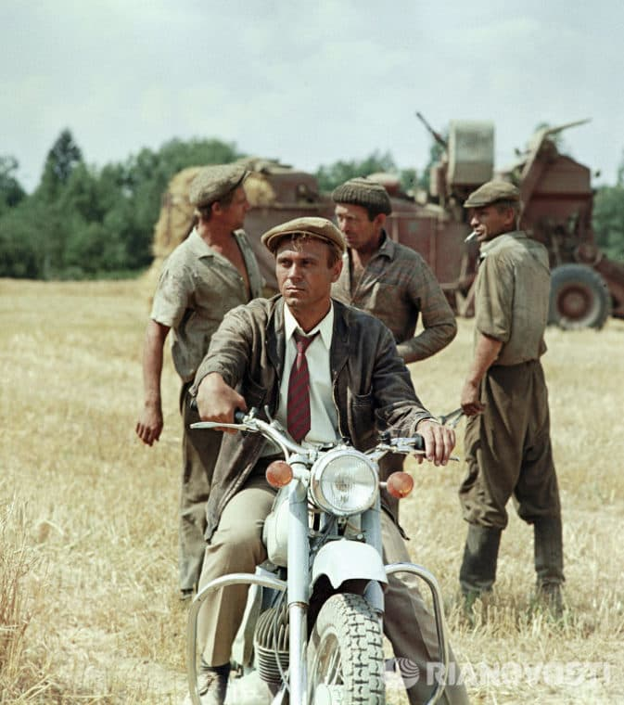
From 1970 to 1976, Menshov's place of work was the film studios "Mosfilm", "Lenfilm" and the Odessa Film Studio. In 1976, Vladimir released his full meter called "The Draw". The following year, this tape broke rental records, and in 1978 Menshov received the RSFSR State Prize for it. Director Menshov's finest hour struck in 1978, when he began preparing for the filming of his Oscar-winning film "Moscow does not believe in tears." The role of the main character starred an unknown actress Vera Alentova, Menshov's wife. The roles of other characters were performed by popular artists, whom the viewer knew perfectly well. Menshov did not even dream that the film would be such an incredible success. It seemed to everyone that this was another modern Cinderella story, which was filmed a lot.

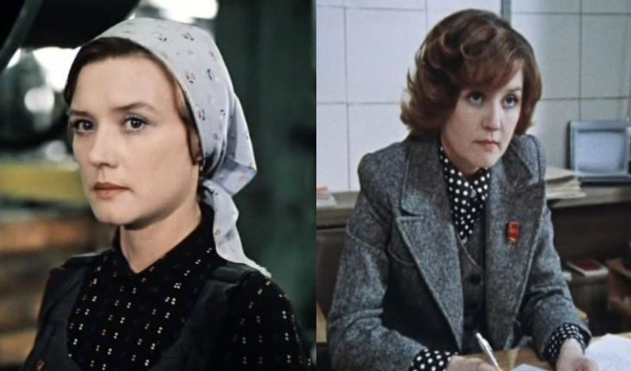

1981 it was this year that Moscow Does Not Believe in Tears was awarded an Oscar in the Best Foreign Language Film nomination. After that, Menshov and all the creators of the picture received the State Prize of the USSR in the Union.
Teacher. Attention, let's move on to the first task. You have questions and answers on the tables. Please read the question and choose the correct option.
(Индивидуальная работа учащихся)
- When was Vladimir Menshov born?
а. on September 17 in 1939
b. on September 18 in 1940
c. on September 19 in 1949
2. What was the name of Vladimir Menshov's mother?
a. Maria Alexandrova
b. Svetlana Anatlievna
c. Antonina Dubovskaya
3. How did the parents react to their son's choice regarding the theater institute?
a Parents did not approve of son's choice.
b Parents supported their son in his choice.
4 . In what year did the cinematic biography of V. Menshov begin?
a. His cinematic biography began in the same 1970. He starred in a picture of his classmate Pavlovsky, which was called "Happy Kukushkin".
b. His cinematic biography began in the same 1971. He starred in a picture of his classmate Pavlovsky, which was called "Sad Kukushkin".
c. His cinematic biography began in the same 1970. He starred in a picture of his classmate Pavlovsky, which was called "Happy Ivanov".
5. Who played the main role in the film "Moscow does not believe in tears"?
a. Elena Yakovleva
b. Vera Alentova
c. Svetlana Svetlichnaya
6. In what year did the film "Moscow does not believe in tears" receive an Oscar?
a. in 1981
b. in 1983
c. in 1984

Тeacher. Well done! I'm sure you did the right job. Please exchange papers with each other. Check if the correct answers match the key.
Guys, look at the portrait on the screen. Think about what we are going to talk about now, what will the next section of our lesson be called? Quite right. About family, about love ... "Youthful love of a lifetime" - this is the name of the next page of our lesson.
I invite to this stage the guys who independently prepared information in the love of Vladimir Menshov.

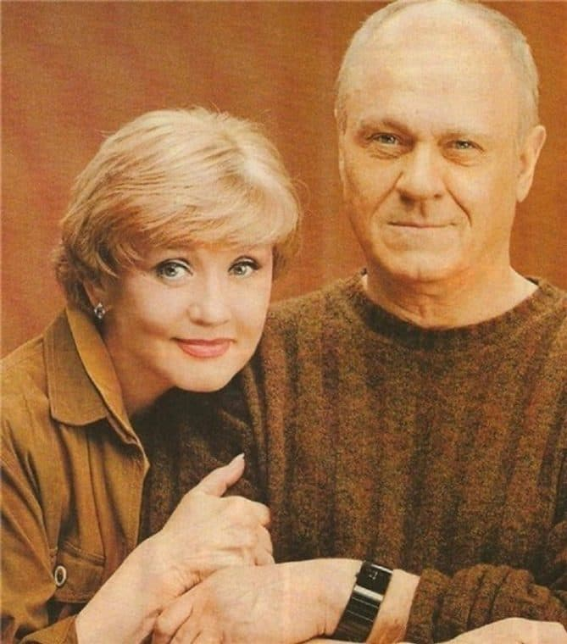
Pupil 1. Vera Alentova and Vladimir Menshov were one of the most beautiful and strong couples of Soviet and Russian cinema. Although, according to the spouses, their relationship has always been difficult. Moreover, Vera Valentinovna and Vladimir Valentinovich assured that they were not supposed to be together.
After all, in fact, the actors were very different: Alentova is an educated and self-sufficient woman, Menchov is a talented, but at the same time shy man. However, these differences in character did not prevent them from living a long family life and understanding that they love each other very much, that they are happy with each other, that they will not have such feelings and relationships with others.
Alentova and Menshov realized their feelings by the third year - before that they were connected only by friendship. But from the first date to the wedding, very little time passed: the lovers immediately realized that they wanted to spend their whole lives together. There were no funds for a magnificent celebration, so they noted it modestly: in a hostel with classmates, on the table, as Alentova later tells, “herring, cucumbers, tomatoes.”
Pupil 2. At first, it was not easy for the newlyweds: there was not enough money, they could not get separate housing. After graduating from the university, the spouses had to part at all: Vladimir was assigned to the Stavropol theater, and Vera remained in Moscow, where she got a job at the Pushkin Theater. The forced separation lasted several years.
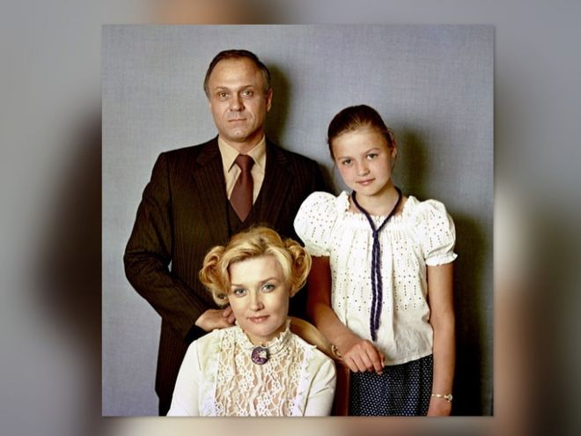
Two years after Menshov returned to Moscow, the stars had a daughter, Yulia. The times were very dark: there was a catastrophic lack of money, there was no one to ask for help, the tension in the couple grew. As a result, Vera and Vladimir made the difficult decision to leave, but did not begin to dissolve the marriage.
The second parting of the lovers lasted three years. All this time, Menshov often visited his wife and daughter, brought them gifts from business trips. Alentova, who by that time had already received her apartment, registered her husband and did not interfere with his communication with little Yulia. Gradually, things began to improve, dreams come true, and a place for love again appeared in life. The director and actress reunited and have not parted since.
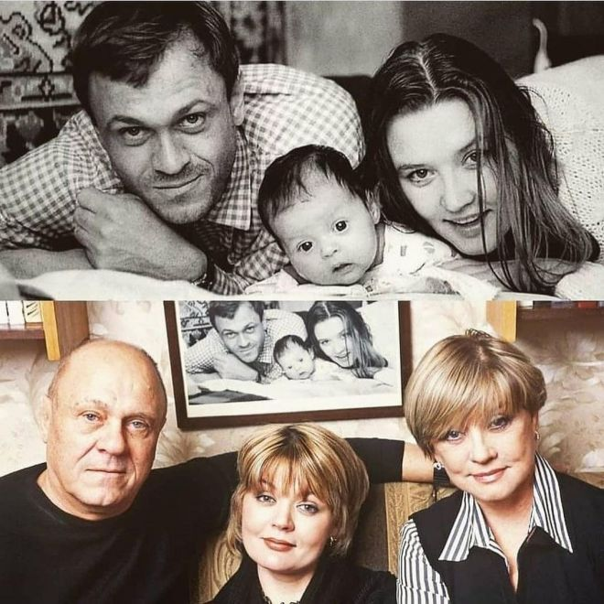
But for almost 60 years of marriage, they have become very similar to each other. Vera Valentinovna and Vladimir Valentinovich, having celebrated their golden wedding, decided to get married, because, in their opinion, this marriage was originally concluded in heaven.
The actors said that their union should not have been formed at all, and to hold out for so long is generally a miracle. According to Alentova, her relatives, who during earthly life were clergy, prayed for them in heaven.
Pupil 3. Vera Valentinovna and Vladimir Valentinovich, despite their different characters and sometimes conflicting relationships, were very happy with each other. Alentova said that once her husband accompanied her to Leningrad on tour, and a few days later she had a birthday. The actress was so sad that they would not be together on such a holiday that she told her husband about her experiences. Menchov, without thinking twice, jumped into the train with her without a ticket, lay down in her place and fell asleep. “I sat, looked at him and thought: “What a blessing it is that he went with me!” He gave me an amazing birthday party in Leningrad, ”recalled Vera Alentova.

Teacher. Thank you very much, dear speakers.
Dear Guys! Your attention is an excerpt from the diary of Vera Alentova, dedicated to Vladimir Menshov. You need to read and correctly open the hide brackets.
(Индивидуальная работа учащихся)
“For the first time I paid attention to him after (to listen)__________, where it (to turn)__________ out that we had the same repertoire with one girl. I (to read) __________better and (to pass)__________. And although I obviously didn’t like it, he (to follow)________ me into the dumplings, a conversation (to begin)__________ Volodya (to be)________ very erudite, he (to read)_________ a lot. Somehow he hooked me, we became friends, "-
from the diary of
Vera Alentova.

Teacher. Now I suggest you review the fragments of the films that V. Menshov shot and the pictures with his participation. All these pictures and roles are very familiar to us and dearly loved. After watching, a task awaits you, be careful.

Вниманию предоставляется ряд виде отрывков из фильмов :
1 . "Ликвидация" - маршал Советского Союза Георгий Жуков.
2. "Диверсанты" - генерал военной разведки Калязин.
3. "Москва слезам не верит"
4. "Любовь и Голуби"
5. матрос Мартьянов в фильме «Соленый пес»
6. граф Бестужев "Екатерина"

Teacher . Now with the help of the numbers on your desk, I propose to choose the movie you like the most. Vote!

1 . "Liquidation" - Marshal of the Soviet Union Georgy Zhukov.
2. "Saboteurs" - military intelligence general Kalyazin.
3. "Moscow does not believe in tears"
4. "Love and Doves"
5. Sailor Martyanov in the film "Salty Dog"
6. Count Bestuzhev "Catherine"

Thank you! Sorry, but our lesson is coming to an end. There is very little time to embrace such an outstanding personality as Vladimir Menshov!

Закончить наш урок я хочу отрывком из фильма Юлии Меньшовой «ПАПА: Последнее интервью В.В. Меньшова».
Рефлексия.
Address to those present. Teacher. A few words about today's lesson. What did you like? What do you remember? You will receive grades for the lesson based on the results of your individual work. Homework p. 84. ex. 3
Good luck!

