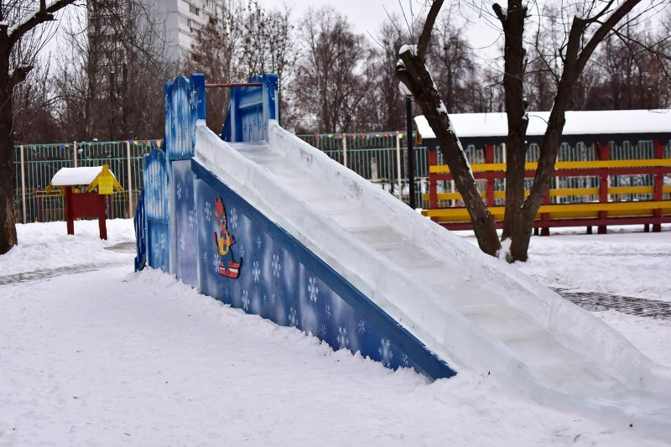

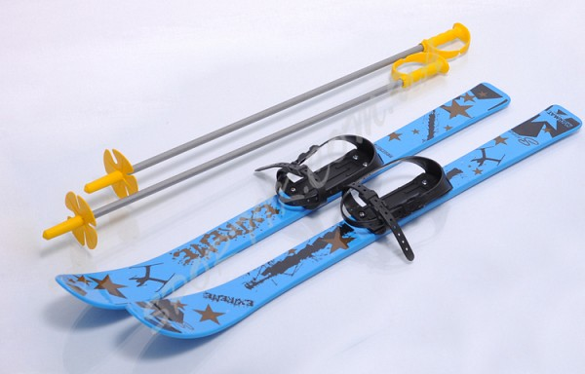

|  |
| --- |
| C:\Users\User\Desktop\санки.jpg |