Приложение 1
ir [з:] | er [з:] | ur [з:]
bird | her | purple
girl | term | fur
birth | mercy | hurt
birthday | herd | nurse
dirty | nerve | burn

----------------------------------------------------------------------------------------------------------------------------------------------------------------------------------------------------

ir [з:] | er [з:] | ur [з:]
bird | her | purple
girl | term | fur
birth | mercy | hurt
birthday | herd | nurse
dirty | nerve | burn

Приложение 2

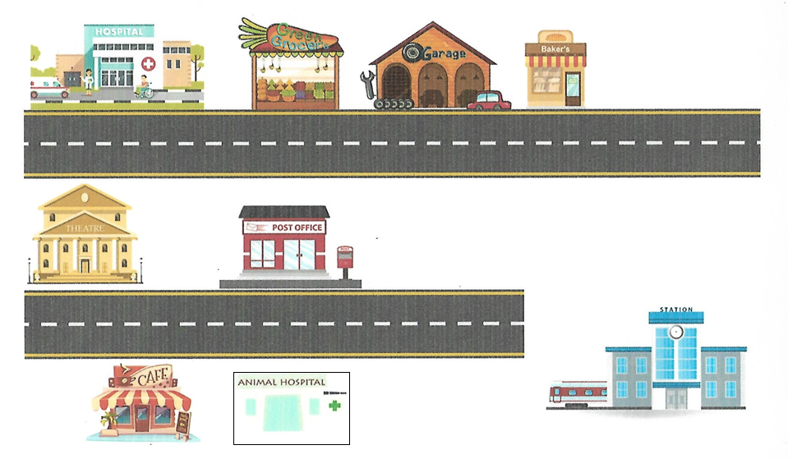

Приложение 3

Chuckles

Приложение 4
