Приложение 1
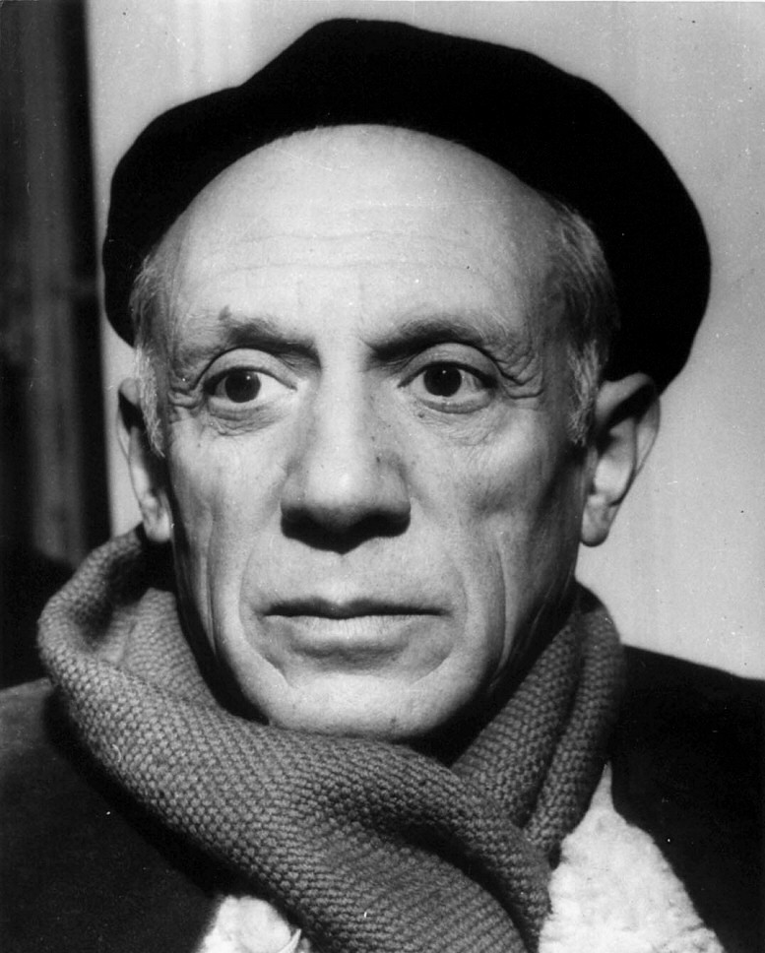

Pablo Picasso (a Spanish painter)

Приложение 2
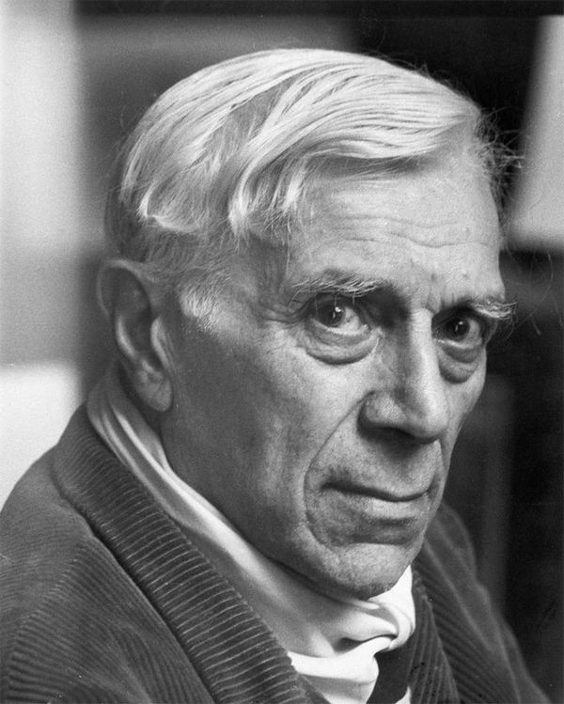

Georges Braque (a French painter)

Приложение 3
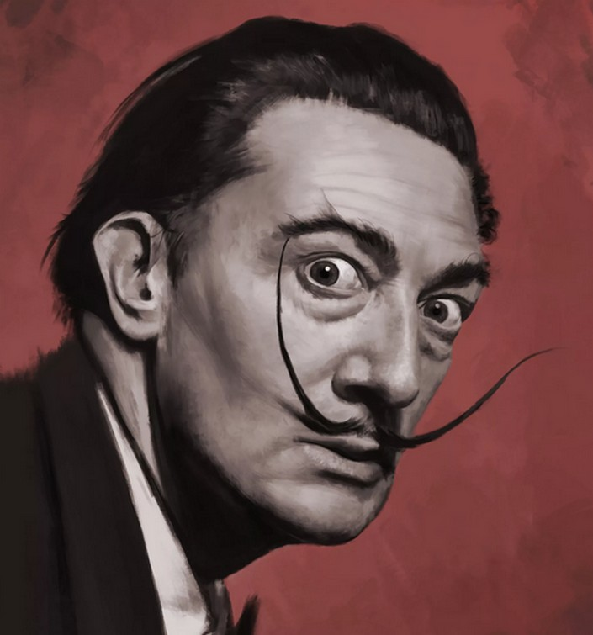
Salvador Dali (a Spanish painter)

Приложение 4
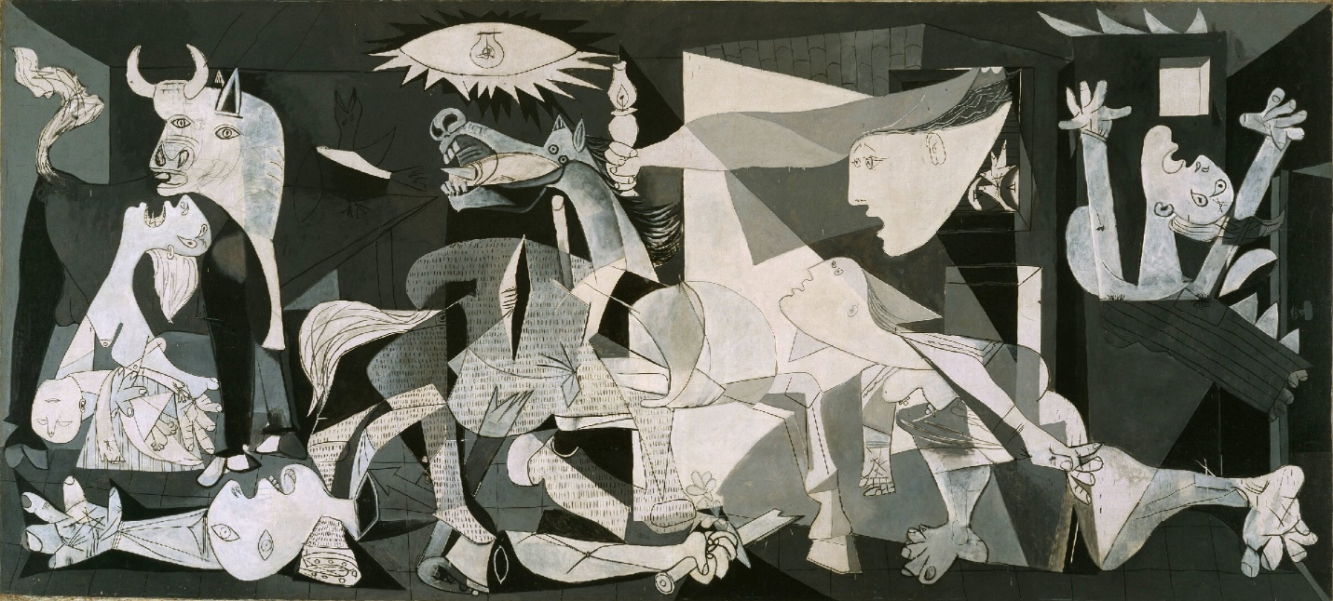
Pablo Picasso, Guernica (1937), oil painting (powerful anti-war painting in history)
Queen Sofia National Museum of Art, Madrid

Приложение 5
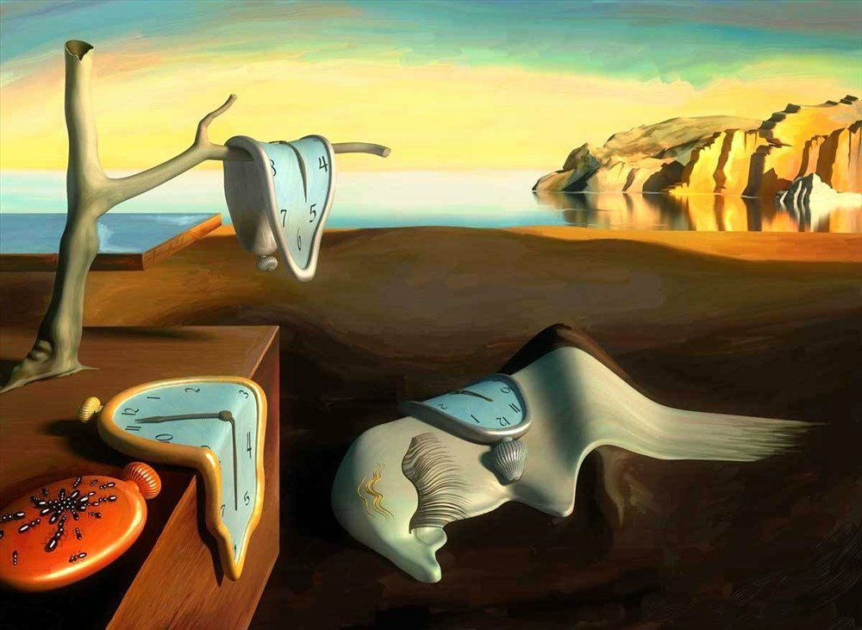

Salvador Dali, The Persistence of Memory (1931), oil on canvas
Museum of Modern Art, New York

Приложение 6
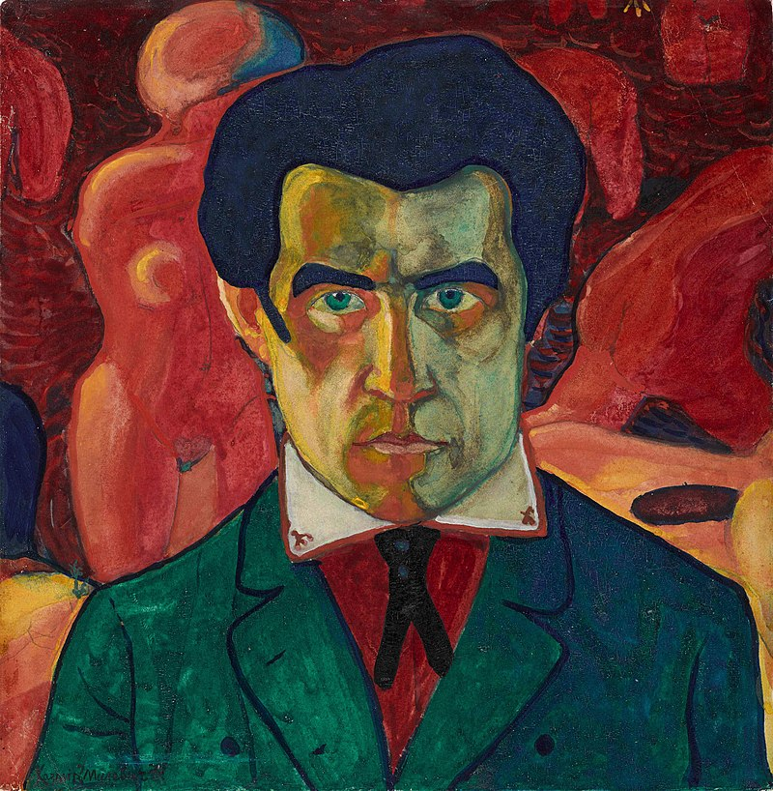
Self-Portrait (1908 or 1910-1911) (Kazimir Malevich)
Kazimir Severinovich Malevich (23 February 1879 – 15 May 1935) was a Russian avant-garde artist and art theorist, whose pioneering work and writing had a profound influence on the development of abstract art in the 20th century. Born in Kiev to an ethnic Polish family, his concept of Suprematism sought to develop a form of expression that moved as far as possible from the world of natural forms (objectivity) and subject matter in order to access "the supremacy of pure feeling" and spirituality.

Приложение 7

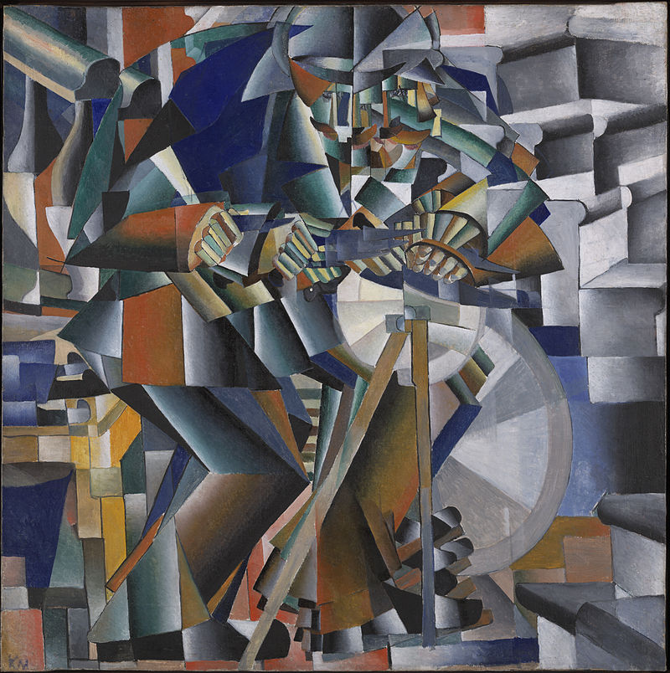
Kazimir Malevich, Tochil'schik (The Glittering Edge) 1912-13, oil on canvas, (Yale University Art Gallery, New Haven (Connecticut)

Приложение 8

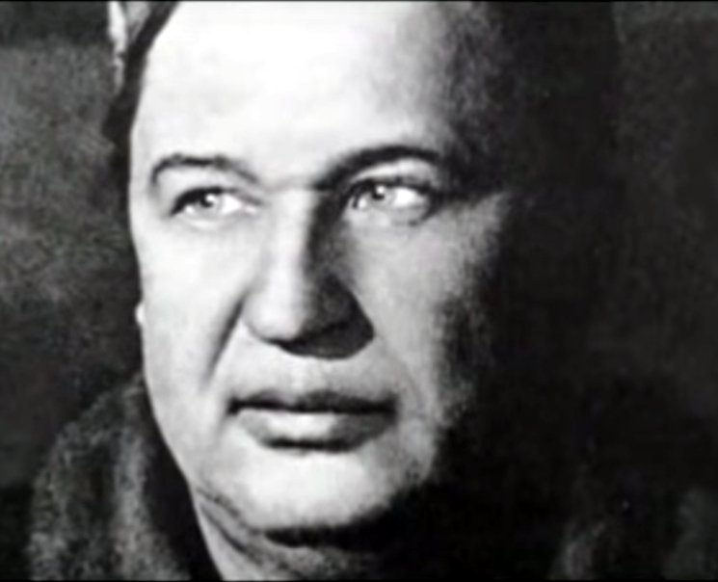
Aristarkh Lentulov (1882-1943), photo c. 1930s.
Aristarkh Vasilyevich Lentulov (Russian: Аристарх Васильевич Лентулов; 16 January 1882 – 15 April 1943) was a major Russian avant-garde artist of Cubist orientation who also worked on set designs for the theatre. He was the representative of Optimistic Cubism (it was his own view of Cubism).
Aristarkh Lentulov was born in the town of Nizhny Lomov in Penza Oblast, Russia into the family of a rural priest. He studied art in the Penza and Kiev art schools from 1897 to 1905, and then in the private studio of Dmitry Kardovsky in Saint Petersburg in 1906. From 1910 to 1911, Lentulov studied at the studio of Henri Le Fauconnier and the Académie de La Palette in Paris.
He lived in Moscow from 1909, and he was one of the founders of the avant-garde exhibiting association of artists, the Jack of Diamonds group ( скандально известное художественное объединение авангардистов «Бубновый валет». This group remained active until its dissolution in 1916.

Приложение 9
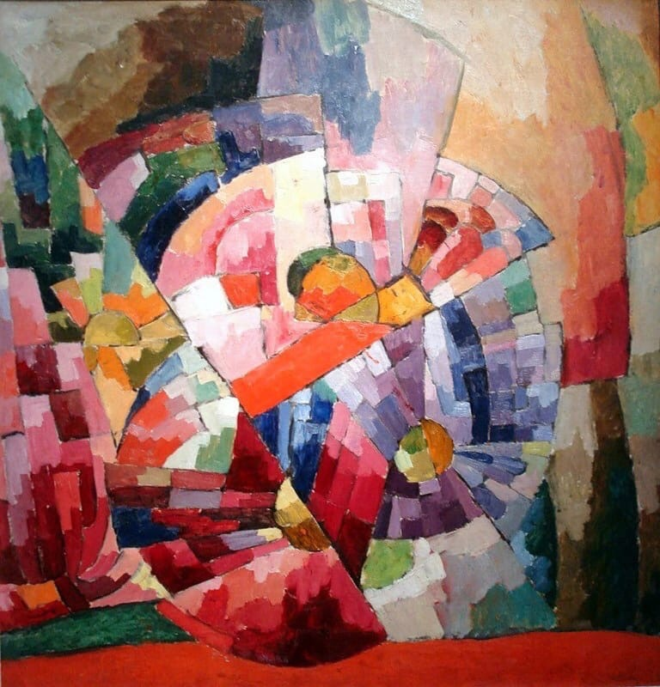
Aristarkh Lentulov, Astry 1913, oil on canvas, Tretyakov Gallery, Moscow.

Приложение 10
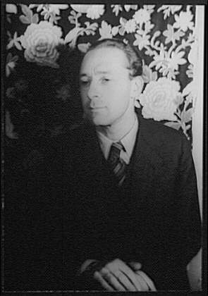

Pavel Fyodorovich Tchelitchew : Па́вел Фёдорович Чели́щев (3 October 1898 – 31 July 1957) was a Russian-born surrealist painter, set designer and costume designer.
Tchelitchew was born to an aristocratic family of landowners and was educated by private tutors. Tchelitchew expressed an early interest in ballet and art. His family was forced to flee Russia after the Russian Revolution in 1917. He studied under Aleksandra Ekster at the Kiev Academy, and after graduation worked designing and building theater sets in Odessa and later Berlin from 1920-1923. Tchelitchew was born to an aristocratic family of landowners and was educated by private tutors. Tchelitchew expressed an early interest in ballet and art. His family was forced to flee Russia after the Russian Revolution in 1917. He studied under Aleksandra Ekster at the Kiev Academy, and after graduation worked designing and building theater sets in Odessa and later Berlin from 1920-1923. In 1923 he emigrated to Paris and later became the American citizen.

Приложение 11

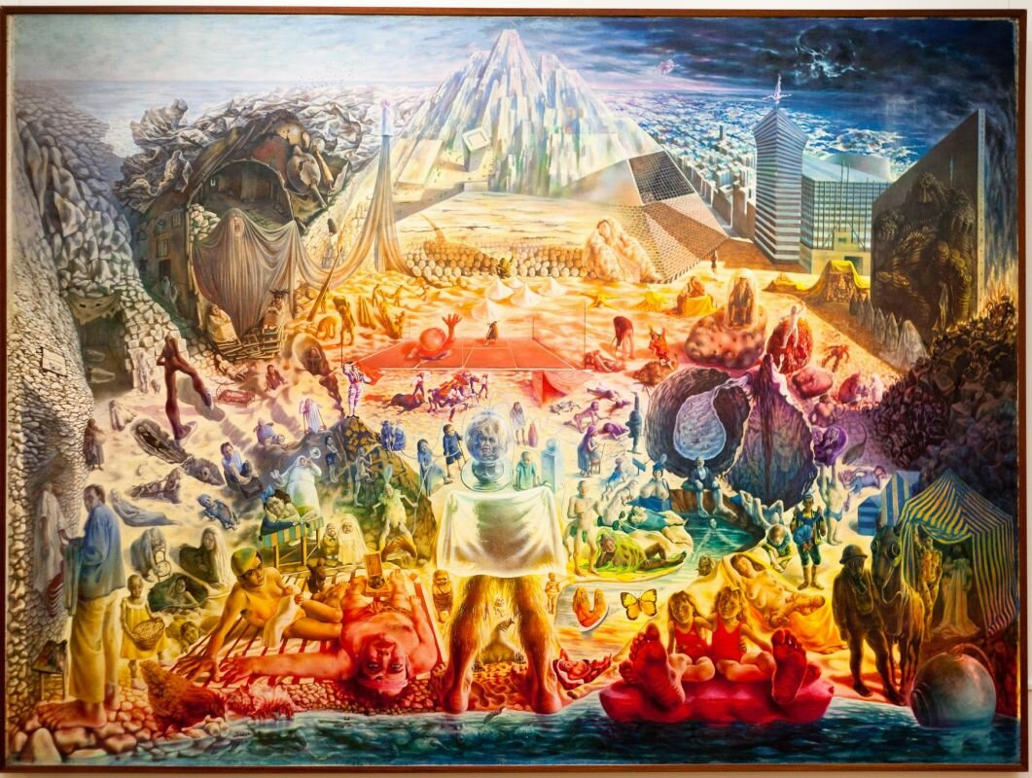
Pavel Tchelitchew, Phenomena, 1938 oil on canvas, Tretyakov Gallery, Moscow

