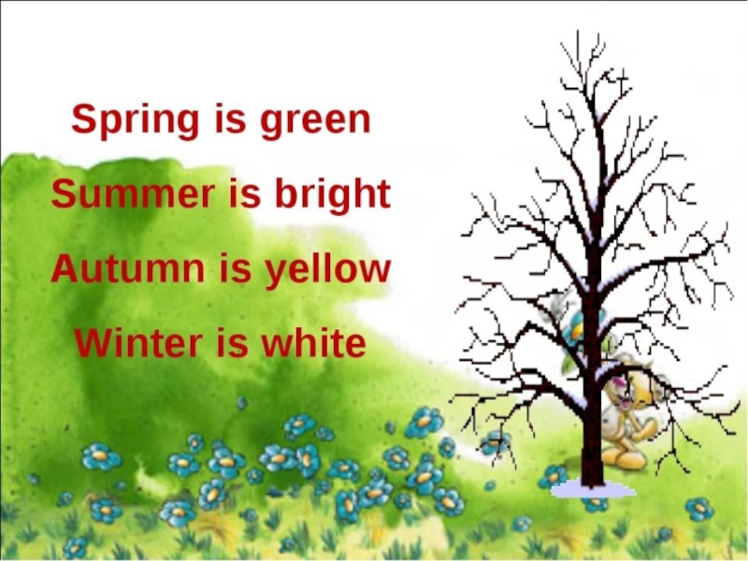
When is your birthday?
My birthday is in………..

Фонетическая зарядка
[t] elephant autumn
[d]duck dog
[s]snowman spring
[r]rain run

[r]rain run

[r]rain run
